**Approve Workday Transactions**

**Quick Reference Guide**



The Quick Reference Guide is designed to walk **Approvers** through the approval process in Workday. By the end of this QRG, you will know how to approver transactions in Workday.

The worktags assigned to a transaction determine the approval workflow. If the transaction is **Project** related, it will route to the **Project Budget Specialist** to approve. If the transaction is **Designated** or **Gift** related, it will route to the **P2P Approver** to approve.

As an Approver, you will receive a notification in your **Workday Inbox** for the tasks you need to review and approve in Workday.

On the Workday **Home** screen:

1. Click the **Inbox** icon.



1. Click on the applicable inbox task available under the **Actions** tab.

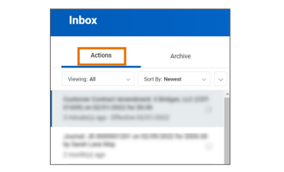

1. Scroll down to view all the worktags related to the task and check for accuracy. See below for guidance based on the type of transaction (services, projects, overhead, or inventory).

|  |  |  |  |  |  |
| --- | --- | --- | --- | --- | --- |
| Billables | ***Services - All Customer Work Orders that are not eBuilder Projects*** | | | | |
| **Worktag User Input** | |  | **Worktag Default** | |
| Cost Center | Requestor's Cost Center |  | Company | UVA_207 Rector & Visitors of UVA |
| Designated | DN000311 FM-Education and General |  | Business Unit | BU16 CO-Operations Admin |
| Program | PG00216 FM-Services |  | Fund | FD001 Unrestricted Operating Fund (State 03000) |
| Internal Reference | Work Order & Phase |  | Function | FN035 Physical Plant Admin |
| ***Projects - All eBuilder projects*** | | | | |
| **Worktag User Input** | |  | **Worktag Default** | |
| Company | Company associated with Project |  | Cost Center | CC0550 FM - Project Clearing |
| Project | eBuilder Project Name |  | Business Unit | BU16 CO-Operations Admin |
| Internal Reference | eBuilder chart of accounts number |  | Fund | FD055 Capital Project Default |
|  |  |  | Function | FN059 Capital Projects – Unexpended Plant |



|  |  |  |  |  |  |
| --- | --- | --- | --- | --- | --- |
| Non-Billables | ***Overhead - Goods or services purchased for organization use*** | | | | |
| **Worktag User Input** | |  | **Worktag Default** | |
| Cost Center | Requestor's Cost Center |  | Company | UVA_207 Rector & Visitors of UVA |
| Designated | DN000311 FM-Education and General |  | Business Unit | BU16 CO-Operations Admin |
| Program | PG00215 FM-Overhead |  | Fund | FD001 Unrestricted Operating Fund (State 03000) |
|  | |  | Function | FN035 Physical Plant Admin |
| ***Inventory - Utilizes AIM system to manage inventory (restricted use)*** | | | | |
| **Worktag User Input** | |  | **Worktag Default** | |
| Cost Center | Requestor's Cost Center |  | Company | UVA_207 Rector & Visitors of UVA |
| Designated | DN000311 FM-Education and General |  | Business Unit | BU16 CO-Operations Admin |
| Program | PG00214 FM-Inventory |  | Fund | FD001 Unrestricted Operating Fund (State 03000) |
|  |  |  | Function | FN035 Physical Plant Admin |

1. If required, enter comments in the comment box. It is recommended that you write a brief description indicating

you have reviewed the task and provide the date as confirmation.

1. Take appropriate action for the inbox task. Depending on your role, you may see the following options displayed differently:
   * Click **Approve** or **Submit** if the details provided are accurate. This option sends the task to the next approver or if no approvers exist, completes the process.
   * Click **Send Back** if the details provided are incorrect and the initiator of the task is required to make changes. Enter a reason in the pop-up box. This option sends the task back to the initiator of the task.
   * Click **Add Approvers** if you need to forward the transaction to anyone outside of the approval chain. Not all tasks will have this option.
   * Click **Deny** to reject the task and enter a reason in the pop-up box. Then click **Submit**. The initiator will receive a notification in their Inbox that their request was denied.

Be sure to review the task carefully before selecting Deny as this completely cancels the task and it will no longer be able to be edited or viewed.


* + Click **Save for Later** to save any edits you have applied to the transaction and keep the task in your in your inbox to review later.
  + Click **Cancel** to close out the task without saving any edits you have applied to the transactions and keep the task in your inbox to review later.
  + Click on the **More** icon (…) to view additional actions that are not displayed. Not all tasks will have this option.

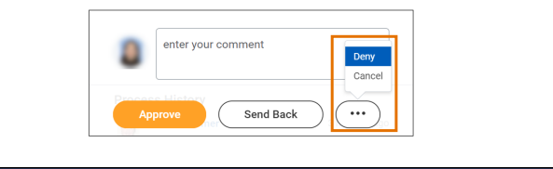

**Approve Workday Transactions**

**Quick Reference Guide**