UVA Facilities Management
Custodial Services
Customer Feedback for Wall of Shine!
Updated March 1, 2023

Hi Tiffanny,

I want to let you know that I requested that Mary clean the Library on Wednesday morning because we had a group from Ash Lawn coming to take an historic tour of Monroe Hill. She did a beautiful job and I told her so today. I adore Mary and we have worked together for many years. Also, can you let her know that John Casteen has the spare key to the Law Office. Men!

Cheers,
Chris

Good morning Wanda,
I wanted to follow up in writing about the comments I made this morning regarding James Bledsoe and the work which he performs in Skipwith Hall.
I transferred into Skipwith Hall due to the large number of staff in my office and the response to COVID19. I have had the opportunity to observe James as he performs his duties. I wish to offer praise to you for him, regarding his work ethics. These are my observations:
James works well without supervision. Whenever I see him, he is involved with making Skipwith Hall clean, and SAFE for staff.
James always uses his PPE. Since the start of COVID19, I have not seen him without a face cover. Even with the face cover, you can perceive that he does his duties with a smile on his face. He is pleasant with every encounter.
James approaches his duties with focus and energy. Whenever I see him, he is engaged in his duties, whether it is cleaning a restroom or emptying trash cans, or various other duties. He accepts the responsibility he has to provide a safe environment to Staff here in the building.
I feel safer knowing that James is in the building. I truly appreciate all he does to help me perform my duties. It is a privilege for me to serve UVA alongside James. He is wonderful individual who contributes greatly to UVA. I am sure you are proud to serve with him. I know that I am proud of him, too.
Best,
Michael E. Duffy, CAFM

Dear Mr. Newton and Ms. Buckingham,
I hope you will not object to my writing you — but I felt I had to tell you the splendid job Lois Crenshaw and Eugene Chambers (our maintenance/facilities staff in New Cabell Hall) are doing to keep NCH clean during this difficult time of the pandemic. I cannot imagine two more dedicated and more accommodating people. They are model employees — always with a mask, always at the job, always helpful, and always ready to be of assistance. I have been at the University 46 years, and I have never seen NCH in better condition than it is right now — halls and rest rooms in spic-and-span condition. It is a pleasure to have a work area like ours, and we owe it to people like Lois and Gene.
We too often, I think, take our maintenance staff for granted. We expect our surroundings and work areas to be clean and in working order, and we forget the effort and hard work it takes on the part of colleagues like Lois, Gene, and others to achieve this goal. I therefore like to let it be known, from time to time, how much we appreciate them, especially in difficult situations like the present one. We could not do our work if they did not first do theirs. We are so fortunate to have such people on our team.
Sincerely,
Mark J. Elson
Professor of Slavic Languages and Literatures

Mark and Vibha,
I trust this message finds you both doing well. I write to provide acknowledgement to those on your teams supporting the School of Education and Human Development. I have received a number of kudos over the past several weeks regarding the work your teams have done to prepare for a safe return of students, faculty, and staff to Grounds. I know that this was an undertaking and we feel very well taken care in our facilities both on and off-Grounds. Our collective thanks to Tiffanny, Jamie, Ryan, Kenny, and the teams supporting them for the outstanding effort this summer and fall.
Best,
Joey

Hi Tiffanny,

I am Mary Greene, working at 2420 Old Ivy Rd. I am writing to inform you of a great job that the cleaning crews has perform here in the last two weeks. Allen. Benita and Titus has gone about and beyond the call of duty cleaning here at 2420 Old Ivy Rd.

They have been cleaning the bathrooms and door handles all day and mopping the bathroom and our break rooms – which I haven’t seen since we move in over a years ago.

They are truly some awesome workers. We need more workers like them. Doing an excellent Job!

Mary Greene

Hello Mr. Katina,

This is William Bray with the Monitoring Station. I just wanted to let you know that myself and many of my colleagues have been thoroughly impressed with Simon’s performance when maintaining our workspace. He is the most thorough custodial worker we have had yet, and has been very diligent in showing up both on time, and being consistent in sanitizing our area. In a time where we need to be extra careful of keeping a clean environment he goes beyond our expectations and we are very glad to have him. Please be sure to pass along our gratitude!

-William Bray
UVA Police Dept Monitoring Station

Hi Katarina,

I wanted to take a moment to let you know how wonderful Wanda is over here at O’Neil Hall. She keeps this building remarkably clean while always being friendly and professional. I see her working hard both day and in the evenings and I appreciate all she does to keep our work environment a place to be proud to come to each day! It is a pleasure to have Wanda as a colleague.

Kind regards,
Michael

Hi Katarina,

I work in the Michie North bldg. I mentioned this to you before, but I wanted to follow up in writing to say how much I appreciate Sandy. When I enter the building it smells clean and I love that. Sandy works hard and always has a pleasant demeanor and attitude. The bathrooms and small with no ventilation and they get a lot of use. Sandy does a good job in spite of that. It’s easy to see she takes pride in her work and she connects to people all the while moving and doing her job. I also remember her from my years in Alderman Library. Sandy hasn’t changed. She still has great work ethic. Please let her know she’s much appreciated and well liked.

Sincerely,
Jennifer

Geralyn,
It was a pleasure to meet you this morning! Per your suggestion, I am writing you to let you know about the fabulous work that Sandy Payne does for us in HR at the Michie South Building. Sandy is a very conscientious worker…flexible and helpful! I know we drive her crazy with all of our celebrations and popcorn making we do however Sandy just goes with the flow and is very eager to assist us with any spills or clean ups that we may have. She even provides us with suggestions when needed and smiles as she cleans with one of the best attitudes around! She is a keeper! We need more employees like Sandy who always lead by example to others everyday.
Thank you,
Gretchen Kaufman

Dear Ms. Radovic,
I would like to say that on behalf of UVA International Studies Office that it is a pleasure working with one of your employees, Ms. Tonya Sillett. She is always cheerful, dependable and does an excellent job on caring for the Minor Hall building. Tonya pays meticulous attention to detail, communicates great with others as to what tasks she will complete in their offices and for other general tasks that will be going on. She is self motivated and willing to go beyond what is required. We have every confidence in her ability to continue to do an excellent job. Thanks so much for your time.
Sincerely,
UVA International Studies Office

Good morning, Wanda,
I had intended to share at the TIHWDI ceremony what a great job did James did in helping me ready the space, but as usual with these sessions, time slips away.
Please let James know how much I appreciated everything that he did and how he did it. I had ideas on how I wanted things set up, but James had better ideas and I was impressed that he spoke up with suggestions. For example, he suggested splitting the tables so that the red carpet could be rolled down the middle, and he spent several minutes straightening it out and positioning it 'just so'. He moved many chairs around, but always first surveyed where chairs were and then moved them in the most efficient ways to meet our planned arrangement.
In addition to his help, James has a wonderful 'I want to be of service' attitude

Dear Brandon,
We would like to start by saying that we are sorry about what happened a few weeks ago with the trashcan.
We want you to know that we appreciate everything you do for us and the attitude with which you do it. We thought it was all of our responsibilities to reach out to you and make things right.
We noticed that you enjoy drawing and are an avid artist, so we hope this gift helps you discover more of your passion.
Thank you for putting up with us!
Sincerely,
Dunglison 2L

Good afternoon,
Just wanted to give you a special thanks for allowing Rene Lukole to work with us today. He was very cooperative, hardworking & diligent with the responsibilities given to him by me. It was my distinct pleasure to have the opportunity to work with Rene
Thanks,
Vic

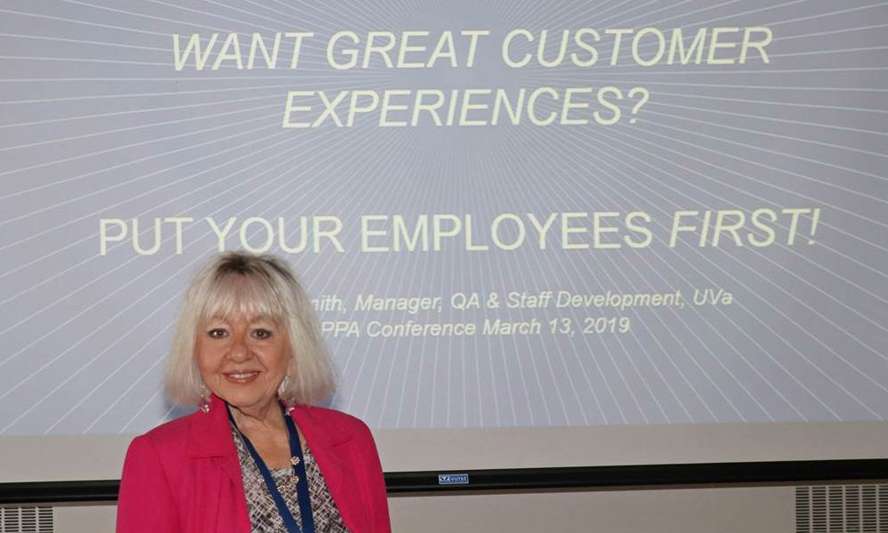
UVA’s Custodial Services Department presented at the March 2019 VAPPA conference which was held at UVA. The program, titled, “Want Great Customer Experiences? Put Your Employees First!” was presented by Staff Development and Quality Assurance Manager, Sandra A. Smith.

Good afternoon,
Just wanted to give you a special thanks for allowing Amber Remy and Joselyne Irabibona to work with us today. They were both very attentive, hardworking and diligent with the responsibilities given to her by me.

It was my distinct pleasure to have the opportunity to work with Amber & Joselyne. They gave 110% throughout the day. When given the task to move to another station, they had no complaints, they just got at it, and put out great effort all day.

Thanks,
Vic

Dear Ms. Snead,
I just wanted to write to say how happy we are in the Leake Lower Level about how our carpets look. Some serious cleaning happened here over the weekend and they look great! Thanks to you and to the housekeeping team! We see Norman over here a lot and I’ve said the same thing to him, but wanted to pass it up the chain.
Thanks again,
Theo Diamond

Hi Katarina,
I just wanted to thank you for the exceptional job you and your crew did with the floors in our department.
The floors looks great and you did this job unbelievably fast!
We in the Clinical Skills Center appreciate your hard work and your great job ethic.
We are lucky to have you!
Thank you again!
Mandana

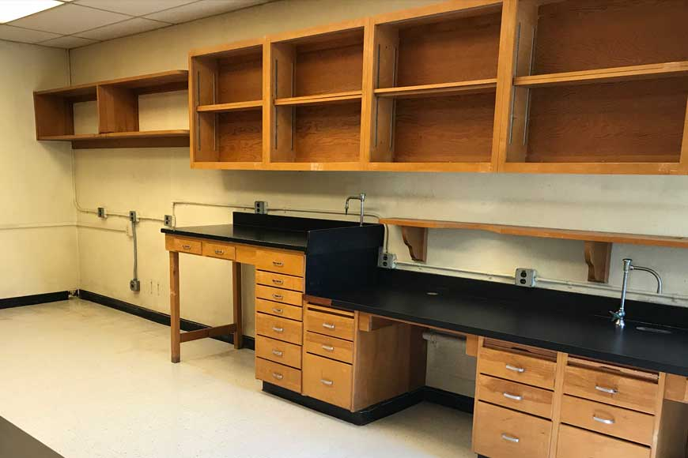
Ryan, thank you and your team for doing an awesome job cleaning this space.
Bruce Shifflett

Simenesh Gebreselasse received her fifth safety star this month reporting this trash. Heavy unsafe trash in outside cans, Pinn Hall.
She won four other stars for reporting safety concerns in Pinn Hall:
- May 31 - Leak in hallway on sixth floor near 6019B & C
- June 1 - Loose Threshold, trip hazard in Conference Room 2327
- June 6 - Light out at ramp taking trash out late at night, area not lit up as it should be
- June 8 - wire sticking up from trash can lid, may cut someone empting trash
Other awards:
- June 4 - Betty Mkungusi - Leak in cold room. She asked supervisor before getting up the water as instructed. After calling EHS, they said it was okay to mop up the water.
- June 5 - Hassan Mohammed - water in hallway from leak in 6019 C. Hassan called to report water in the hallway. Occupant fixed the problem with the water distiller so this should end the water in the hallway.
I am so proud of the reporting to get these safety issues corrected in a timely manner before someone got hurt.
Thank you,
Judy

Yea Tracy Smith! 14 out of 16 High Qualities! (other two were Needs Improvement!) Great job!
Great job for several supervisors this week: Tracy Smith; Geri Findley; Jessica Snow; Katarina Radovic; Tila Kharel!!!! PLEASE CELEBRATE WITH THE FRONTLINE ASSOCIATES WHO MADE THIS POSSIBLE!
This week closed out with so many HQ’s we were very, very proud of everyone!
Best,
Sandra

Hi Hattie,
I just want to let you know what breath of fresh air it has been to have your staff in our building. After all of the issues we had with the contract crew in the previous year, it was such a relief to have Kim and Harry assigned to our building. Not only have they done a great job of keeping the building looking good and clean, they are friendly and responsive. I cannot recall one time this year where we had any issues with daytime cleaning. As a matter of fact, I broke a dish in our kitchen one day. Kim came in as I was on the floor picking up glass and chased me away. She said, just call, we will take care of it. That would never have happened with the previous crew.
In that light, I will also add that it is a pleasure to see you and to work with you as well. You regularly check in and are proactive about making sure our needs are met.
Thank you and your great crew for a wonderful year!
Best,
Barbara J. Gibbons

Reggie,
I want to tell you how much We all appreciate having James Bledsoe here. He is truly amazing. He never stops working. The quality of his work is noteworthy. He is always on the lookout for anything that needs to be taken care of. His personality offers some of the very best customer service skills I have seen. James represents his department in a manner that displays respect, Vision & Passion.
He helps in Creating and caring for the physical environment in which those who seek enlightenment, knowledge, health and productive lives can flourish.
When I read our core values, I thought of James Bledsoe immediately. He is an excellent example of someone who displays these values daily. He has also helped me smile more.
I see someone who will inspire others to be second to none. to take pride in our work while sharing respect for ourselves, each other, and our University and it’s community.
Core values that James emulates
Collaboration: Striving to work together and with others to accomplish the purpose and vision of the University by sharing knowledge, learning and building consensus
Respect: Sharing a common respect for ourselves, each other and our University community
Integrity: Striving for honesty and equity in all our endeavors
Excellence: Striving to be second to none in all that we do
Pride: Taking pride in the beauty of our grounds, the grandeur of our buildings and the quality of our work
Community: Making the University and our community a better place to study, work, heal and live
For safety to be a success, you have to start – start doing something. Hazard identification and control activities, training, start a safety committee; do something, anything! There is no magic to delaying– no one will undertake safety efforts on your behalf. But just as importantly, our experience clearly suggests that if you pay attention to the basics, consistently deploy them and engage your workforce on-the-whole, you will make progress and hedge your bets toward success.
Mark Roach
Associate Director Utilities Department

Hi Hattie,
I just wanted to thank you for the wonderful service we received this past weekend for our Second Look Visit.
When I arrived on Saturday morning the Learning Studio had been cleaned so nicely from the reception on Friday afternoon. Please let the appropriate supervisor know that I was really impressed with the service we received.
Thanks again!
Janet K. Small

Dear Janitor (Elizabeth Powell),
First of all, I'm sorry that I don't know your name, second of all, thank you. Thank you for doing foundational, essential work in Shannon at UVA. This place would be a mess without you, as I'm sure you know. Thank you for cleaning the floors, tables, glass, mirrors, toilets, sinks, doorknobs, and showers of Shannon. You do a stellar job and do not get compensated in thanks enough.
On top of all of that cleaning, you do it without complaint, and when I see you cleaning in the morning, you have a smile on your face that brightens my whole day ahead.
You deserve a lot more thanks than just a poster for not only completing your job every day, but for doing it with a smile and pride.
We all appreciate you and your hard work silently, but I hope that a few of us say "thanks" in the morning because you deserve a thousand thank you's.
Thank you for everything you do and for doing it with a smile,
A Shannon resident

Good Morning Vibha,
I would like to give you a praise report on Norman. Apparently he was using WW dumpsters and he almost slipped on black ice. He made a phone call to me to warn my staff that black ice was presented and he suggested we put salt down by the dumpster. I think this was an accident waiting to happen, but Norman saved the day. Please share with his supervisor.
Thanks
Tanyia Moore

Dear Tabby,
Thank you for keeping Hallsey Hall looking so nice, clean and welcoming to our students and visitors! We really appreciate it and are so happy to have you with us. Happy Holidays!

Your friends in The Dept of Statistics

Dear Judy,
I happily write to express our great satisfaction with the work of Kalenga Kilumba, who cleans the Claude Moore Medical Education Building. Early on Kalenga cleaned the second floor which includes the men's and women's restrooms. Each morning we could always count on entering a clean and fully stocked area. Kalenga is always extremely pleasant and humble, a joy to have around. He takes pride in his work and wants to do a fulfilling job.
After some restructuring, Kalenga was moved to the first floor of the building. It did not take long for everyone on that floor to appreciate Kalenga's personality and work as well! If, for whatever reason that Kalenga may not be here, he is missed immediately.
Kalenga appears to be grateful for the opportunity to work. He is always professional, responsible and he stays connected. After moving down to the first floor, he stopped by to visit me here on the second floor. One of his well-spaced visits was after the Fourth of July holiday. I asked if he had a good weekend and he beamed and told me he had participated in the Naturalization Ceremony at Monticello. I was able to share in his joy!
All of us here are pleased that Kalenga has been assigned to our building.
All the best,
Mary O'Leary

Wanda,
Good afternoon. I wanted to take a second to let you know that Norman and the team always do an exceptional job keeping the Leake Building immaculate however yesterday Norman and the team went above and beyond in preparation for yesterday's “Open House”.
Please extend our gratitude to the team and let them know that we see the great job that they do!
Thanks again!
William Hussey, Jr.

I wasn’t able to be at the open house – jury duty that Thursday – but was impressed to see last minute prep at about 6 pm on Wednesday for the event. Outstanding! Thank you!
Cheryl

Dear Geri,
I wanted to follow-up on our conversation from Friday and share my gratitude for Reece’s performance on Sunday, September, 17th.
Sunday, September 17th was a remarkable day in the Rotunda’s history as the Confederate Memorial plaques were removed from the building’s façade. This work was done early in the morning and was a tense and hurried endeavor. I was supremely impressed by Reece’s composure and commitment to continuing his work notwithstanding the sensitive and potentially, though thankfully unrealized, conflictive nature of the work. His attitude was superb and commendable. On top of all of that, the work was messy and we managed to dump decades of dirt, birds’ nests, and other assorted muck all over his clean floors which he was more than happy to re-clean.
I’ve been impressed by Reece since day one, but found him to be exceptional in this opportunity.
I hope these thoughts can be shared both with Reece and with management.
Best,
Adam

Dear Mr. Webb,
On behalf of the staff and membership at the Senior Center, I would like to thank you for your support of the 2017 United Way Laurence E. Richardson Day of Caring, 20 September 2017. Our excellent group of volunteers from UVA Facilities Management continues to do our Transparent Window project here at the Senior Center, and we truly appreciate the volunteer efforts.
Although the Senior Center is a volunteer driven organization, there are some volunteer projects our seniors are not physically able to do and washing windows and second story windows is one of those projects. The UVA Facilities Management Team under the direction of, Kevin Key and Reggie McGhee, plus your volunteer team of Hattie Agee, Phillip Cabell, Bucky Crickenberger, Jesse Johnson, Raymond Jackson, Sandy Morris, Kenny West and Duane Wood; along with your leadership and Wayne Mays, they did a magnificent job cleaning our windows. They not only did a first-rate job with the volunteer project, they did it with smiles, team-work and enthusiasm. We always enjoy having them on-site. Personally, Reggie, Kevin and I, have built a good relationship and we have the process under control, which makes everything run smoothly.
Senior Center, Inc. is an independent, 501(c)(3) funded entirely by private contributions, member and program fees, and special events; we do not receive federal, state or local government funding. We are now one of seven Senior Centers that has been accredited three times in the United States. Our mission is to positively impact our community by creating opportunities for healthy aging through social engagement, physical well-being, civic involvement, creativity and lifelong learning. With this mission, our next large goal is our Capital Campaign towards building the Center at Belvedere. Our local aging populations, in the greater Charlottesville area will more than double from 27,000 in 2000 to 56,000 by 2020. We envision a center that will transform our ability to support individuals and families, keep seniors living independently in their homes, help other non-profits, and relieve strained social services.
Thank you for your generosity and involvement in United Way Day of Caring.
Sincerely,
Kimberly K. Haynes
Coordinator of Volunteer Resources

Reggie:
This note is one of the best that I’ve read. I am thrilled because this customer recognized Dora’s initiative, was impressed and then communicated it to us. These words are music to my ears, “Dora came forward to suggest the action, we agreed a date, she got approval from her supervisor - all done in a businesslike fashion - we were very impressed!” This is a super example of staff taking initiative, my dream come true. Please let Dora know that I thank her for her professionalism and initiative, and Congratulate her for making the department proud.
Vibha

Thank you for cleaning up after us all summer long! Have a great summer.
iDTech staff

Dear Tanya,
Thank you for all you do to help make UVA Orientation run smoothly. We so appreciate all your efforts and work towards Housekeeping and making our facilities run smoothly. We look forward to working with you again soon!
Sincerely,
Sharon

KUDOS!!! To FM Housekeepers in New Cabell Hall this week.
Please share with the two FM employees in Cabell that their work was recognized. A Classroom staff member requested I meet him in this room-he wanted to show me something.
He explained he had been watching the new housekeepers working for days off and on to get this auditorium cleaned up. He said they were on their hands and knees scrubbing with brushes.
Wilson Hall 402 classroom “auditorium” is spotless.
All levels had been scrubbed clean-the floor under and behind the seats on all rows and all corner spaces have been scraped and scrubbed.
The seats are free of gum, spills and dirt. All the seats have been wiped down-every inch of the seats have been dusted, scrubbed and are shining like brand new.
This room looks honestly marvelous!
Sharon Bingler Drumheller

Hi Judy,
I hope this finds you doing well! I wanted to let you know what a pleasure it is to have Tashi on our floor and that I really appreciate his attentiveness to detail. Twice this week I was pleasantly surprised by things he discovered and cleaned so that I didn’t have to. Earlier in the week, we began a defrosting of the freezer on the staff fridge, which required us to move it out of the office kitchen in 5007. It’s been years since we did this, so of course the floor area was filthy. When I came in the next morning, prepared to get the cleaning materials out, I was happily greeted by a shining floor instead of dust bunnies and dirt! Tashi cleaned it without being asked...he just saw that it needed to be done and took care of it! And then again this morning, I found a clean surface that I was prepared to clean! Yesterday, I had the Bunn coffee maker removed from 5313, with a plan of moving the department microwave up to the counter where it would be easier to reach. The counter was a bit of a mess from where the coffee pot had been sitting unused for a few years. I grabbed all the cleaning supplies and headed in there this morning, only to be greeted by a spotless countertop, which meant that all I had to do was move and clean the microwave!
As you know, he was equally attentive to this level of detail and put in a great deal of effort to keep my office clean when it got moved a few months ago. I’m grateful for his dedicated service and hard work to keep our department looking nice. It’s really great to have someone working with us who can anticipate what we need before I even think to ask for help with it. I don’t always get a chance to see Tashi these days – between my office relocation and the increase in meetings I have to attend with my new role in the department – so I hope you will be able to relay to him my gratitude and appreciation for his hard work.
With best wishes,
Jolene

I just wanted to give recognition to Tila Kharel for his assistance at the graduation ceremony on Sunday.
As I looked for an appropriate rest room to take my 83 yr old disabled father in a wheel chair to, Tila immediately saw my dilemma and offered to direct me to an alternate restroom in the building. What a relief I felt to have Tila personally escort me, not just direct me where to go! When the restroom had a lighting issue Tila didn't hesitate to offer his personal cell phone as a flashlight; while simultaneously alerting the appropriate electrician to take care of the situation. I didn't bring my personal cell phone with me.
Tila's courteousness and respectful manner made me feel as though I was a VIP and my father recognized Tila's unparalleled service as well. As a corporate executive in his prime, I know he would have handed Tila a handsome gratuity if he could.
With all the pomp and circumstance over, I didn't want this gesture of service to be overlooked. I hope that all the graduates at UVA are as service oriented as Tila in their future professions. Tila's personal attention was much appreciated.
If you have an employee recognition award, I would highly recommend Tila for recognition. So many behind the scenes employees don't get the credit they deserve and I hope Tila would be considered for his actions assisting me and my father.
Sincerely,
Beth King

Hi Judy,
I am sorry that I don’t know the name of the woman who is cleaning on the 6th floor this week (Barbara James), however, our employees asked me to let you know what an outstanding job she is doing. She is going above and beyond what is normally expected and we are very impressed!
Sharon

With sincere appreciation and warmest thanks to you.
Thank you so much for everything you have done this year. We appreciate it more than you know. This is just a small gift from all of the residents to you. Have an amazing summer!
Sincerely,
Gibbons Dorm & Association Council

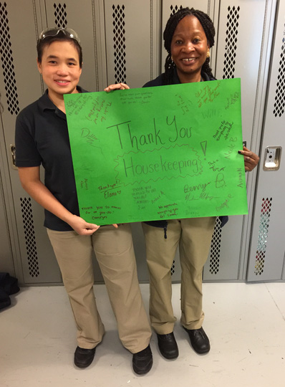

Dear Tila,
I just wanted to confirm in writing what I told you during your inspection today. We feel so lucky to have Anita and Corey working on our side of the building! I can always tell when Anita is out on those rare occasions because when she’s here, the ladies restroom is so fresh and clean. When she’s not here it gets done but not the way she does it! She is always willing to either find a solution or point me in the right direction when there’s some kind of dilemma, like someone getting sick or something not working right. There has also been quite a few times when she has found something valuable that a student has left behind and brought it to me, making the student very happy, especially the girl who left her cell phone with a cover holding a bunch of cash, her ID card and a couple of credit cards! Believe me that girl was really happy! She is just so nice to have around here!
Corey is always out here working on the floors and gathering trash for us. He’s proud of his shiny floors and so are we!
I think they make a great team over here and you just need to know how much we appreciate them!
Regards,
Liz

Dear Aura,
Thank you for all you've done for us this past year. Your smiling face has brightened our mornings when we most needed it! Please accept these flowers and gift card as a token of our appreciation and gratitude for all your hard work!
With Much Love,
Kellogg 4th Left
(Rooms 425-438)

Dear Judy,
As follow up to our McLeod Hall conversation about Adequate Kabari, I write to underscore what you already know about this fine young man: Adequate is an asset to the University! He is hard-working, determined to do good work, pained when workload means that despite his best efforts the building isn’t clean enough to suit him, and ceaselessly cheerful – even when he is under the weather. He is far more than what his name suggests, Adequate. He is a great blessing to those of us who serve or study in McLeod Hall.
All good wishes,
Linda

Dawa Ji:
Excellent work, thank you. Your performance is highly respected and appreciated by us all, always. We know that we can always count on you.
Vibha

Dear Vibha,
I have been in the same office in Olsson Hall suite number 112 since I joined the faculty of the University of Virginia in 1987. With this email I would like to thank you and Jimmy Sayre for his outstanding service and unrelenting support during the last eight years as the supervisor of the Southern McCormick Zone, which includes our office of the University-wide Center for Risk Management of Engineering Systems.
Sincerely yours,
Yacov

Lucky,
I wanted to remind you how special you are and that you are valued in the community. I truly appreciate all of your hard work. It is obvious how much you care about all of us, and I think that is really amazing. You make a positive impact in the community every single day.
Thank you for everything,
Alana

Dear Lucky and Facilities:
You are among the kindest, most patient people I have ever met employed here. Your hellos and well wishes are greatly appreciated. We can tell how much you truly care about us as students and people. We care about you, too!
So here’s a thank you for all you do – and the heart you put into it.
Love,
A UVA Student

Dear Mike, Hattie, Ryan and Vibha,
Thank you for all that you did to prepare the building for Senator Tim Kaine’s visit today. Everything looked very nice. It takes a village. From what I understand his visit went smoothly and the students were extremely grateful for his visit.
Again, we are appreciative of your devout attention to this event!
All the best,
Mary

Dear Sharon,
Just wanted to get you a little something to show you how much 3R of Shannon House appreciates you. I know your job isn't easy and you don't always get the credit you deserve for how hard you work. Thank you for all that you do to keep our home clean. We truly appreciate you.
Best,
Shannon, Katie Boilard & Jessica Sookram

Hi Judy,
Just want to thank you for a clean floor today. Really appreciate it. Thanks Beatrice for me. She did a good job! I know my floor is hard to keep clean because of the machines. Just letting you know I noticed it. Thanks again Julie
Julie Shumaker

Dawa Ji:
Excellent work, thank you. Your performance is highly respected and appreciated by us all, always. We know that we can always count on you.
Vibha

Dear Vibha,
I have been in the same office in Olsson Hall suite number 112 since I joined the faculty of the University of Virginia in 1987. With this email I would like to thank you and Jimmy Sayre for his outstanding service and unrelenting support during the last eight years as the supervisor of the Southern McCormick Zone, which includes our office of the University-wide Center for Risk Management of Engineering Systems.
Sincerely yours,
Yacov

Dear Mike, Hattie, Ryan and Vibha,
Thank you for all that you did to prepare the building for Senator Tim Kaine’s visit today. Everything looked very nice. It takes a village. From what I understand his visit went smoothly and the students were extremely grateful for his visit.
Again, we are appreciative of your devout attention to this event!
All the best,
Mary

Vibha,
I hope all is well and that you are having a fantastic start to your New Year. I am writing this email with great pleasure to let you know that a member of your housing staff Reggie is truly valued by the folks here in Monroe Hall. While most people were out on break over the last couple weeks a colleague of mine Sean Reed and I were talking about the housing staff. Once Reggie returned there was a clear difference in the appearance of the building and the restrooms. He has always been helpful and is a delight to have here in the building. I am sure that a lot of times only the complaints are shared but I thought it was necessary for you to know what a wonderful job he has done and is continuing to do. I hope you have a wonderful weekend!
Mike

Joseph,
I wanted you to be aware of what outstanding staff you have! We have an employee who is coming back after maternity leave and she wanted her room (219) in Minor Hall to have the bugs cleaned out of the lights, the double windows unscrewed and taken down and then cleaned between the glass.
We went the route of putting in work orders for facilities to come and clean out the lights and unscrew the windows for housekeeping to then come and wash them. I contacted Tila, asking about the procedure and what I was hoping to accomplish by the 23rd (the date that our employee is coming back).
Unfortunately, I received little to no response from facilities, who indicated they were very short staffed in January. I had put the work order in on Jan. 5th and by Jan. 10th, there was still no response.
Tila took it upon himself to bring Sandy, Brenda and Alia with him this morning to unscrew the windows, clean them AND bring a big ladder to reach the lights in our high ceilings to clean out the bugs.
Their extra effort to get this done for us in the time frame that we needed was a very unexpected wonderful surprise. They all went far above and beyond what they needed to do, taking on some of the things that facilities should have done for us.
Tila is impressive with his quiet demeanor but also wonderful leadership skills. Sandy, Brenda and Alia each have wonderful attitudes to work as a team, but also their personal work ethic shines through.
Thank you for sharing them with us.
Malinda

Dear Michael,
I want to thank you and your staff for everything you all do. I know it’s not easy working in first-year dorms. They can be incredibly inconsiderate and they are very demanding, yet you do your job to the best of your ability and then some. For example, my floor’s housekeeper is Eliza and she does an incredible job. I can always tell when she’s gone through our bathroom because it smells and looks 10 times cleaner. She also always has a smile readily available when she sees me and my residents, and she is just so friendly.
Thank you again and keep up the good work.
Sincerely,
Jessica

Good afternoon Joe,
I just wanted to notify you what a pleasure it was to come to work today. I walked into a well cleaned building that even smelled good. Thanks again for taking care of us. We appreciate all of your hard work.
Iris WaguespacK

Crystal,
Thank you so much for keeping our bathroom and spaces clean. Sorry if it is ever too messy or too gross. We are going to try our hardest to keep it cleanlier. We appreciate all you have done and the work you do for Bonnycastle 2nd floor.
Love,
Bonnycastle 2nd floor

Good afternoon Reggie,
I wanted to share my feelings, and the rest of the department’s feelings as well, about the gentlemen who clean our areas. Both Norman and Brandon are always happy to help us and always with a smile. They are both very courteous and friendly. They do a great job cleaning up the mess we make daily! Also, James, who fills in on occasion is great as well! Always with a smile and always willing to help.
We really appreciate the hard work that they do on a daily basis. Not sure how often they get this feedback, but they deserve kudos!
Thanks,
Elsa L. Sherrill

Hi Mary!
We did it! We cleaned up. There was SO MUCH TRASH. The man who cleans the lounge normally stopped by and was an ENORMOUS help in getting all the trash to where it needed to go. I want to contact his supervisor to thank him for his hard work. His name is Kalenga. Do you know how to contact the supervisor for the cleaning crew in this building?
Thanks again for the heads up about the state of the lounge. That was no way to greet the new first years!
Sincerely,
Eve Privman Champaloux

I wanted to let you know what a super employee you have in Eugene. He has been great to work with here in Carruthers and is liked and respected by all of the employees. We are blessed to have him and want to keep him in our area.
Thank you,
Joyce Dunn

To Whom It May Concern,
I am writing in support of Bushiri, a member of the housekeeping staff at the University of Virginia Health System. Over the past year, Bushiri has performed the daily housekeeping activities for my lab located on the second floor of Jordan Hall. Bushiri has done an excellent job. He is thorough, dependable, and makes every effort to maintain my lab and others in the vicinity in the best possible condition. Furthermore, he is very polite and thoughtful about efficiently performing his duties without interrupting lab activities. He is an asset to the housekeeping staff and the University, and I highly recommend that his performance review should reflect this.
Sincerely,
Michael A. Harding, Ph.D.

Hello Judy,

I’ve talked with the labs here in Cell Biology, there is only positive feedback, everyone is very appreciative of Beatrice’s work. Beatrice is very friendly, always greeting lab staff in or outside of the lab. Beatrice works is always completed quickly and efficiently. We have never had no complaints or concerns with her service.
The office staff finds Beatrice to be reliable, honest and a hard-worker. Beatrice is very friendly both inside and outside the office. Her work is very efficient and done in a professional manner. We are fortunate to have Beatrice on our floor and have had no complaints or problems with her service.
Thank you for the opportunity to provide feedback. It’s always a pleasure to have a person well respected as Beatrice is.
Wanda

Hello Judy,
Beatrice is very friendly, always greeting me as she enters the office. She will also always greet me if she sees me outside the office. I work late so I’m usually around when she starts her duty in the office. She works quickly and efficiently to complete her assigned tasks. If there is something she is unsure of, such as locking a specific office door, she will always ask what should be done. I have had no complaint or problem with her service.
Best,
Lois

Hi Judy,
Mike is one of the best people we have had on this floor in years. He is thorough, conscientious, friendly and always does an great job of cleaning. His attitude is always positive and upbeat. We would be sorry to lose him. The only other person that can equal or better him is Simenesh.

Hope this helps.
Sharon

Safety Stars
Cherie G., for being observant in her work area:
Cheri reported bad wiring on an occupant’s equipment and the occupant was able to get the equipment repaired.

Mary J., for being observant in her work area:
Mary reported the poor condition of the MR4 loading dock steps.

Mary S., for being observant in her work area and reporting back to her supervisor:
Mary reported back on the CMCs that are being used on a temporary basis.

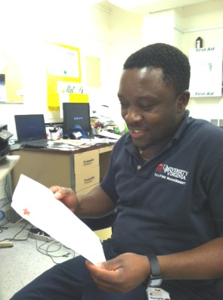

John
Completed the UVA Facilities Management Housekeeping Career Path
May 2015

Good afternoon Keith;
I am writing to express my appreciation and gratitude for Wanda and Dawa’s work at the O’Neil building. They are both friendly and helpful, but even more than that, they bring an attitude of pride in their work that is extraordinary. It is a joy to come to work every day to this beautiful building and experience their great attitudes, their attention to detail, and their commitment and pride to the University. Wanda and Dawa truly exemplify the best of UVA.
Sincerely,
Mary C. Brackett

Dear Ms. Kingrea,
I just want to let you know that Betty is a great housekeeper and should be commended for her hard work. She always comes into my lab with a smile and pays very good and detailed attention to her work. She keeps our floors clean and our bathroom well stocked. She is exemplary. I want you to know that we very much appreciate her taking care of us. She does not know at all that I am contacting you about her.
Kind regards,
Thu Le, MD

Wanda: I really should have done this some time ago! I really wanted to let you know that I appreciate how hard Norman worked on the floors at the James Monroe Law Office & Original Residence here on Monroe Hill a while back. He was so conscientious and did such a wonderful job washing, waxing and polishing the floors. He is a very hard worker and very pleasant to work with as well. Thank you for sharing him with us.
Stephen Paul Plaskon, Ph.D.

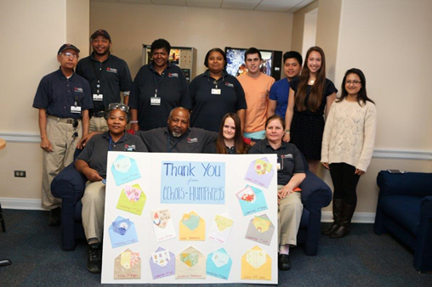

March 2016
Appreciation Breakfast provided to Housing Custodial Team by the students in Humphreys

Dear CDF custodial staff,
I’d like to take the time to sincerely thank you all for everything that you do in order to make CDF a better place. While it may seem at times that your work is unappreciated by CDF residents, we all are truly grateful for the time you take to help maintain CDF’s cleanliness. From picking up trash in the common rooms to cleaning the bathrooms, your work is truly essential to the day-to-day life of CDF residents, and I cannot ever begin to express the upmost gratitude I have for your unending dedication to helping ensure our association’s cleanliness. Thank you again for everything that you all do, we really appreciate it.
Sincerely,
Noah Salzberg

I would like to thank Beatrice for her help cleaning my room. It always looks good because of her. Thanks for training her right so that she does an excellent job. She always has a smile on her face.
Thanks,
Julie

Special,
We wanted to thank you so much for all you do! You are so incredible and we can’t thank you enough for dealing with all of our mess. One of the girls got very sick and we did our best to clean, but I’m so glad we had you. You are so amazing! We love and appreciate you, Special!!!

Student residents at Gooch/Dillard

Hi Judy,
We had a representative from a foundation and a tv crew here today.
Betty found about their visit from my students and did an outstanding job cleaning up the lab so it looked great for their visit. I really appreciate her efforts for today as well as the very professional manner in which she has done her job around here consistently. She's a keeper!

Regards,
John H. Bushweller
Professor
UVA Molecular Physiology and Biological Physics Chemistry

Joe,
I just wanted to write a quick note to commend one of your custodial services employees. I work in the Office of Safety and Emergency Preparedness and we’re responsible for the nearly 200 automated external defibrillators (AEDs) across grounds. Today I was on grounds placing new AEDs in some newly installed cabinets on Central Grounds, one of which was in Clark Hall. I entered through the annex section, not realizing how confusing that building is, and how difficult it is to get to the “main” side of Clark from the annex side. I ran into Markel who was cleaning on the ground floor and asked him how to get to the main side of Clark. Instead of just trying to describe to me where to go, he took time out of his day to show me how to get over to that side. Once over on the main side, he asked what I was looking for and if he could help. Knowing that he probably knows the building better than I, he helped me search the building for what turned up to be a cabinet that wasn’t yet installed (separate issue!) I would have been satisfied if Markel had just told me how to get to the main side of Clark, instead, he went well above and beyond what I was expecting, demonstrated excellent customer service skills (even when the customer is a fellow employee), and really defined what it means to be a team member. Bravo, and thanks for sharing him with us!
Please feel free to share this with him and thank him again for his hard work and dedication to customer service.
Best regards, Lucian Mirra

Good Morning Joseph and Vibha,
My name is Carrie Harper and I am sending this email on behalf of Lois as she does not have access to email right now. Lois wants to express how thankful and appreciative she is to have a wonderful supervisor like Keith. Although Keith has not been supervising Lois for very long he has definitely made a positive impact on her as well as the wholes group. So this email is just to let you know what a difference it makes to have a nice and responsible supervisor.
Thanks,
Lois Crenshaw and Carrie B. Harper
UVA Human Resources

Dear Keith-Just a brief note to tell you how great an employee that Lois is and how much we value her here in UHR. Besides maintaining our buildings in an exemplary fashion, she is a joy to see each morning. I hope that you are able to recognize her contributions.
Best regards,
Michael Schwartz

Good morning Lois,
Just taking a moment to thank you SO much for the lovely office!
I moved a few things around yesterday afternoon (quite a few ☺) and you wasted NO time getting in here and cleaning up all of the rough spots so that it looks brand new.
Thank you again!
Shana Pack
Wellness Program Manager, Hoo's Well

After images on buffing hallway flooring, work performed by new employee Theodore Peters. (BC) Melinda Ashburn was very happy with cleaning results and stated housekeeping does great work in Minor Hall and that employee efforts are greatly appreciated.

Ms. Buckingham,
I work at UVA in the Staffing Office I ride the Green Bus with one of your employees every morning. His name is Joseph who works in Housekeeping.
In early July I had the nerve at almost 60 years old to decide to dislocate my shoulder and break my arm. This has been quite an adventure for me and I am learning the true compassion of my fellow peers and individuals around me during this time. For the first month I was not permitted to drive so there was no problem getting to work and back. With school starting and the doctor’s permission I was finally released to drive to work. I am in my sling while not driving so am one arming the bus ride daily. If you have ever road one of the busses during peak times you know there is a lot of standing. During this time I have had to stand quite bit which I am used to, but is now challenging with one arm.
This brings me to the reason I am writing you. Joe has been the only person who has considered my condition and repeatedly gives up his seat to me. To be fair and honest I have had two other individuals offer one who could have been my Mother, the other a young college student. I can’t tell you how much this has meant to me. He has been a heaven sent on many days. Thank you for having him on your staff and sharing him with us on our bus rides.
I believe he certain has filled the meaning of the University’s RISE values that have been set for us to attain.
Respectfully,
Mildred Critzer, Staffing Clerk
Staffing Resource Office

Hi Vibha,
Thanks for passing along the email from Ms. Critzer and for nominating Joseph as a Respectful Workplace Champion. He clearly has embraced the mission of the Respect@ program by ensuring that the University is a safe place for all. I’ve notified Joseph that he has been named a Champion and we look forward to recognizing him throughout the University community.
I appreciate you taking the time to acknowledge Joseph and for helping to identify the type of outstanding behavior we strive to see shown by all members of the University community. It is such a privilege to be able to celebrate those who truly embody the core values of our community, and a pleasure to emphasize the positive experiences in the workplace.
Best regards,
Tamar Goodale

Hi, I work on the 5th floor of McLeod Hall and I just want to tell you what a pleasure it is to have Kiteto working in our building. Every morning he greets me with a smile and a good morning. He does an excellent job maintaining our building and making it look clean and nice. He takes pride in his work (this shows) and he goes above what is expected and it shows. My office is clean and it gets vacuumed and the chairs get a dusting and when I come in it is nice to know it has been cleaned. I have seen him wipe down the doors and window ledges and trash cans. He does more than just empty the trash on the floor. When there have been functions in the conference room and it has food, he makes sure the trash is emptied and not sitting all night smelling and the room is vacuumed if needed after the event.
These may seem like little things but they are appreciated and noticed. (these are things that have not been consistently done over the years). It is nice to have someone maintaining our” home away from home” in such a manner.
Camille Hicks
Administrative Assistant, Dean for Research
Office for Nursing Research

Judy,
I want to tell you how happy we are here in the Biochemistry Department to have Edison taking care of our housekeeping needs. Edison does a great job and keeps the sixth floor of Jordan Hall looking good. He is also very helpful and always ready to do whatever we may ask of him. His attitude is also good. He’s never grumpy and always smiles and is polite. I hope he continues to work on the sixth floor.
Cordially,
Kevin Cox

