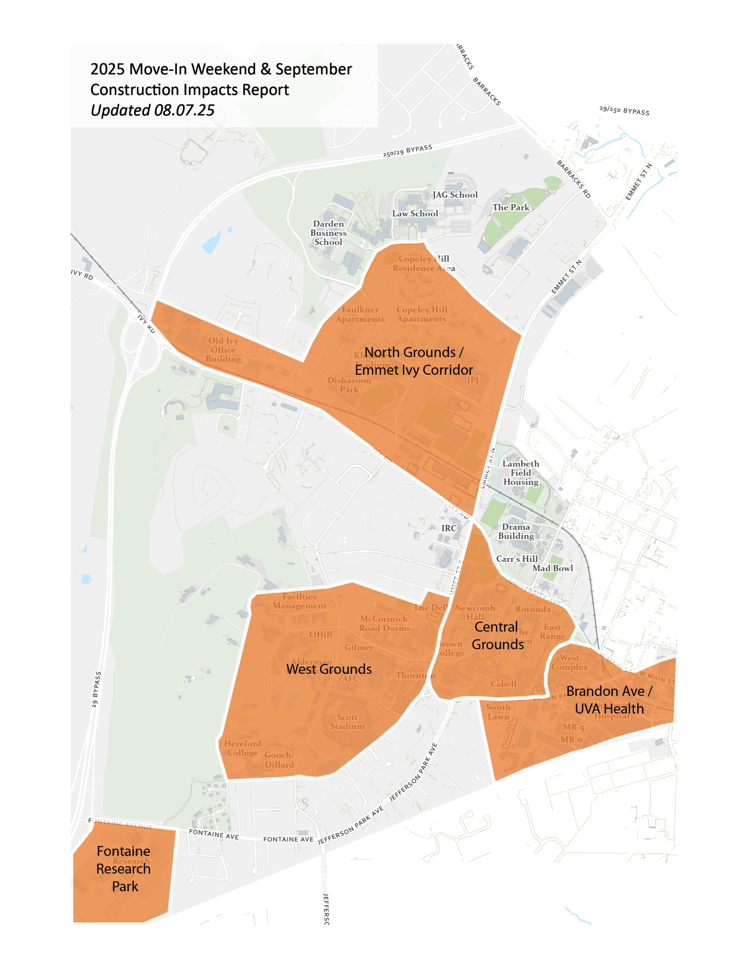
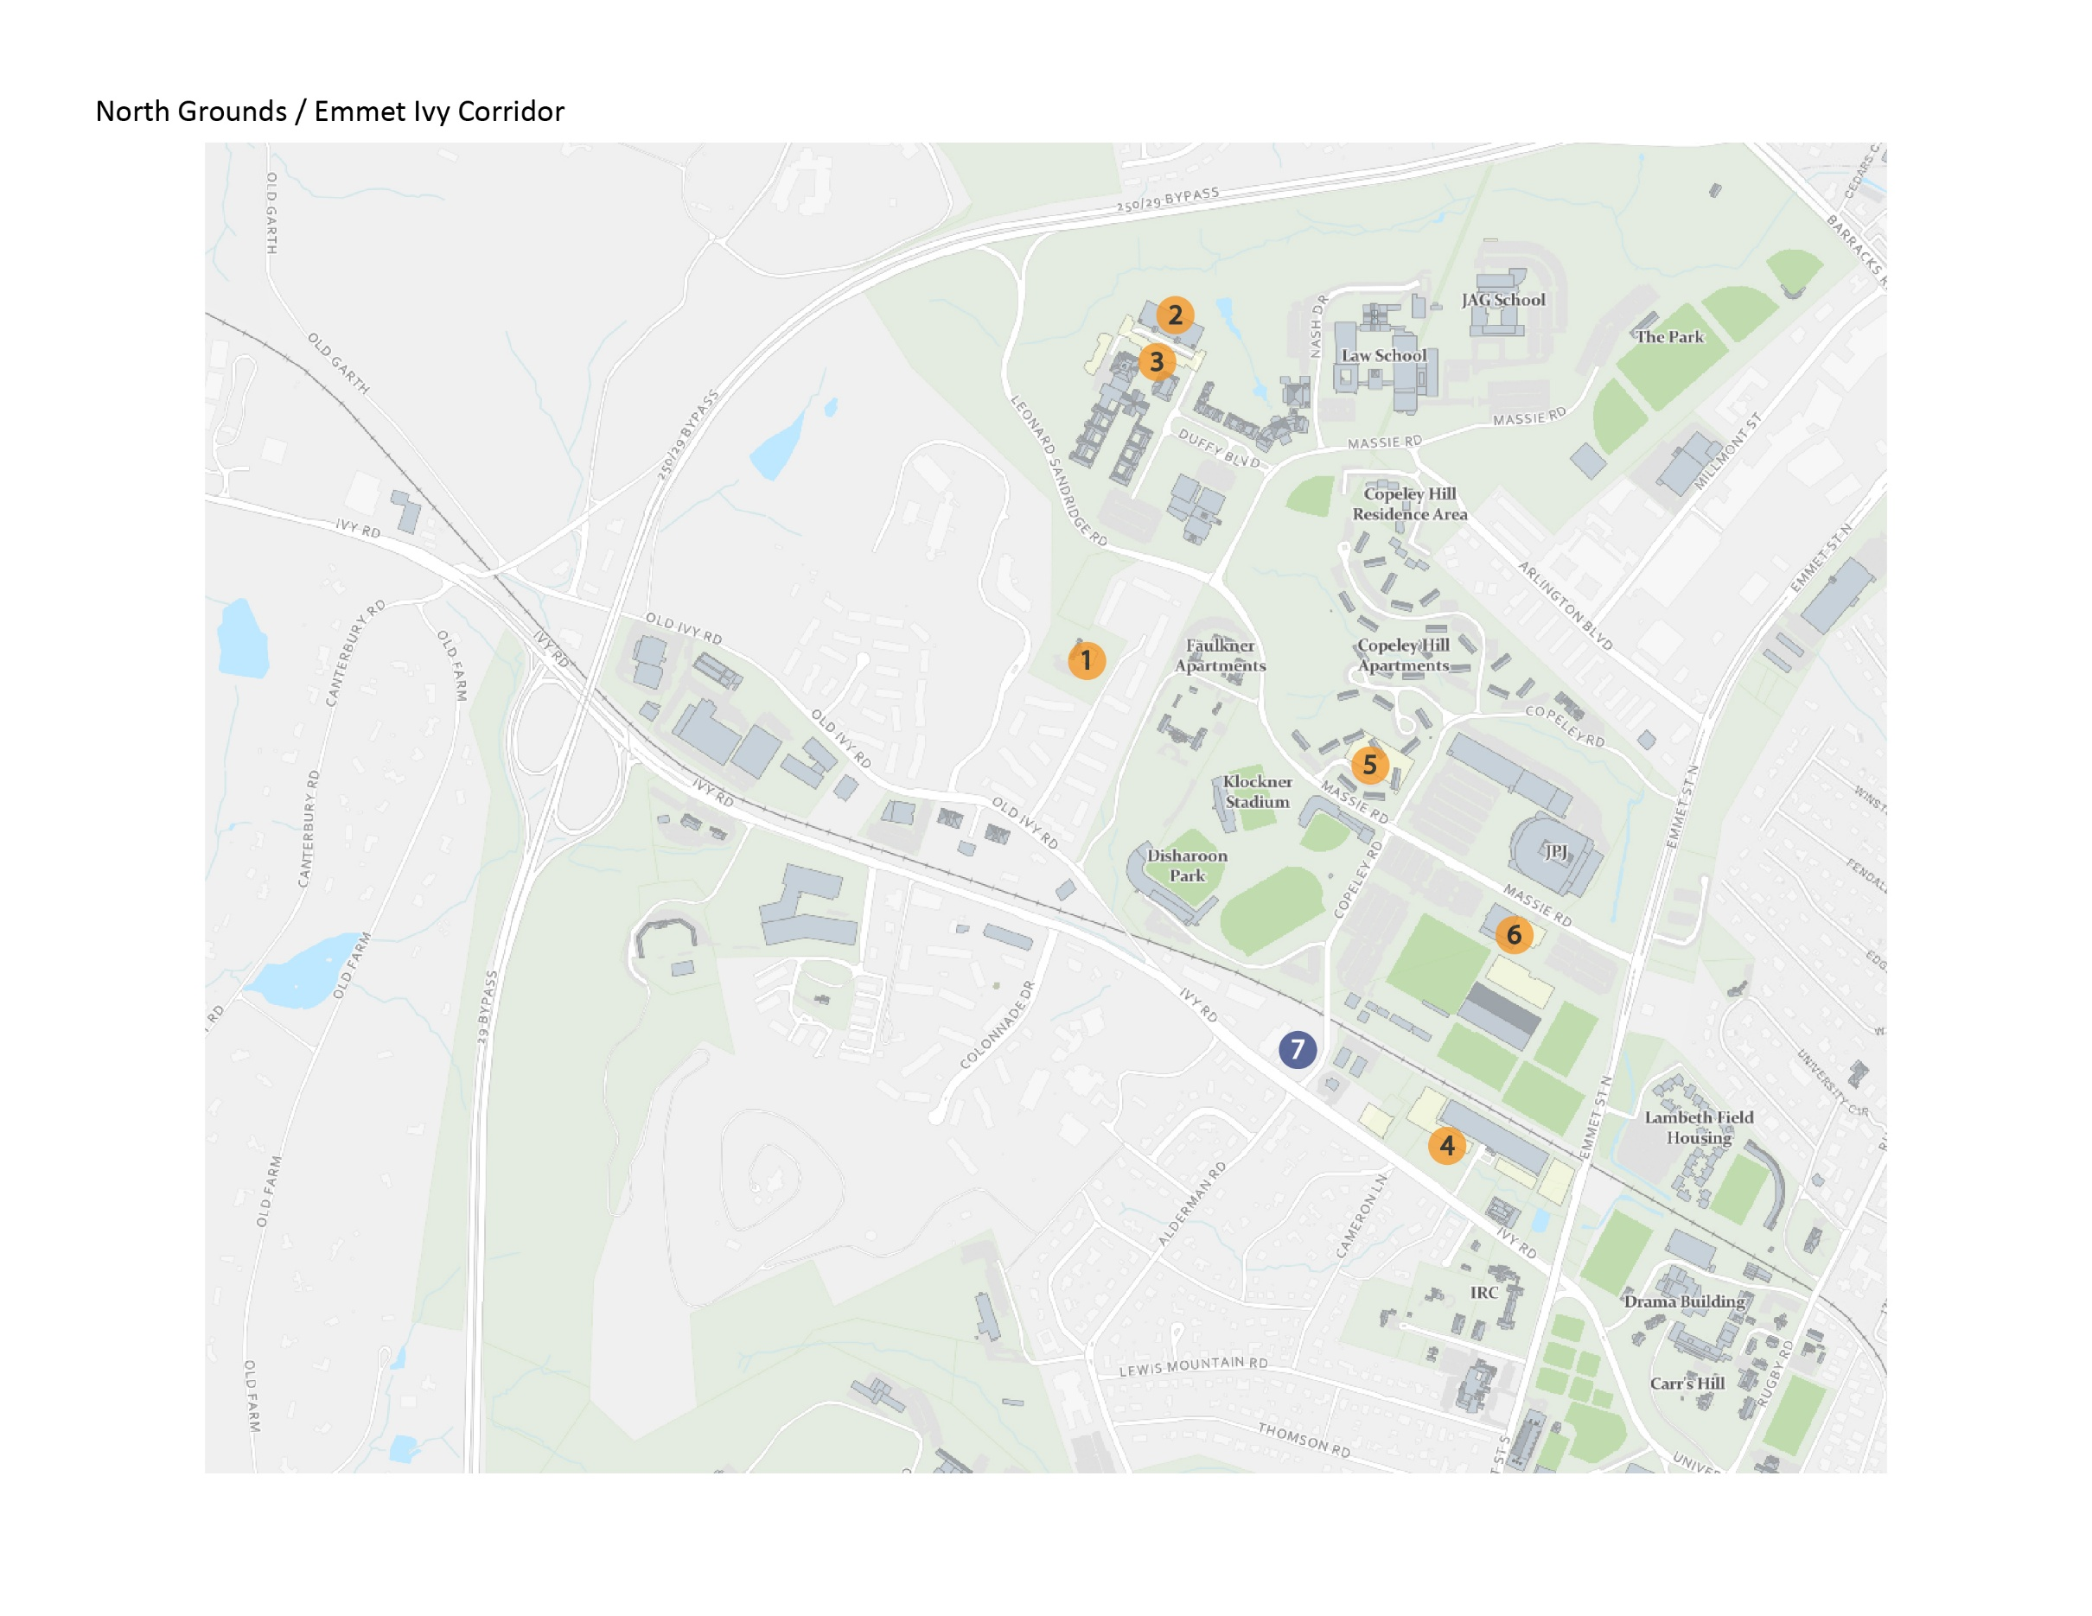

North Grounds / Emmet Ivy Corridor
Map ID | Project Name | Project Contact | Impact and Conditions | Anticipated Substantial Completion
1 | Center for Politics & Montesano Roadway  Extension | Raleigh Roussos  rnd2u@virginia.edu | Ongoing: Potential traffic delays due to construction vehicles entering and exiting the site via the entrance off Leonard Sandridge Road. At this point, all construction activity should be occurring within the site fencing limits. General construction noise and dust impacts will be ongoing until project is completed. | Quarter 4 2025
2 | Darden Parking Garage Maintenance Repair | Shannon Barras  jsb9s@virginia.edu | Ongoing: The contractor has mobilized work on the Darden parking garage. One hundred spaces at a time will be repaired. This project is being coordinated with the Darden Student Housing project. | Quarter 3 2025
3 | Darden Student Housing | Caitlin Murtaugh  cm8nf@virginia.edu | Ongoing: A new pedestrian path and driveway entrance to the parking garage will open in late August. Alternative pedestrian routes will remain in place. | Quarter 1 2027
4 | Ivy Corridor Landscape and Infrastructure  Karsh Institute of Democracy  Ivy Corridor Student Housing  Virginia Guesthouse- University Hotel & Conference Center | Sarita Herman  smh2ne@virginia.edu  Sarita Herman  smh2ne@virginia.edu  Caitlin Murtaugh  cm8nf@virginia.edu  Steve Dempsey  sjd2n@virginia.edu | Ongoing: Increased construction traffic on Ivy Road  with multiple active construction sites between Copeley  and Emmet. Multiple construction site entrances along  Ivy have reduced visibility due to construction fencing.  Bicycles and vehicles should exercise caution in front of  construction gates. City-approved Maintenance of  Traffic plan remains in place. The bike lane adjacent to  Karsh and Second Year Housing sites remain closed for the duration of project. The sidewalk along Ivy Road adjacent to Karsh and Second Year Housing sites remain closed.  Pedestrian detour in place between Copley and  Rothery Roads. General construction noise will be  ongoing through project completion. | Ivy Corridor:  Quarter 3 2026  Karsh Institute: Quarter 4 2026  Ivy Corridor Student Housing: Quarter 4 2027  Virginia Guesthouse: Quarter 4 2025
5 | North Grounds Parking Garage | Kit Meyer  ksm2g@virginia.edu | Ongoing: Excavation continues with multiple dump trucks arriving and leaving the site throughout each day. Crane deliveries of large concrete pieces on tractor trailers will be delivered each weekday through December 2025. | Quarter 4 2026
6 | Harrison Olympic Sports Complex | Brian Williams  gbw5r@virginia.edu | Ongoing: The lower east entrance/exit to McCue is closed, and a portion of the east parking lot will not be available. Portions of the south sidewalk along Massie are closed. The project is currently working on sitework, so dust is possible. Delivery trucks and dump trucks enter the site via Massie Road and there may be impacts as they back into the site. | Quarter 3 2025
7 | The Blume on Ivy | Not affiliated with UVA; informational purposes only | Ongoing:  Ivy Rd. – Vehicles: The right-hand turn lane and bike lane are closed from the Blue Line Bus Stop to the Ivy Rd./Copeley Rd. intersection, continuing to Moe’s Original BBQ. Right turns must be made from the center lane.  Copeley Rd. – Vehicles: The right-hand turn lane is closed. All traffic must use the left turn lane for straight and turning movements. The right turn lane will open periodically for UVA sporting events.  Ivy Rd. – Pedestrians: The north sidewalk remains closed for ongoing development. The south sidewalk remains open, including at the Ivy/Alderman/Copeley intersection.  Copeley Rd. – Pedestrians: The sidewalk remains open. Please note: Traffic patterns in this area may shift or be  modified throughout the duration of the project, as needed and with approval from the City of Charlottesville. | Quarter 3 2027
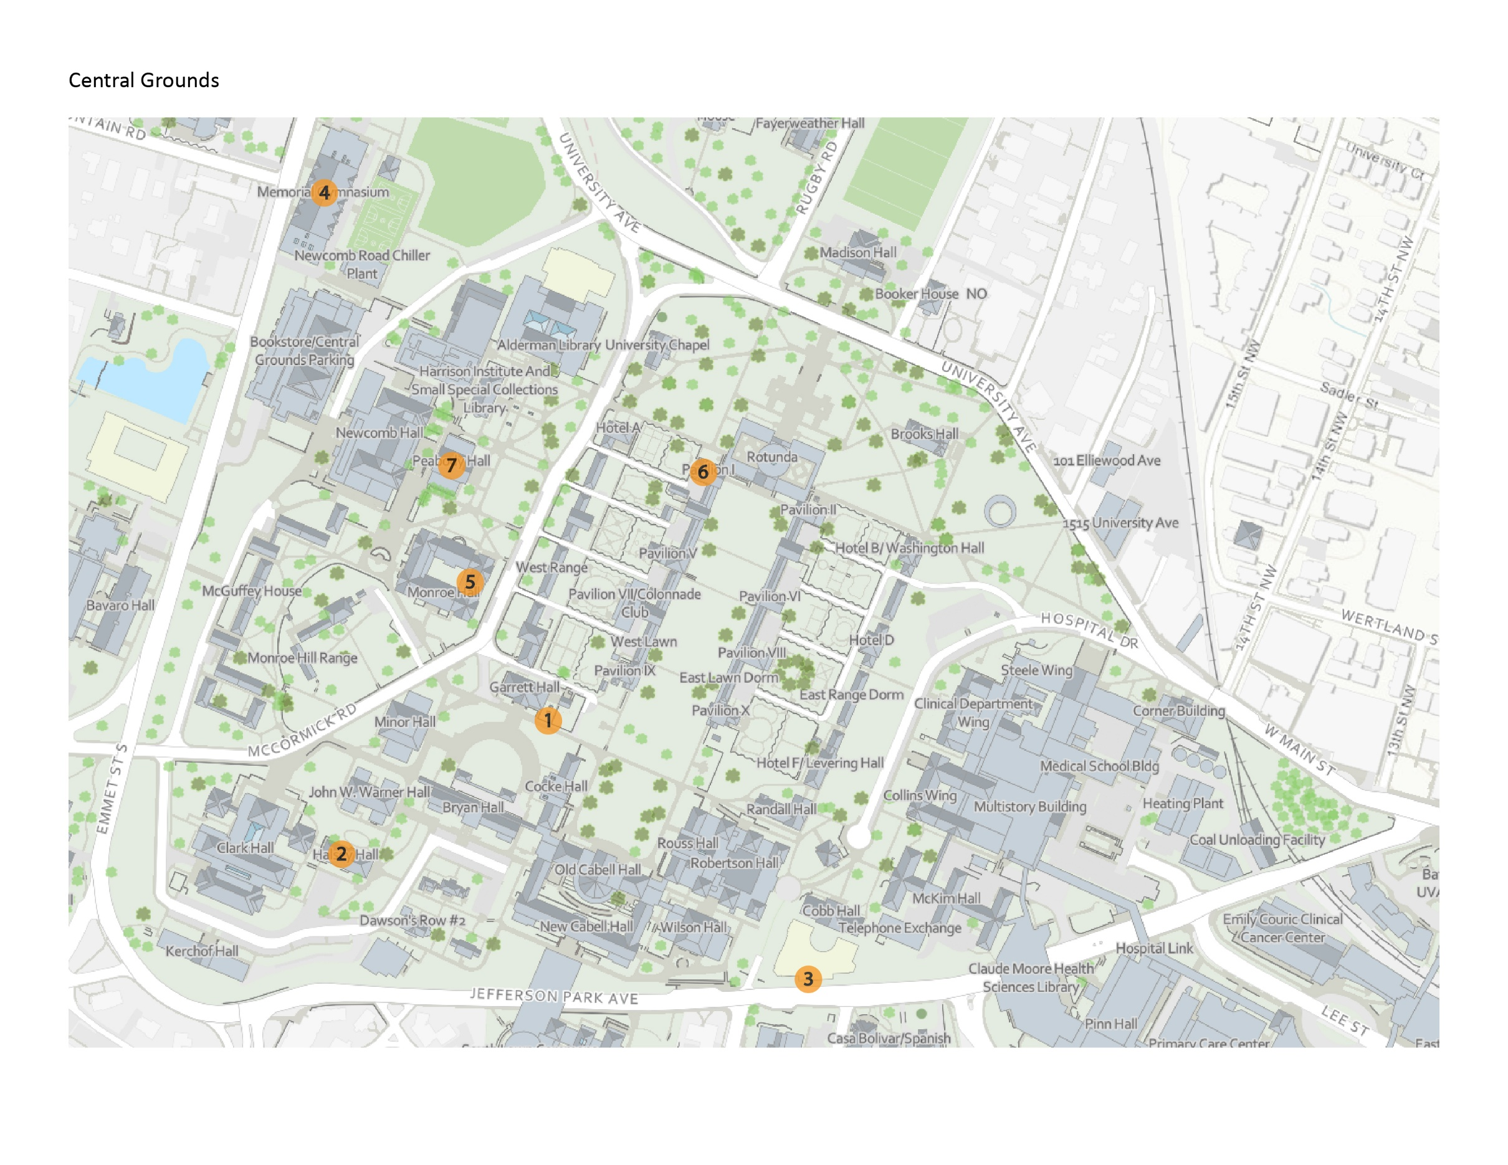

Central Grounds
Map ID |  | Project Name | Project Contact | Impact and Conditions | Anticipated Substantial Completion
1 |  | Garrett Annex Underground Storms Repairs | Kellen Renner-Thomas  kod9dx@virginia.edu | Ongoing: The south stairs to the terrace roof will remain closed until later this year. Terrace remains accessible from Garrett Alley. | Quarter 4 2025
2 |  | Halsey Hall Interior Renovation | Shannon Barras  jsb9s@virginia.edu | Ongoing: Work continues within Halsey Hall. Some parking is blocked off. There will be some noise and construction traffic in the area. | Quarter 4 2025
3 |  | McInture Academic Facility (Shumway Hall)  Jefferson Park Avenue Sidewalk Extension to Lane  Road | Craig Hilten  csh8a@virginia.edu | Ongoing: For materials deliveries, traffic controls are in place for one westbound traffic lane of Jefferson Park Ave. | Achieved  Quarter 2 2025  Quarter 3 2025
4 |  | Memorial Gym Infrastructure & Accessibility Improvements | Amy Mays  arg5j@virginia.edu | Ongoing: Continued impacts around the east side of the building with no parking available at the building. Pedestrian paths and access are marked to allow access to the tennis, basketball, and volleyball courts. | Quarter 4 2026
5 |  | Monroe Hall HVAC Renewal | Charlotte Dickerson  clp5s@virginia.edu | Ongoing: The HVAC renewal renovation is taking place in the Monroe Hall Addition. Access is for authorized construction personnel only and PPE is required. A dumpster is located on McCormick Road for construction use only. Signage and personnel will direct pedestrians to use caution and/or alternate routes as needed during construction deliveries or work-related | Quarter 4 2025
6 | Pavilion I Colossal Column Render |  | Amy Moses  arm8h@virginia.edu | Ongoing: Scaffolding and fencing will remain in place until render is installed on the columns. This will continue through September 2025. | Quarter 3 2025
7 | Peabody Hall Terrace Repair |  | Shannon Barras  jsb9s@virginia.edu | Ongoing: Construction continues behind Peabody Hall in the fenced construction area. There will be some noise associated with this work and access behind the building will be limited. | Quarter 3 2025

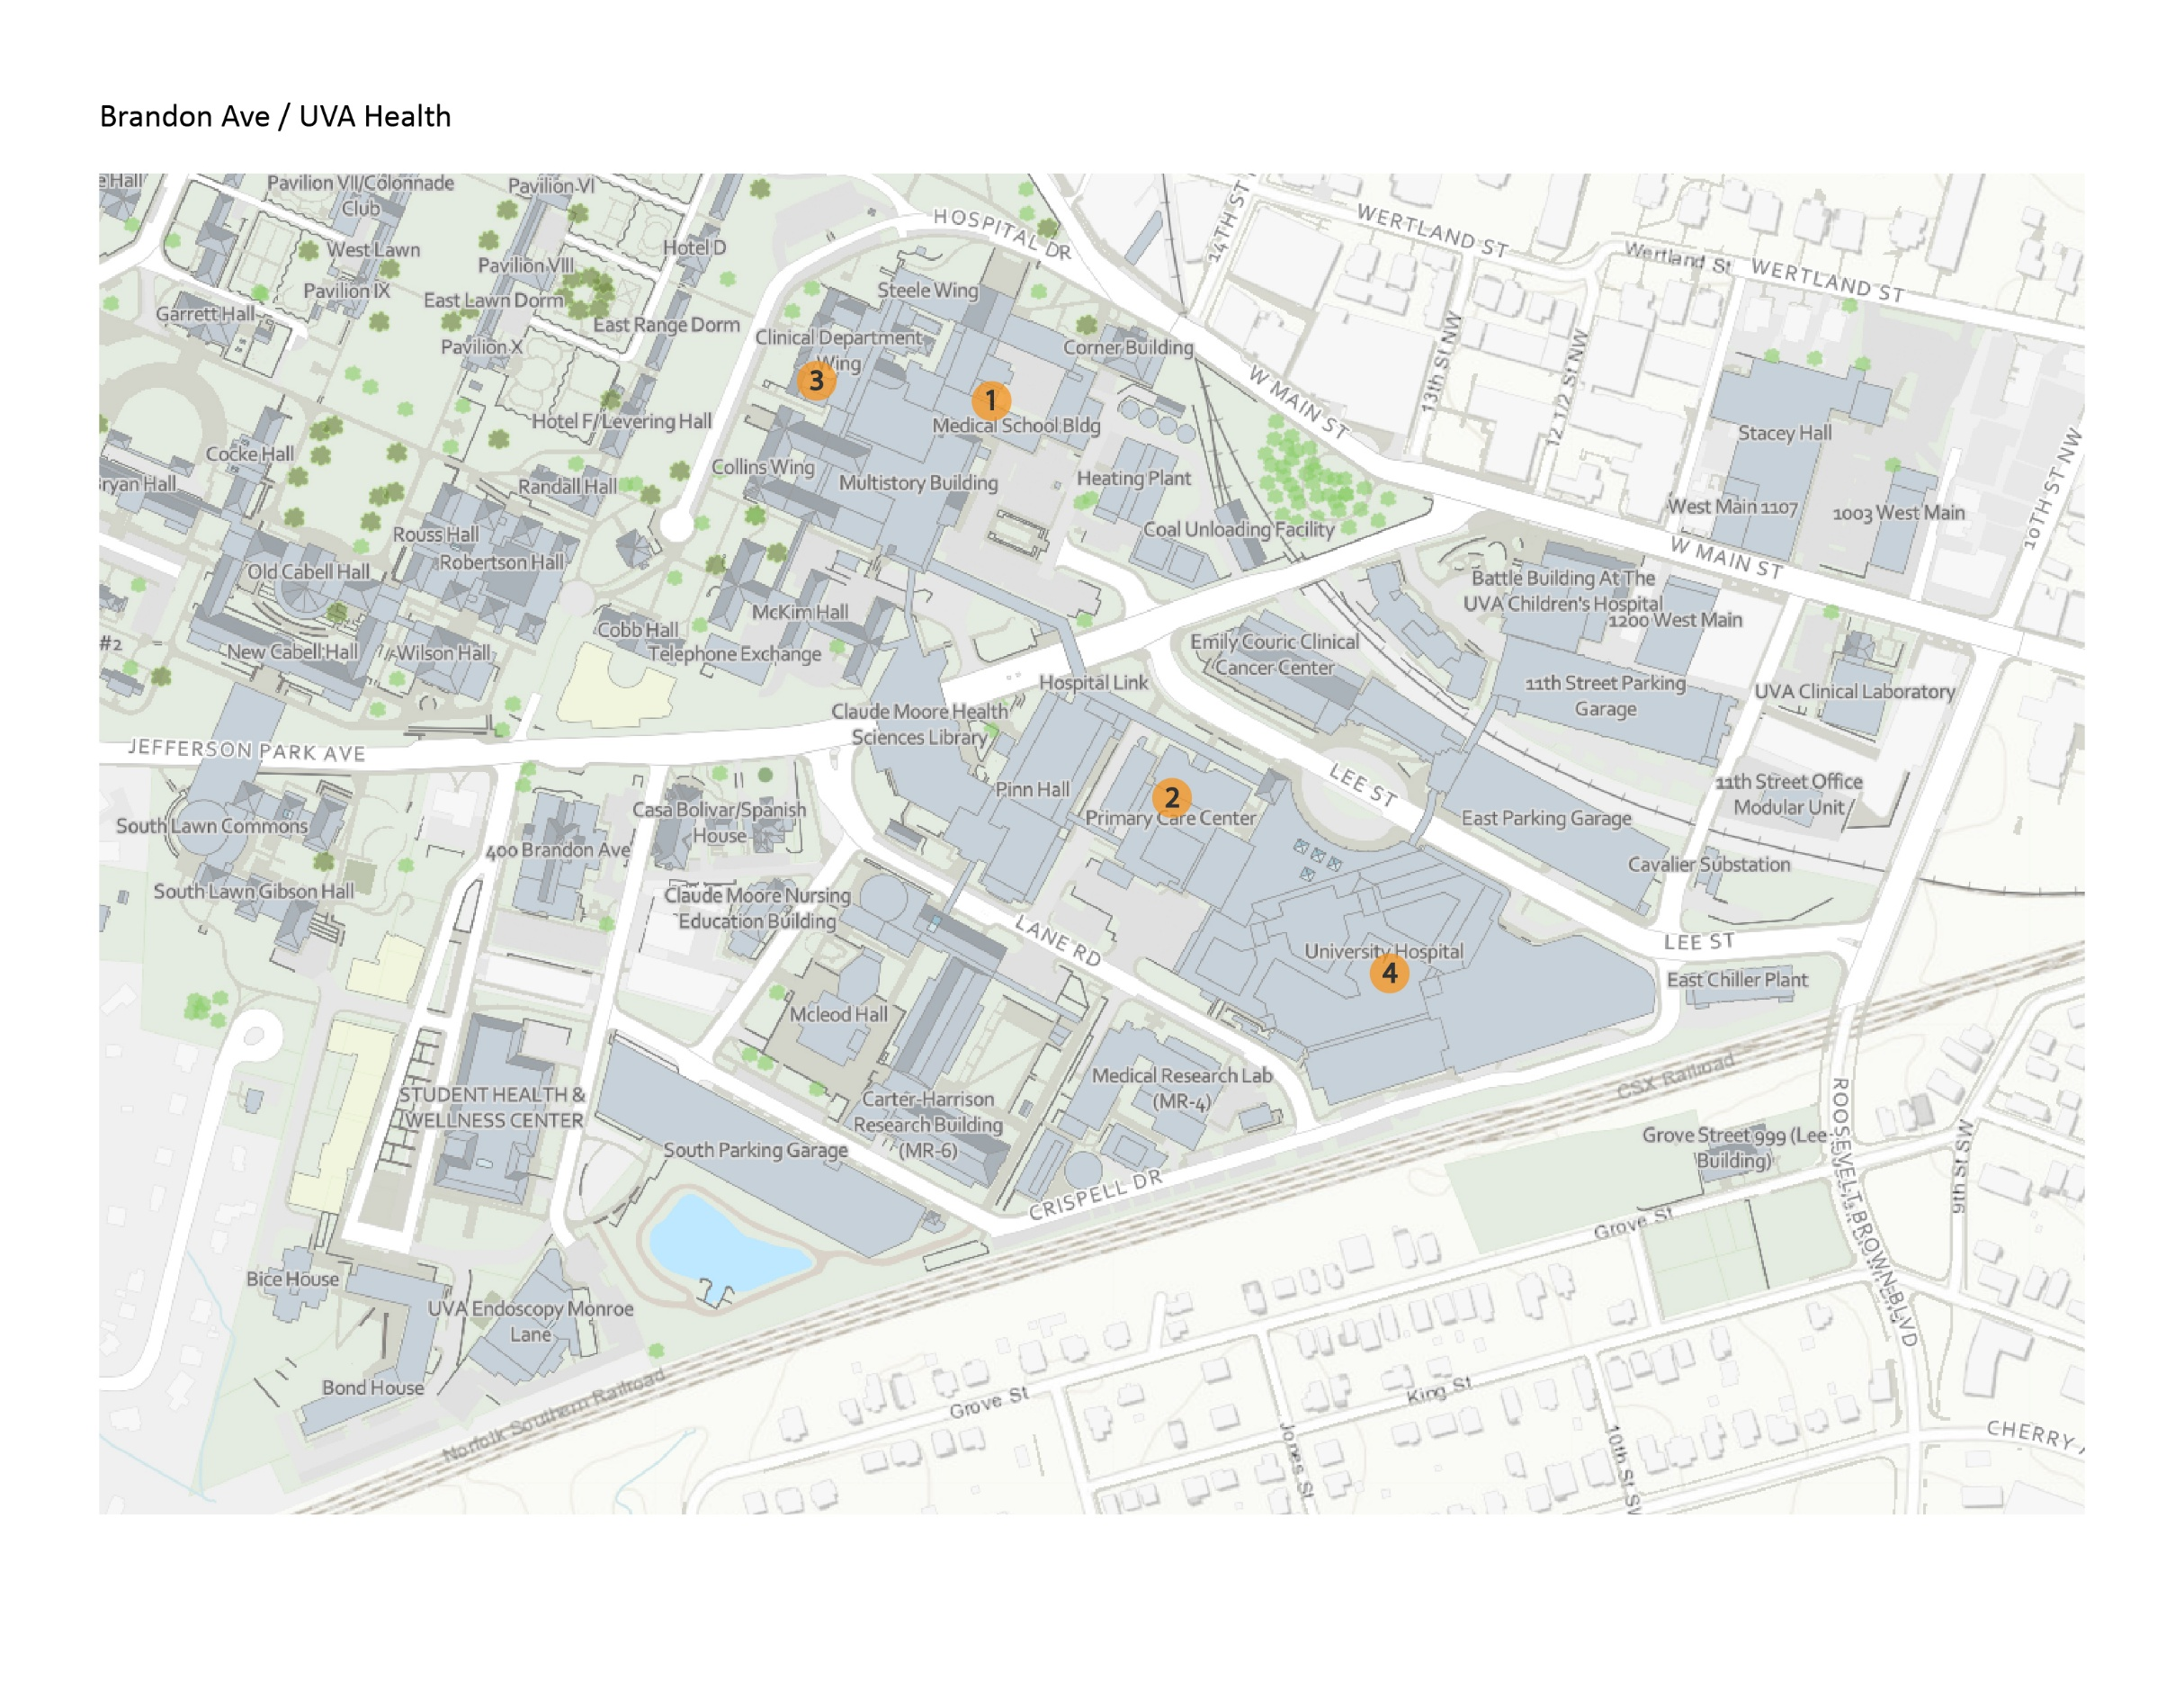

Brandon Ave / UVA Health
Map ID | Project Name | Project Contact | Impact and Conditions | Anticipated Substantial Completion
1 | Old Med School -  Vivarium HVAC Renewal | Andy Theobald  abt4sd@virginia.edu | Ongoing: Contractor will mobilize in Old Med School courtyard parking lot. Site fencing will be erected, which will close a large portion of the parking lot for laydown and material staging. Fencing will remain in place through spring 2026. Signage and barriers will be used to direct occupants and vehicles to the safe paths of egress. All building entrances/exits will remain open during construction. | Quarter 4 2025
2 | PCC Gamma Knife Replacement | Sandra LaFontaine  uax9ux@virginia.edu | Ongoing: A crane will be located at the back of the hospital by the loading dock from mid-August through early September for the removal and installation of a new Gamma Knife. The section of the parking behind the PCC Gamma Knife Clinic will be closed. | Quarter 3 2025
3 | Clinical Department Wing Elevators 3 & 4 Modernization | Andy Theobald  abt4sd@virginia.edu | Ongoing: Elevator 4 in CDW remains out of service through August 2025. Elevator 3 will be taken out of service for approximately eight weeks shortly after elevator 4 is put back in service. Signage and barricades are in place to direct occupants to the functioning elevators in the building. | Quarter 3 2025
4 | University Hospital MRI 1 & 2 Upfits | Jim Loman  jal8bu@virginia.edu | Ongoing: New MRI Upfit equipment for MRI-1 being rigged in on Saturday, September 13, 2025. This will occur through existing facilities, doorways, etc. since it does not include the magnet itself. | Quarter 3 2025

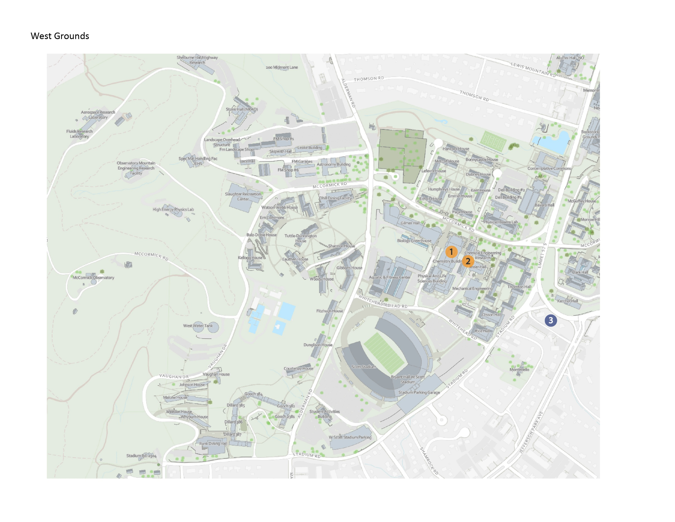

West Grounds
Map ID | Project Name | Project Contact | Impact and Conditions | Anticipated Substantial Completion
1 | Chemistry Addition Chiller Replacement | Dustin Watson  dmw9w@virginia.edu | Ongoing: There are currently small excavations that are open in front of Chemistry Addition facing Whitehead Rd and the parking lot behind AFC near the loading dock. These excavations are being done to expose condenser water piping so non-destructive testing can be completed to evaluate the condition of the existing pipe.  Several parking spaces are closed in the parking lot behind AFC and the lot in front of Chemistry Addition/PLSB.  Barricades are in place and alternate pedestrian pathways are provided. Red danger tape and barricades are in place to prevent pedestrians from entering the work areas.  Noise and dust are being produced by the excavation, backfilling and soon to be paving activities. | Quarter 2 2027
2 | Low Temperature Hot Water (LTHW) Conversion | Dustin Watson  dmw9w@virginia.edu | Ongoing: There will be 4-5 construction vehicles parked near the sidewalk, loading dock area and transformer lot around Wilsdorf Hall on both McCormick Road side and Whitehead Road side of the building.  Engine-driven welding machines will be located on the patio area between Wilsdorf Hall and McCormick Rd. for pipe work that will be taking place in the tunnel and mechanical room below. The machines will produce noise between the hours of 7 a.m. – 5 p.m. The small work area will be fenced off and screened and will not block the sidewalks or impact pedestrian traffic. An extensive amount of demolition is ongoing. Dust and odors will be produced from cutting metal and will be exhausted outdoors. | Quarter 3 2025
3 | The Verve | Not affiliated with UVA; informational purposes only | Ongoing: The Verve apartment construction project will impact Stadium Road, Emmet Street, and Jefferson Park Avenue (JPA), both northbound and southbound.  Sidewalk Closures: Stadium Road and Emmet St. and southbound JPA sidewalk detours will remain in place until project completion.  Vehicular and Bus Disruptions: Both northbound and southbound JPA traffic will experience periodic  closures, with vehicular detours routed through Stadium Road. | Quarter 3 2027

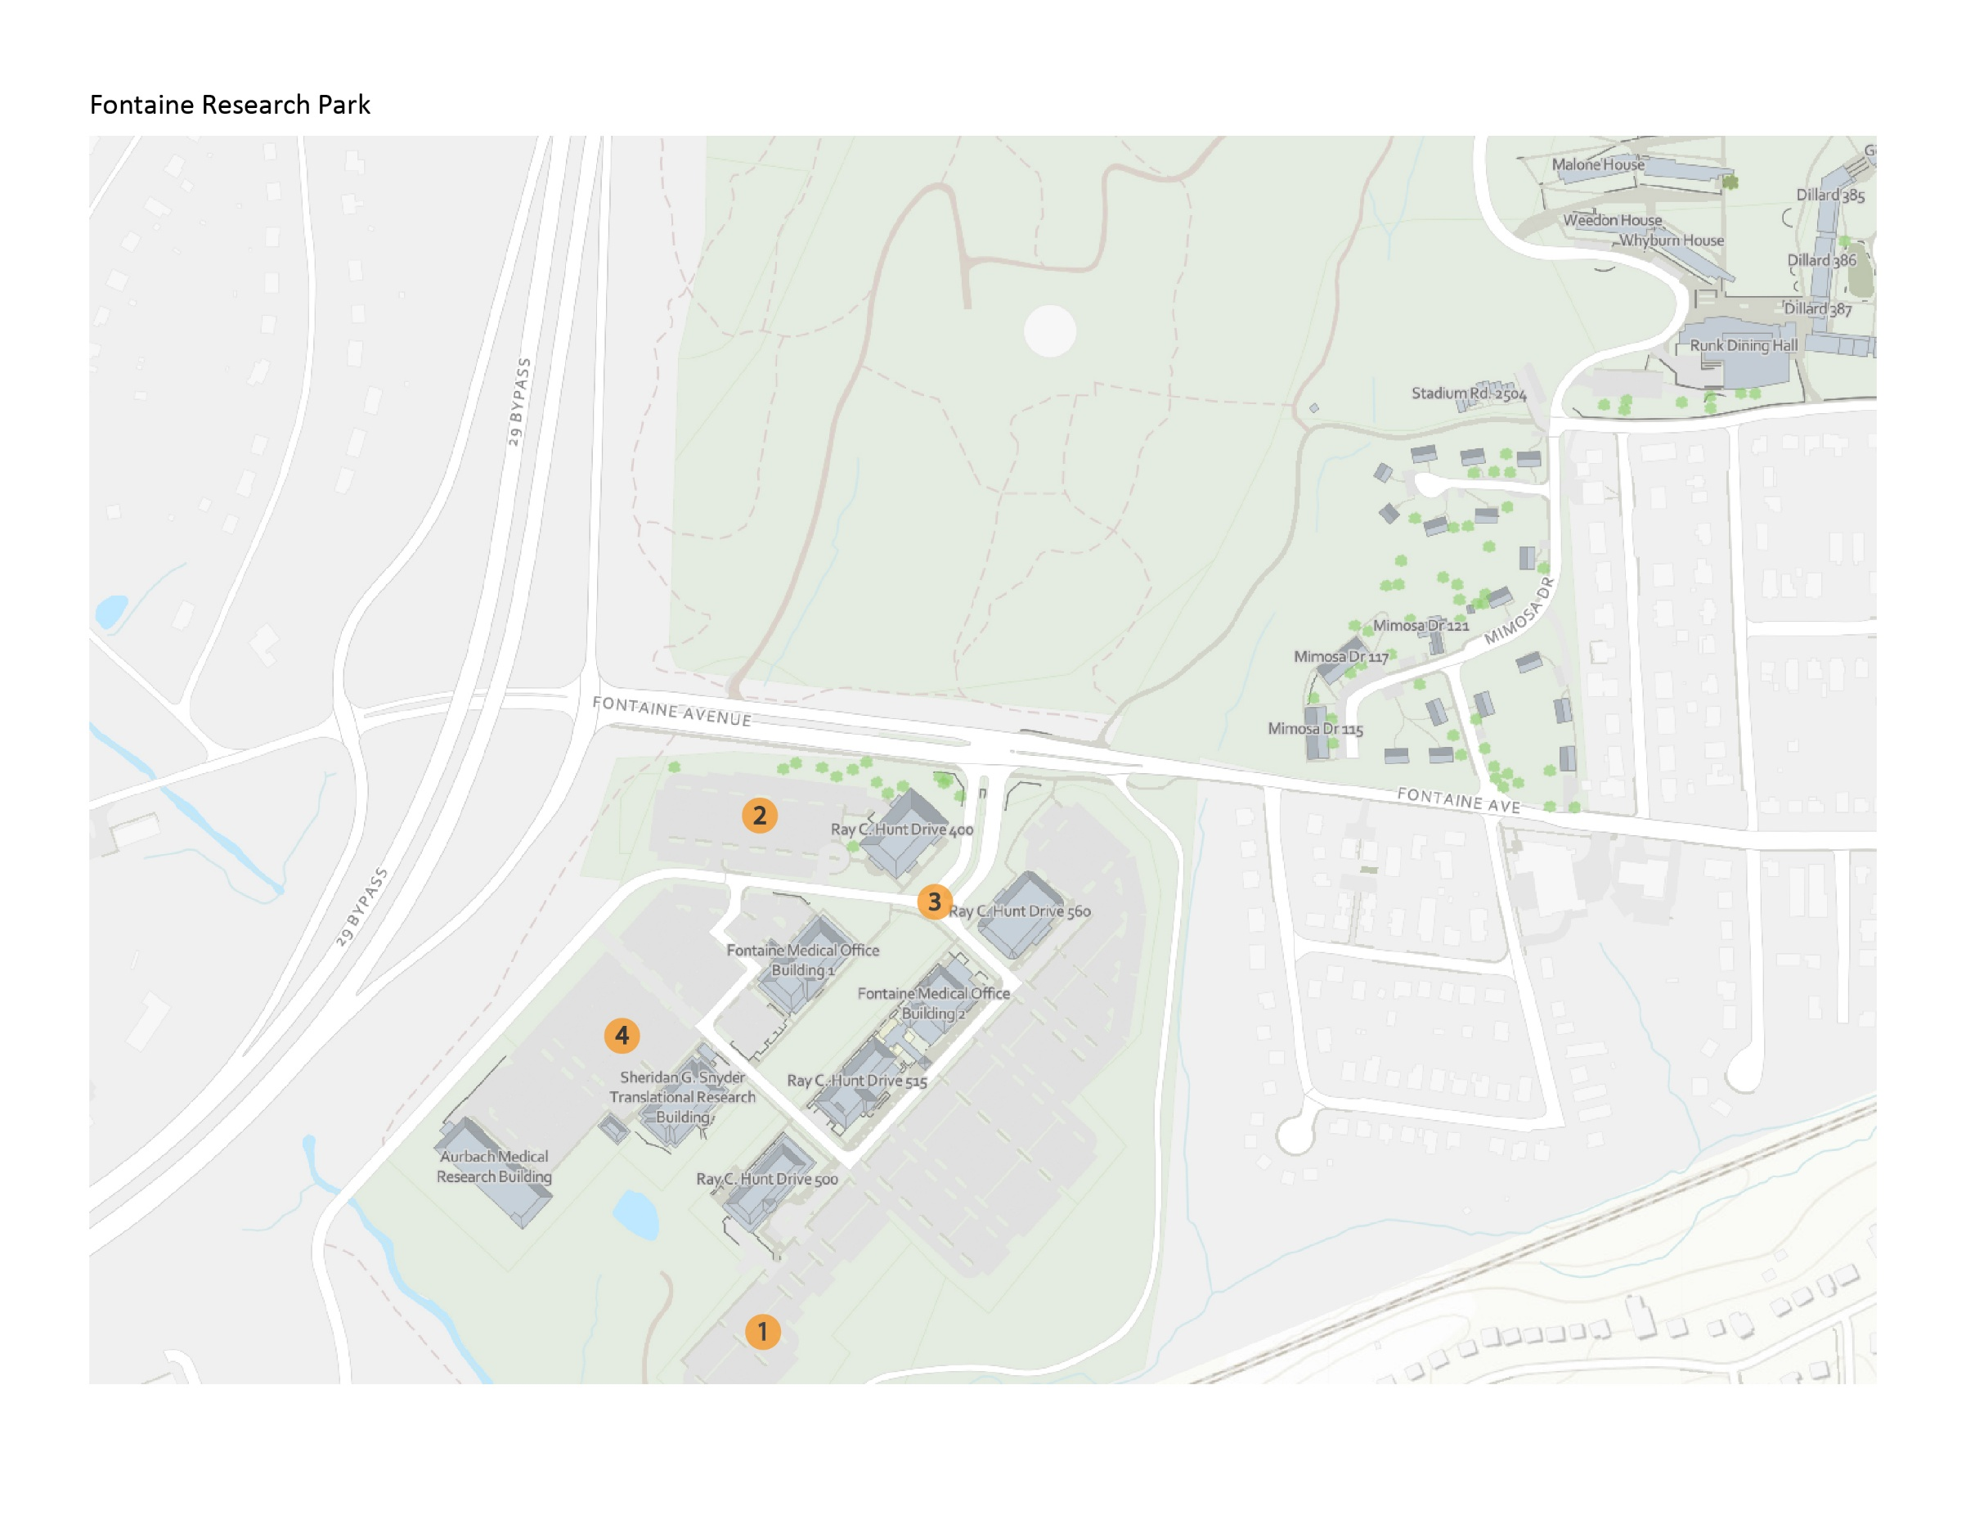

Fontaine Research Park
Map ID | Project Name | Project Contact | Impact and Conditions | Anticipated Substantial Completion
1 | Fontaine Research Park Central Energy Plant & Utilities | Chris Pouncey  cp2xa@virginia.edu | Ongoing: Construction traffic will continue in and out of the site through the existing access points, and the fence lines will remain the same in the near term | Quarter 2 2026
2 | Fontaine Research Park Parking Garage | Taryn Spence  tsh2n@virginia.edu | Ongoing: Ray C. Hunt Drive will be closed through mid-August to allow completion of wet utility installation, hardscape and paving south of the garage. Alternate route continues through spine road. Vehicular/pedestrian signage and traffic controllers remain in place to assist park guests. Impacts to the temporary service area, dumpster location and the ADA parking spaces in front of 400 RCH are being reviewed to determine the best way to complete the hardscape and tie-in with the roundabout. Once the workplan is determined construction alerts will be issued. As usual, Fontaine is bustling with construction. Visitors should keep their heads up and phones down to allow the safest navigation through the park. | Quarter 3 2025
3 | Fontaine Research Park Roadway Infrastructure | Taryn Spence  tsh2n@virginia.edu | Ongoing: The roundabout will close mid-August to allow for demolition and execution of the final roundabout plan to include curbing, etc. Alternate routes will be required. Traffic signage and traffic channelizing devices will be present to direct vehicular traffic during work activities. Flaggers will be present to direct vehicular traffic during unloading and loading. Lane reductions and closures will be minimized as much as possible. All lane impacts will be fully opened at the end of each day. There will be typical construction equipment noise associated with this work. - Dates are subject to weather impacts. This construction alert will be revised accordingly. All building means of egress will be maintained during construction. | Quarter 4 2025
4 | Manning Institute of Biotechnology | Mashal Afredi  ma4g@virginia.edu | Ongoing: Alternative pedestrian route with overhead protection in place between Aurbach and Snyder/LiSA. This path will be moved prior to September 2025. Noise and dust will continue to impact, particularly to Aurbach and Snyder/LiSA.  The site condition outside the construction fence that is most impactful is to the east of the site where there is a utility corridor from the FCEP to Biotech. Temporary signage is in place, including FDC's and Fire Hydrants, and periodic review of site conditions with office of S&S is ongoing. | Quarter 3 2027

