**­­­­­­­­**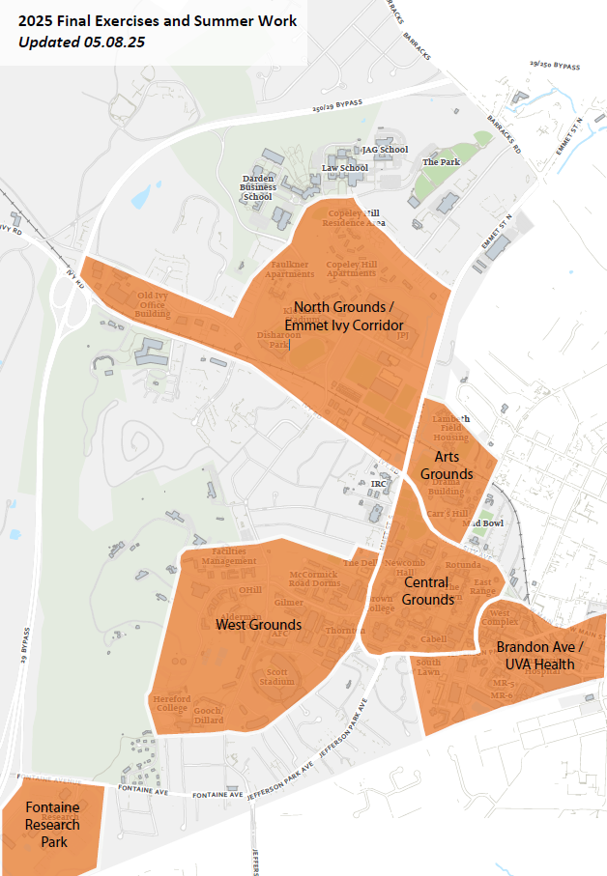

Emmet Ivy Corridor/North Grounds Construction Projects

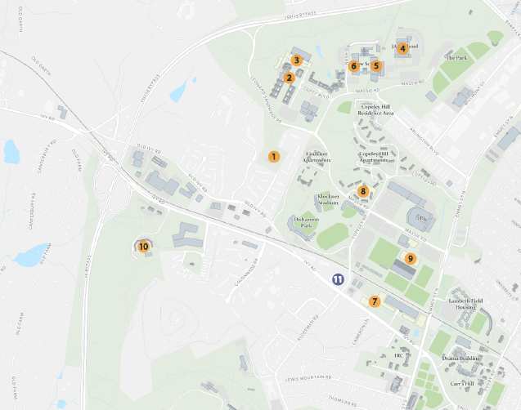

**Emmet Ivy Corridor/North Grounds**

|  |  |  |  |  |
| --- | --- | --- | --- | --- |
| **Map ID** | **Project Name** | **Project Contact** | **Impact and Conditions** | **Anticipated Substantial Completion** |
| 1 | Center for Politics & Montesano Roadway  Extension | Raleigh Roussos  [rnd2u@virginia.edu](mailto:rnd2u@virginia.edu) | **Ongoing:** Potential traffic delays due to construction vehicles entering and exiting the site via the entrance off Leonard Sandridge Road. At this point, all construction activity should be occurring within the site fencing limits. General construction noise and dust impacts will be ongoing through project completion. | Quarter 4 2025 |
| 2 | Darden Elevator  Replacement | Shannon Barras  [jsb9s@virginia.edu](mailto:jsb9s@virginia.edu) | **Ongoing:** The Classroom's elevator will be taken out-of use  for modernization. Some noise will be present for the duration of construction. Signage will be in place directing building users to alternate elevators. | Quarter 3 2025 |
| 3 | Darden Student Housing | Caitlin Murtaugh  [cm8nf@virginia.edu](mailto:cm8nf@virginia.edu) | **Final Exercises:** Pedestrians exiting the Darden Parking garage will continue to utilize alternative paths.  **Summer:** The Darden Garage is tentatively scheduled to be closed 5/19 to 6/4. | Quarter 1 2027 |
| 4 | JAG School 5th Floor AHU Replacement | Shannon Barras  [jsb9s@virginia.edu](mailto:jsb9s@virginia.edu) | **Ongoing:** The removal of units 3, 4, and 5 will be occurring during this time. There will be noise and construction activity around the area and in the parking lot. | Quarter 4 2025 |
| 5 | Law School Brown Hall 399 IT Office Renovation | Joe Gitz  [jwg3p@virginia.edu](mailto:jwg3p@virginia.edu) | **Summer:** There will be noise and dust on and around  the project area on the third floor of Brown Hall. | Quarter 3 2025 |
| 6 | Law School Slaughter Hall Clinics Renovation | Joe Gitz  [jwg3p@virginia.edu](mailto:jwg3p@virginia.edu) | **Summer:** There will be noise and dust on and around the project area on the 1st and 2nd floors of Slaughter Hall. | Quarter 3 2025 |

**Emmet Ivy Corridor/North Grounds**

|  |  |  |  |  |
| --- | --- | --- | --- | --- |
| **Map ID** | **Project Name** | **Project Contact** | **Impact and Conditions** | **Anticipated Substantial Completion** |
| 7 | Ivy Corridor Landscape and Infrastructure  Karsh Institute of Democracy  Ivy Corridor Student Housing  Virginia Guesthouse- University Hotel & Conference Center | Sarita Herman  [smh2ne@virginia.edu](mailto:smh2ne@virginia.edu)  Sarita Herman  [smh2ne@virginia.edu](mailto:smh2ne@virginia.edu)  Caitlin Murtaugh  [cm8nf@virginia.edu](mailto:cm8nf@virginia.edu)  Steve Dempsey  [sjd2n@virginia.edu](mailto:sjd2n@virginia.edu) | **Ongoing:** Increased construction traffic on Ivy Road  with multiple active construction sites between Copeley  and Emmet. Multiple construction site entrances along  Ivy have reduced visibility due to construction fencing.  Bicycles and vehicles should exercise caution in front of  construction gates. City-approved Maintenance of  Traffic plan remains in place. The bike lane adjacent to  Karsh and Second Year Housing sites will be taken  offline in April and will remain closed for the duration of  project. The sidewalk along Ivy Road adjacent to Karsh  and Second Year Housing sites remain closed.  Pedestrian detour in place between Copley and  Rothery Roads. General construction noise will be  ongoing through project completion. | Ivy Corridor: Quarter 3 2026  Karsh Institute: Quarter 4 2026  Ivy Corridor Student Housing: Quarter 4 2027  Virginia Guesthouse: Quarter 4 2025 |
| 8 | North Grounds Parking Garage | Kit Meyer  [ksm2g@virginia.edu](mailto:ksm2g@virginia.edu) | **Ongoing:** Expect intermittent traffic impacts along Massie Road at the main construction entrance across from Palmer Park due to blasting and trucks hauling dirt. Expect short term traffic impacts at Copeley Road near Peyton Court due to utility tie ins. The sidewalk closure along Massie Road will remain in place. | Quarter 4 2026 |
| 9 | Harrison Family  Olympic Sports Complex | Brian Williams  [gbw5r@virginia.edu](mailto:gbw5r@virginia.edu) | **Ongoing**: The lower east entrance/exit to McCue is closed and a portion of the east parking lot will not be available. Portions of south sidewalk along Massie are closed. The project is currently working on sitework so dust is possible. Delivery trucks and dump trucks enter the site via Massie Road and there may be impacts as they back into the site. | Quarter 4 2025 |
| 10 | Orthopedic Center Ivy Road Parking Expansion | Megan Buschi  [jsg5fr@virginia.edu](mailto:jsg5fr@virginia.edu) | **Ongoing:** The OCIR employee parking has been moved to an alternative location, and the P&T shuttle service runs daily. Reed Ln. is closed to vehicular through traffic but open to construction. | Quarter 3 2025 |

**Emmet Ivy Corridor/North Grounds**

|  |  |  |  |  |
| --- | --- | --- | --- | --- |
| **Map ID** | **Project Name** | **Project Contact** | **Impact and Conditions** | **Anticipated Substantial Completion** |
| 11 | The Blume on Ivy | *Not affiliated with UVA; informational purposes only* | **Ongoing:**  **Ivy Rd. – Vehicles:** The right-hand turn lane and bike lane are closed from the Blue Line Bus Stop to the Ivy Rd./Copeley Rd. intersection, continuing to Moe’s Original BBQ. Right turns must be made from the center lane.  **Copeley Rd. – Vehicles:** The right-hand turn lane is closed. All traffic must use the left turn lane for straight and turning movements. The right turn lane will open periodically for UVA sporting events.  **Ivy Rd. – Pedestrians:** The north sidewalk remains closed for ongoing development. The south sidewalk remains open, including at the Ivy/Alderman/Copeley intersection.  **Copeley Rd. – Pedestrians:** The sidewalk remains open. **Please note:** Traffic patterns in this area may shift or be  modified throughout the duration of the project, as needed and with approval from the City of Charlottesville. | Quarter 3 2027 |

Central Grounds Construction Projects

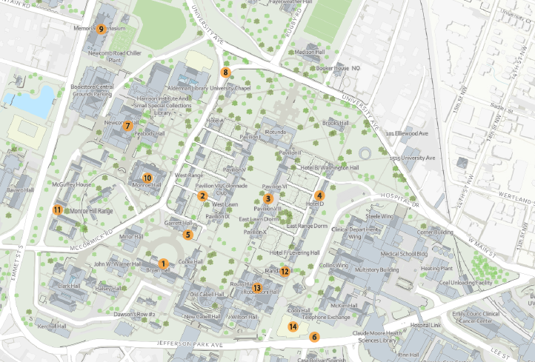

**Central Grounds**

|  |  |  |  |  |
| --- | --- | --- | --- | --- |
| **Map ID** | **Project Name** | **Project Contact** | **Impact and Conditions** | **Anticipated Substantial Completion** |
| 1 | Amphitheater Exterior Structural and Envelope | Amy Moses  [arm8h@virginia.edu](mailto:arm8h@virginia.edu) | **Summer:** After Reunions, phase II construction will begin. There will be scaffolding around the building, including on the stage and extensive work accessed from the rear alley. Construction will continue throughout the school year until the weeks prior to Graduation 2026. | Quarter 2 2026 |
| 2 | Colonnade Alley Renovation | Kellen Renner-Thomas  [krennerthomas@virginia.edu](mailto:krennerthomas@virginia.edu) | **Summer:** Colonnade Alley will be closed this summer for stormwater improvements. This will limit all vehicular and pedestrian access including the parking court. Access to the women's restroom will be maintained. | Quarter 3 2025 |
| 3 | East Lawn Roof & Railing Pavilion VI - VIII | Amy Moses  [arm8h@virginia.edu](mailto:arm8h@virginia.edu) | **Summer:** After Reunions, the colonnade between Pav VI and VIII will be closed to pedestrians and re-routed until student move-in. | Quarter 4 2025 |
| 4 | East Range Step Replacement | Amy Moses  [arm8h@virginia.edu](mailto:arm8h@virginia.edu) | **Summer:** The stairs at East Range student room 18 will  be replaced. Work expected to take two weeks and will be arranged around the conference use of rooms. | Quarter 4 2025 |
| 5 | Garrett Annex Storm Sewer  Replacement | Kellen Renner-Thomas  [krennerthomas@virginia.edu](mailto:krennerthomas@virginia.edu) | **Summer:** Underground storm repairs require the  demolition of the existing ADA ramp and planting beds  along the south side of Garrett Hall. A temporary ADA  ramp will be installed to maintain access into the building. There may be temporary sidewalk closures in  the area. | Quarter 3 2025 |
| 6 | Jefferson Park Avenue Sidewalk Extension to Lane  Road | Craig Hilten  [csh8a@virginia.edu](mailto:csh8a@virginia.edu) | **Ongoing**: Traffic controls are in place for one  westbound traffic lane of Jefferson Park Ave for  material deliveries. Traffic controls will be removed to  help reduce congestion for major events. | Quarter 2 2025 |

**Central Grounds**

|  |  |  |  |  |
| --- | --- | --- | --- | --- |
| **Map ID** | **Project Name** | **Project Contact** | **Impact and Conditions** | **Anticipated Substantial Completion** |
| 7 | Newcomb Hall Grease Trap Replacement | Joe Gitz  [jwg3p@virginia.edu](mailto:jwg3p@virginia.edu) | **Summer:** Second floor dining will be shut-down from  6/2-7/1 for installation of a new grease trap. | Quarter 2 2025 |
| 8 | McCormick Road Chapel Triangle Improvements | Amy Eichenberger  [ace8a@virginia.edu](mailto:ace8a@virginia.edu) | **Summer:** Construction will begin on May 19th. Scheduled completion is July 18th. Construction will require a roadway closure to all through traffic, except for emergency vehicles. An adjacent roadway to the south will accommodate UVA FM and other University and special events vehicles as required. There will be a vehicular detour, alternate pedestrian paths, as well as relocated ADA parking spaces. Additionally, the Garrett Trolley stop will be offline and the McCormick Trolley stop will be relocated to University Avenue near the Rotunda for the duration of construction. | Quarter 3 2025 |
| 9 | Memorial Gym Infrastructure & Accessibility Improvements | Amy Mays  [arg5j@virginia.edu](mailto:arg5j@virginia.edu) | **Ongoing:** Continued impacts around the east side of the building with no parking available at the building. Pedestrian paths and access are marked to allow access to the tennis, basketball, and volleyball courts. | Quarter 4 2026 |

**Central Grounds**

|  |  |  |  |  |
| --- | --- | --- | --- | --- |
| **Map ID** | **Project Name** | **Project Contact** | **Impact and Conditions** | **Anticipated Substantial Completion** |
| 10 | Monroe Hall HVAC Renewal | Charlotte Dickerson  [clp5s@virginia.edu](mailto:clp5s@virginia.edu) | **On-going:** The HVAC Renewal renovation is taking place in the Monroe Addition. Access is for authorized construction personnel only and PPE is required. A dumpster is located on McCormick Road for construction use only. Signage and personnel will direct pedestrians to use caution and/or alternate routes as needed during construction deliveries or work-related activities. Construction noise and dust are generally limited to the interior of the addition.  **Final Exercises:** The dumpster will be removed for  events and the job site will be secured.  **Summer work:** Construction activities will continue  through the end of 2025. | Quarter 4 2025 |
| 11 | Monroe Law Office  Archeology | Amy Moses  [arm8h@virginia.edu](mailto:arm8h@virginia.edu) | **Ongoing**: Further abatement is currently occurring and  archeology will begin again soon in the crawl space. | Quarter 4 2025 |
| 12 | Randall Hall Climate Condition  Improvements | Kellen Renner-Thomas  [krennerthomas@virginia.edu](mailto:krennerthomas@virginia.edu) | **Summer:** Randall Hall will be partially closed for the  summer as Phase 2 of work is completed. There will be  an increase in construction vehicles in the area but the  work will be contained to the interior of the building. | Quarter 3 2025 |
| 13 | Rouss Robertson Water  Infiltration Study | Shannon Barras  [jsb9s@virginia.edu](mailto:jsb9s@virginia.edu) | **Ongoing:** Some investigative work will take place in the  courtyard area. | Quarter 3 2025 |

**Central Grounds**

|  |  |  |  |  |
| --- | --- | --- | --- | --- |
| **Map ID** | **Project Name** | **Project Contact** | **Impact and Conditions** | **Anticipated Substantial Completion** |
| 14 | Shumway Hall and Cobb Hall  Renovation Project | Craig Hilten  [csh8a@virginia.edu](mailto:csh8a@virginia.edu) | **Ongoing**: Ruppel Drive ADA improvements have been  completed and Ruppel Drive has been re-opened.  Traffic controls are in place for one westbound traffic  lane of Jefferson Park Ave for material deliveries. Traffic controls will be removed to help reduce traffic  congestion for major events. | Achieved Quarter 2 2025 |

UVA Health / Brandon Ave Construction Projects

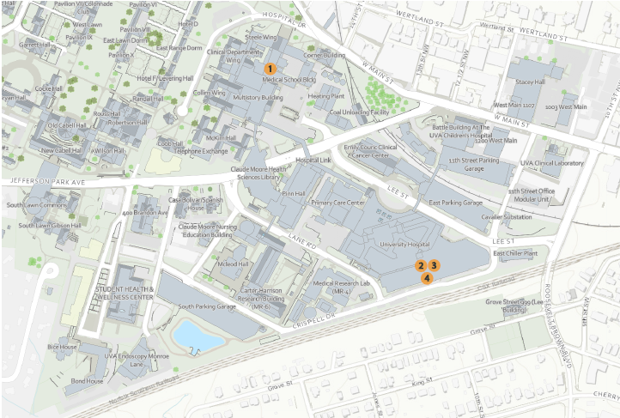

**UVA Health/Brandon Ave**

|  |  |  |  |  |
| --- | --- | --- | --- | --- |
| **Map ID** | **Project Name** | **Project Contact** | **Impact and Conditions** | **Anticipated Substantial Completion** |
| 1 | Old Med School -  Vivarium HVAC Renewal | Andy Theobald  [abt4sd@virginia.edu](mailto:abt4sd@virginia.edu) | **Ongoing:** Construction will begin in May/June of 2025 and last through the end of the year. A significant portion of the Old Med School Courtyard parking lot will be impacted by this construction. All building entrances/exits will remain open at all times during construction. Signage and fencing will be in place to direct pedestrians. There will be some noise impacts in the area of the courtyard as well. | Quarter 4 2025 |
| 2 | University Hospital -  Replace CT ED-8 Room 1205 | Kevin Silson  [pks3k@virginia.edu](mailto:pks3k@virginia.edu) | **Summer:** Replacement of existing CT device with new device. Piping will be run through an occupied space in the basement. | Quarter 3 2025 |
| 3 | University Hospital Fire Alarm Annunciation  Replacement Phase 2 | Jon Bruneau  [jcb9d@virginia.edu](mailto:jcb9d@virginia.edu) | **Ongoing:** Work will be visible to occupants, however, dust and noise is managed through the ICRA process. | Quarter 2 2026 |
| 4 | University Hospital  Kitchen Elevators  Modernization | Andy Theobald  [abt4sd@virginia.edu](mailto:abt4sd@virginia.edu) | **Ongoing:** Construction began in late March and will last for approximately 4 months. Elevator 14 will be out of service for approximately eight weeks. Elevator 13 will be out of service for eight weeks after that. There will be a period of one week at the end of the project when both elevators are out of service. Signage and barricades will be in place to direct occupants to the functioning elevator. | Quarter 2 2025 |

West Grounds Construction Projects

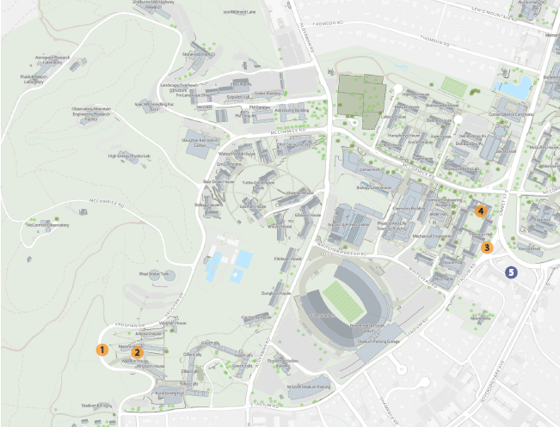

**West Grounds**

|  |  |  |  |  |
| --- | --- | --- | --- | --- |
| **Map ID** | **Project Name** | **Project Contact** | **Impact and Conditions** | **Anticipated Substantial Completion** |
| 1 | 36" RWSA Raw Water Main - Ragged Mountain to Observatory Water Treatment Plant | Caitlin Murtaugh  [cm8nf@virginia.edu](mailto:cm8nf@virginia.edu) | **Summer:** A portion of Hereford Drive will be closed starting May 25th through July 31st. There will be night work with lane closures in Fontaine Ave. between Ray C. Hunt Dr. and the ramps to 29. | Quarter 3 2025 |
| 2 | Hereford College Interior Four Pipe  Conversion | Shannon Barras  [jsb9s@virginia.edu](mailto:jsb9s@virginia.edu) | **Ongoing:** Sidewalk running between Norris/Malone and Weedon/Whyburn will be used for construction access and parking. Pedestrian access will be maintained through the western staircases. The central staircases will be for construction use only. | Quarter 3 2026 |
| 3 | Low Temp. Hot Water Conversion Phase 3B | Dustin Watson  [dmw9w@virginia.edu](mailto:dmw9w@virginia.edu) | The sidewalk along Thornton Hall C and E has been reopened to pedestrians. All construction fencing will be demobilized prior to Final Exercises and Summer Work. | Quarter 4 2025 |
| 4 | Thornton Hall A Wing | Joe Gitz  [jwg3p@virginia.edu](mailto:jwg3p@virginia.edu) | **Summer**: Select second floor A Wing offices will be temporarily off-line as we complete this project. | Quarter 3 2025 |
| 5 | The Verve | *Not affiliated with UVA; informational purposes only* | Ongoing: The Verve apartment construction project will impact Stadium Road, Emmet Street, and Jefferson Park Avenue (JPA), both northbound and southbound.  Key impacts include:  **Sidewalk Closures:** Stadium Road and Emmet St. and southbound JPA sidewalk detours will remain in place until project completion.  **Vehicular and Bus Disruptions**: Both northbound and southbound JPA traffic will experience periodic  closures, with vehicular detours routed through Stadium Road. | Quarter 3 2027 |

Fontaine Research Park Construction Projects

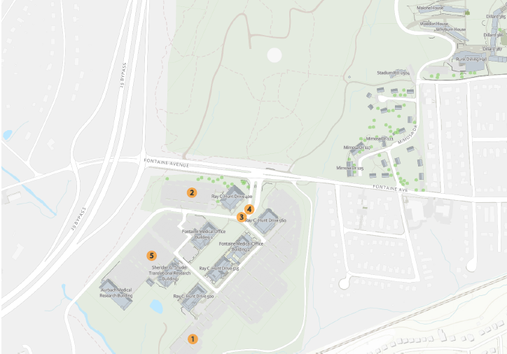

**Fontaine Research Park**

|  |  |  |  |  |
| --- | --- | --- | --- | --- |
| **Map ID** | **Project Name** | **Project Contact** | **Impact and Conditions** | **Anticipated Substantial Completion** |
| 1 | Fontaine Research Park Central Energy Plant & Utilities | Chris Pouncey  [cp2xa@virginia.edu](mailto:cp2xa@virginia.edu) | **Ongoing:** Construction traffic will continue into and out of the site through the existing access points, and the fence lines will remain the same in the near term | Quarter 2 2026 |
| 2 | Fontaine Research Park Parking Garage | Taryn Spence  [tsh2n@virginia.edu](mailto:tsh2n@virginia.edu) | **Ongoing:** Ray C Hunt Drive is closed to through-traffic until mid-July 2025. The roundabout and Spine Road are being used as the primary alternate route while the road is closed. Deep utility work in Ray C Hunt drive and along the service access road at building 400 is creating both intermittent and continuous noise and vibration during rock excavation with a hoe ram. This impact will mirror other rock removal work previously experienced at the Park. Patients will utilize the round about and Spine Road to access building 415. Signage is posted to assist in wayfinding and traffic controllers are onsite directing vehicular traffic. Temporary ADA parking spots and an area for servicing building 400 has been created and is actively being used during the road closure. All visitors to Fontaine Research Park should be aware of  ongoing construction, impacts to normal routes, and be on alert for lane narrowing, heavy presence of construction traffic and pedestrians in crosswalks that bisect alternate routes. | Quarter 4 2025 |

**Fontaine Research Park**

|  |  |  |  |  |
| --- | --- | --- | --- | --- |
| **Map ID** | **Project Name** | **Project Contact** | **Impact and Conditions** | **Anticipated Substantial Completion** |
| 3 | Fontaine Research Park Roadway Infrastructure | Taryn Spence  [tsh2n@virginia.edu](mailto:tsh2n@virginia.edu) | **Ongoing:** New traffic pattern through Fontaine Research Park while Ray C Hunt is closed to through traffic. Spine Road will be very busy with foot traffic and vehicular traffic. Crosswalks throughout the park intersect with traffic. Pedestrians to heed caution, keep heads up and be alert to surroundings. Signage and traffic controllers onsite to direct pedestrians and vehicles. Starting in mid-July, the contractor will remobilize onsite and finish the roundabout splitter islands, and install the new sidewalk and site lighting at the Fontaine entrance. | Quarter 3 2025 |
| 4 | Fontaine Research Park Sitewide Stormwater  Improvement | Taryn Spence  [tsh2n@virginia.edu](mailto:tsh2n@virginia.edu) | **Ongoing:** The roundabout and spine road will be used as the primary alternate route while Ray C Hunt drive is closed from March 24 - mid-July 2025 for utility work associated with the Garage. This route will be utilized by patients navigating to building 415. Signage will be posted to assist in wayfinding. The contractor will remobilize onsite to finalize work in the roundabout and the entrance in mid-July. This work will create future re-routing of traffic, lane narrowing, and construction noise. | Quarter 3 2027 |
| 5 | Manning Institute of Biotechnology | Mashal Afredi  [ma4g@virginia.edu](mailto:ma4g@virginia.edu) | **Ongoing:** There will be mild impacts to pedestrians between Aurbach and Snyder while the contractor builds the covered pedestrian walkway in mid-May. Pedestrian traffic will be maintained at all times, with a few temporary detours as needed to complete the walkway. | Quarter 2 2027 |