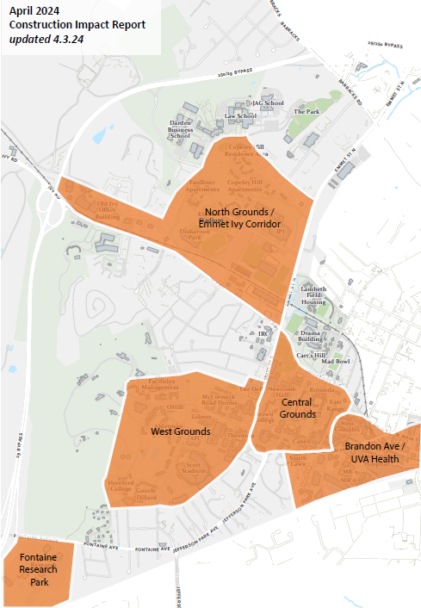

Central Grounds Construction Projects

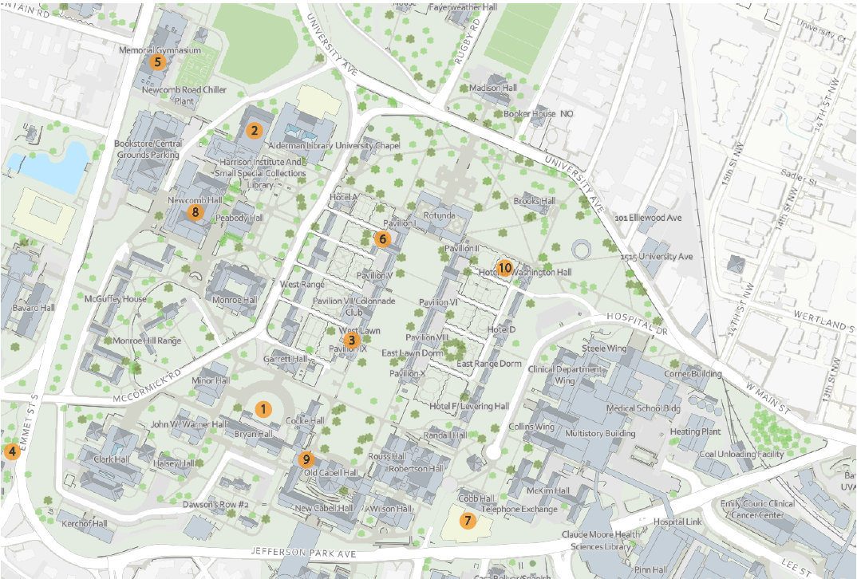

Central Grounds
Map ID | Project Name | Project Contact | Impact and Conditions | Anticipated Substantial Completion
1 | Amphitheater Roof and Exterior | Amy Moses  arm8h@virginia.edu | Scaffolding will start to come down in sections March  27. Roof work will continue after scaffolding is  removed. | May 2024
2 | Clemons Library Waterproofing & Infiltration Repair | Shannon Barras  jsb9s@virginia.edu | The back exterior stairs at the second level of Clemons will be closed during the project duration. | April 2024
3 | Colonnade Column  Restoration Pavilions VII-IX & Pavilion IX | Mark Kutney  kutney@virginia.edu | Masons will be working on columns in front of  Pavilion IX. | May 2024
4 | Low Temperature Hot Water- Emmet Street and Newcomb Road | John Marshall jsm7uz@virginia.edu | Continuation of work along Stadium Drive to the east  of Thornton and Olsson Halls. | September 2024
5 | Memorial Gym Infrastructure & Accessibility Renewal | Amy Mays  arg5j@virginia.edu | Construction laydown and parking area behind Mem  Gym along the fire lane will be closed to pedestrian  or vehicle parking through January 2026. | December 2025
6 | The Mews Renovation | Henry Hull  hmh5xj@virginia.edu | Traffic on Mews Alley, work occurring in and the  Mews, adjacent to Pavilions I and III. | December 2024
7 | McIntire Academic Facility (Shumway Hall) | Craig Hilten  csh8a@virginia.edu | Pedestrian detours will remain in place until the Ruppel  Drive ADA improvements can be completed. Traffic  controls are in place for one westbound traffic lane of  Jefferson Park Ave to be used for construction  entrances and material deliveries. Traffic controls were  approved by the City and will be removed  intermittently to help reduce traffic congestion for  major events. | May 2025

Central Grounds
Map ID | Project Name | Project Contact | Impact and Conditions | Anticipated Substantial Completion
8 | Newcomb Hall AHU  Replacements and  Upgrades | Joe Gitz  jwg3p@virginia.edu | AHU Delivery 4/13. This is a weekend to  minimize impacts. | October 2024
9 | Old Cabell Hall Pergola Repairs | Mark Kutney  kutney@virginia.edu | Paint removal will begin as soon as weather permits.  Pedestrian access and safety are being addressed.  Potential noise impacts to classroom are being  addressed. | August 2024
10 | Pavilion II Garden Path | Amy Moses  arm8h@virginia.edu | Pathway test areas in lower garden will be removed  and replaced with finish permeable material  through the end of April. | April 2024

UVA Health / Brandon Ave Construction Projects

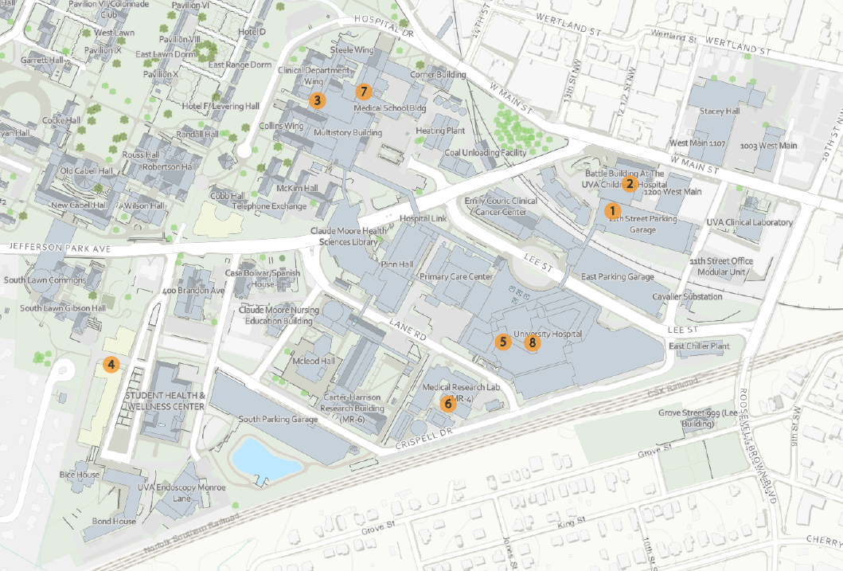

UVA Health/Brandon Ave
Map ID | Project Name | Project Contact | Impact and Conditions | Anticipated Substantial Completion
1 | 11th Street Garage Critical Repairs | Andy Theobald  abt4sd@virginia.edu | The project is taking 100 parking spaces at a time in the  11th Street Parking Garage. Currently the repairs are on  the top deck of the garage, so the impact is minimal. | June 2024
2 | Battle Building -Employee Gym | Caitlin Schafer  ceb9d@virginia.edu | Noise and dust will be within the Battle Building existing retail space and adjoining sidewalk along W. Main Street. The most disruptive work will be done outside of surgery hours; located below the space on basement level (nights and weekends). Increased alley traffic to access the rear service spots affected, but no disruption to surrounding main streets. | August 2024
3 | Davis Wing Plastic  Surgery Renovation | Sandra Lafontaine  uax9ux@virginia.edu | Construction zone will be closed beginning April 1.  Signage and barriers will be provided. This space is  strictly interior. No vehicular traffic is affected. Noise  and dust while limited will be generated during the  project beginning April 15. Adjacent spaces have been  notified. | June 2024
4 | Gaston House and Ramazani House | Brian Williams  gbw5r@virginia.edu | The western lane of Brandon Ave is closed for  construction. Eastern lane is two-way traffic. Pedestrian  pathway is along eastern sidewalk and either up to  South Lawn via the temporary path or up to JPA. | July 2024
5 | Guided Ultrasound &  MRI Expansion | Jim Loman  jal8bu@virginia.edu | Traffic congestion and pedestrian safety: the current  arrangement of fencing, staging, materials hoist,  signage, and covered/protected pedestrian passageway  is expected to remain in place through the end of this  calendar year. | November 2024`

UVA Health/Brandon Ave
Map ID | Project Name | Project Contact | Impact and Conditions | Anticipated Substantial Completion
6 | MR4 Steam Replacement | John Marshall  jsm7u@virginia.edu | A portion of the sidewalk near the M20 lot will be  replaced to correct some unsuitable panels. This work  began in late March. Expect to see flaggers and a  partial lane closure while work is occurring. | April 2024
7 | Old Med School Switchgear Replacement | Andrew Theobald  abt4sd@virginia.edu | Construction will begin on April 1st. The contractor will take a staging area in the courtyard parking lot of Old Med School. Work will occur in the occupied corridors on the 1st and 2nd floors, and in a few offices on the 2nd floor. Outages will need to occur to switch loads over to new gear when the new gear is installed. This will occur in the Summer. Exact impacts of these outages are TBD. Construction will last through end of 2024. | December 2024
8 | University Hospital Endo Rooms 3 & 6 | Jim Loman  jal8bu@virginia.edu | Project is completely internal to the University Hospital.  The project management team is working closely with  the general contractor to implement ICRA and Life  Safety measures to eliminate any hazards to patients or  staff, and will be putting up appropriate signage making  them aware of boundaries. Noise and dust will be  managed through clear and frequent communication  with users as well and previously reviewed and  approved ICRA containment. | July 2024

West Grounds Construction Projects
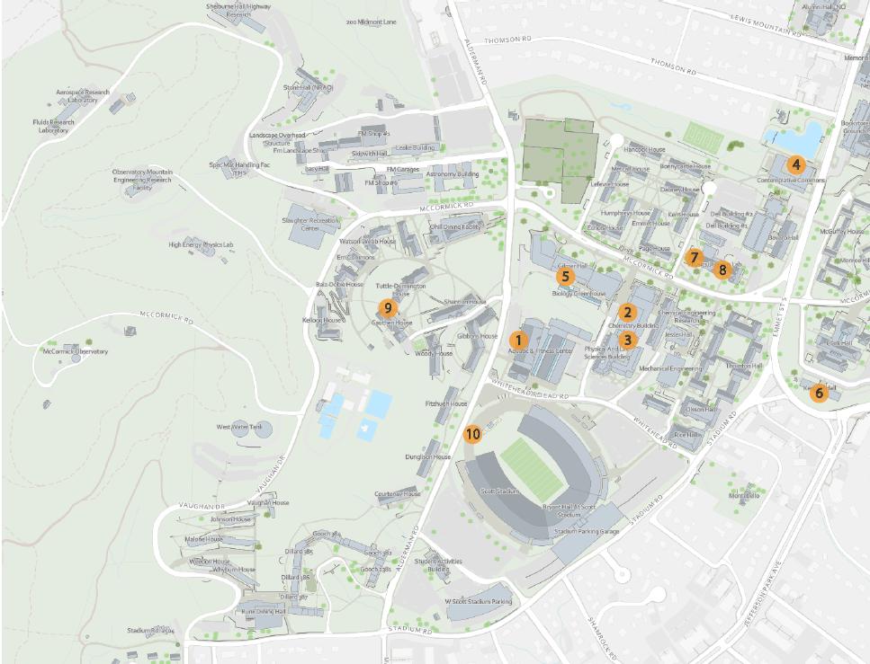
West Grounds
Map ID | Project Name | Project Contact | Impact and Conditions | Anticipated Substantial Completion
1 | AFC Exterior Repairs | Shannon Barras  barras@virginia.edu | Construction in the area started March 3rd. Scaffolding  will be erected in the back parking lot of AFC. Then some  brick cutting will take place. There will be some, but  minimal noise associated with the work. Parking places  along the building will not be available during  construction. The scooter parking will be moved to the  other side of the building. | May 2024
2 | Chemistry Building Addition Fume Exhaust Renewal | Taryn Spence  tsh2n@virginia.edu | Crane erection on Chemistry Way to remove existing  doghouse from the Chemistry Addition roof. Barricades  will be erected and flagman will be onsite during the  removal. Some parking spaces will be impacted and  coordinated through P&T to ensure ADA spots are  accommodated and relocated. | April 2024
3 | Chemistry Addition Labs 280, 372, and 380 Improvements | Amy Eichenberger  ace8a@virginia.edu | Continued minor construction activities, primarily in Labs  379 and 380 which may include noise during business  hours. | April 2024
4 | Contemplative Commons | Sarita Herman  smh2ne@virginia.edu | Site fence removal is ongoing through mid-April. Emmet  Street bridge final painting and guardrail infill panels  require intermittent partial lane closures in Emmet. Two-way vehicular traffic will be maintained. Bridges will remain closed to the public until final completion of the project. | April 2024
5 | Gilmer Hall Addition Improvements | Amy Eichenberger  ace8a@virginia.edu | Continued minor interior renovations will include  some noise and partial circulation impacts. | August 2024
6 | Kerchoff Hall Room 101 Renovations | Shannon Barras  barras@virginia.edu | The impacts will be minimal as the construction phase is  nearing completion. There may minimal construction  noise and work will be seen in area or room 101. | May 2024

West Grounds
Map ID | Project Name | Project Contact | Impact and Conditions | Anticipated Substantial Completion
7 | Physics Building Rooms 042 - 044 | Caitlin Schafer  ceb9d@virginia.edu | Noise and dust within rooms 042 - 044. Work will be  performed around class schedules and lab operations. | May 2024
8 | Physics Building Classrooms | Taryn Spence  tsh2n@virginia.edu | Installation of large round top windows adjacent to  Bonnycastle sidewalk on the west side of the Physics  Building. Partial sidewalk closures may be intermittent. | July 2024
9 | Physics Building Renewal | Taryn Spence  tsh2n@virginia.edu | Continued impacts on the north side of the Physics  building where active Phase 3 construction is underway.  Heavy construction is traffic and deliveries anticipated.  Sitework improvements will impact circulation on the  south side of Physics and require intermittent closure to  traffic to accommodate the extent of work. Signage will  be installed along McCormick entrance as required.  Pedestrian and vehicular traffic to be cautious. | August 2024
10 | Scott Stadium Endzone Scoreboard | Brian Williams  gbw54@virginia.edu  Mike Doto  md2aw@virginia.edu | A portion of the Scott Stadium West lot and West Gate  will be closed from the beginning of February until the  end of July.  Alderman Road and the eastern sidewalk will be closed  9:30 am - 3:00 pm Monday - Friday (Saturdays as  needed) from March 4, 2024 through May 31, 2024  except for the following dates:  o Spring Football Game - April 20th  o HRL Move Out - May 8th - May 12th  o Graduation - May 15th - May 20th  During a closure, road signs and barriers will be utilized  to detour vehicles around the stadium via Whitehead  Road and Stadium Road. The east sidewalk will be  closed and blocked. The west sidewalk along Alderman  will stay open for pedestrian access. ADA signage will be  placed at the closest road crosswalks. | August 2024
Emmet Ivy Corridor/North Grounds Construction Projects
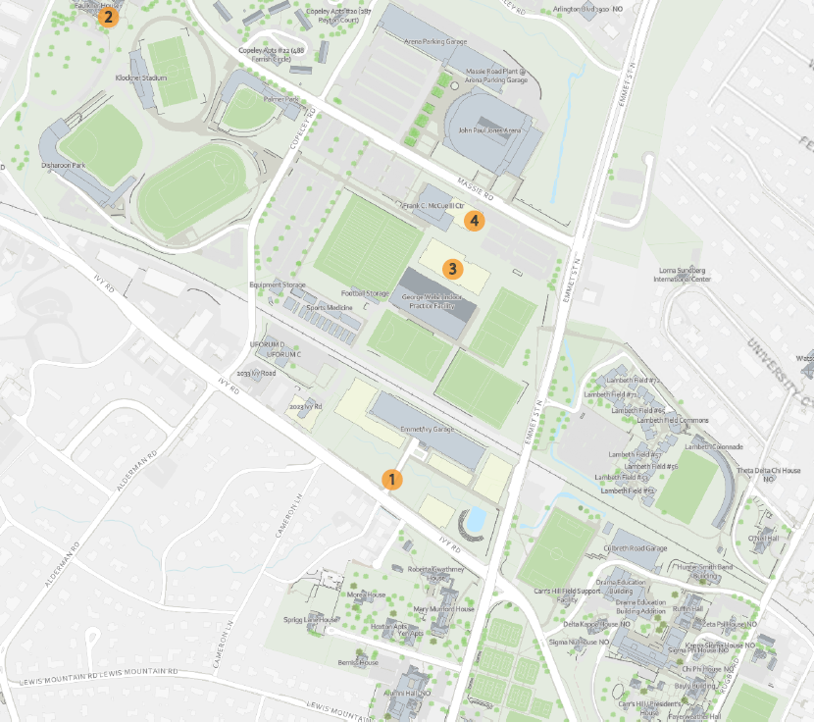

Emmet Ivy Corridor/North Grounds
Map ID | Project Name | Project Contact | Impact and Conditions | Anticipated Substantial Completion
1 | Emmet/Ivy Corridor including School of Data Science and Virginia Guesthouse | Megan Buschi  jsg5fr@virginia.edu | There will be long term sidewalk closure on the north side of Ivy Road from Copely Rd to the bus stop west of Rothery Rd. This closure will support completion of Ivy Corridor Phase 2 and will continue through construction of Karsh Institute. Pedestrian traffic will be routes on the south side of Ivy Road using existing barrier-free crosswalks and sidewalk. | SDS: Achieved March 2024  VG: August 2025
2 | Faulkner House HVAC  Renovations Phase 1 | Shannon Barras  barras@virginia.edu | Construction continues in the area. We are working with  the user group to provide adequate cooling while the  space remains under construction. | May 2024
3 | Football Operations Center | David Sellars  des7n@virginia.edu | Ongoing Impacts:  East parking lot and lower east entrances to McCue  closed. Portions of south sidewalk along Massie  closed. Old pathway from Goodwin bridge closed. | May 2024
4 | Olympics Sports Complex | David Sellars  des7n@virginia.edu | Ongoing Impacts:  The lower east entrances/exits to McCue are closed, and  the remainder of the east parking lot will not be  available. Portions of south sidewalk along Massie  closed.  Portion of UHall west lot closed for Promenade work.  New ADA crosswalks opened and old ones removed at  Copeley Road. | November 2025

Fontaine Research Park Construction Projects
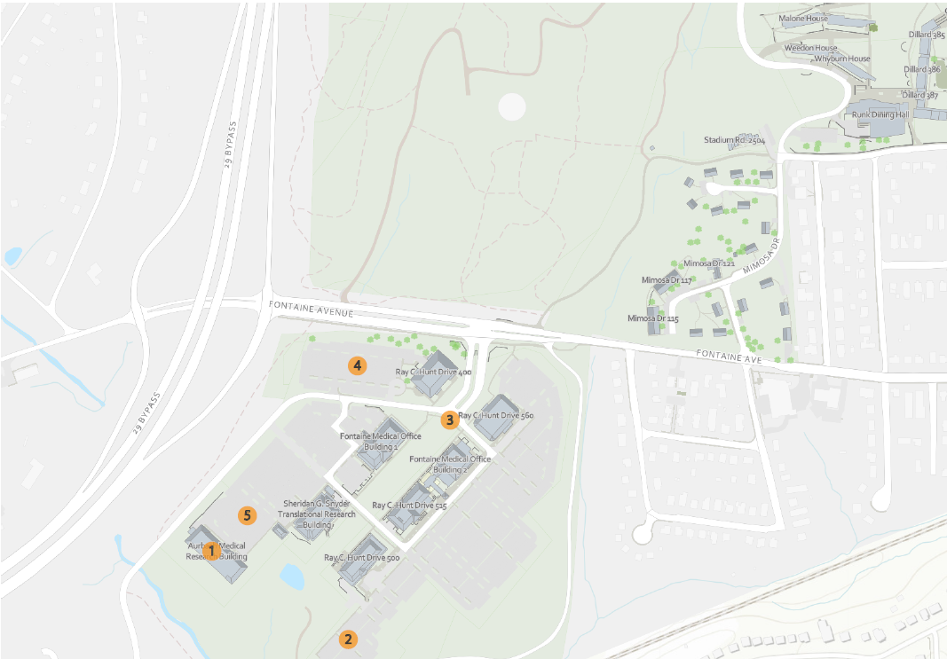
Fontaine Research Park
Map ID | Project Name | Project Contact | Impact and Conditions | Anticipated Substantial Completion
1 | Aurbach Room G162 Renovation | Andy Theobald  abt4sd@virginia.edu | Work at Snyder will begin around March 1st. and last through July. Impacts will be in microscope suite of A050, A054, A055, and A056. Noise and dust impacts will be moderate. Construction barriers will be set up to protect occupants and equipment as needed. | July 2024
2 | Fontaine Central Energy Plant & Utilities | John Marshall  jsm7uz@virginia.edu | Continuation of impacts to parking in the area to  the east of 500 Ray C Hunt. | August 2026
3 | Fontaine Research Park Roadway Infrastructure | Taryn Spence  tsh2n@virginia.edu | Ongoing construction at the Fontaine Research Park  entrance and Spine 2 area to install utilities, remove  entry median, install temporary pedestrian walkway to  connect the pedestrians from the 500 side of the park  to 415 continues. | August 2024
4 | Fontaine Research Park Parking Garage | Taryn Spence  tsh2n@virginia.edu | Site enabling work at 400 Ray C Hunt to establish  temporary ADA parking for use during construction of  the Garage. Associated work includes installation of  safety fence adjacent to the main entry, removal of  some trees, curb and gutter demolition and  installation of temporary sidewalk contained within the  fencing. | November 2025
5 | UVA Institute for Biotechnology | Mashal  Afredi-Hartman  ma4g@virginia.edu | Primary impacts in April will be from relocating existing  utilities from the building footprint in preparation for  Blasting May 20th. Additionally, there will be impacts to  Natural Resources drive as we build the massive  retaining wall to the west of our site.  Impacts are being coordinated with stakeholders,  including P&T, SOM, HS, Forestry, and State Police. | April 2027

