The University of Virginia (University or UVA) invites highly qualified Architectural/ Engineering (A/E) firms to submit a Letter of Interest/ Statement of Qualifications and associated supporting materials for consideration in the selection of a consultant team to provide architectural, and engineering design services for the adaptive reuse of the Transitional Care Hospital for Behavioral Health in accordance with the latest version of the UVA Higher Education Capital Outlay Manual (HECOM).

Purpose & Program Background:

The University Hospital, part of the UVA Medical Center complex, has continued to experience a dramatic increase in patient volumes year after year. This has stressed the inpatient resources at the University Hospital and highlighted the need to create additional capacity for high acuity inpatients. UVA Health’s goal is to increase reach within the region and continue to expand services.

The proposed adaptive reuse of the UVA Health Transitional Care Hospital facility has been identified in the 2026 Integrated Space Plan as one of the initial investments for expanded services. UVA Health has determined the existing facility will be repurposed for inpatient Behavioral Health Services. With increasing numbers of patients seeking comprehensive psychiatric services, this project will address the need for Behavioral Health services in the region and greatly expand mental health care in the community and surrounding region.

Opened in 2010, the former UVA Health Transitional Care Hospital facility previously provided Long-Term Acute Care (LTAC). The existing 40-bed, 68,000 SF facility, currently operates as a nursing simulation facility and provides outpatient radiology services for UVA Health. Additionally, there are 10 beds available on the third floor that formerly supported the Hospice of the Piedmont.

Project Drivers:

Key considerations for the adaptive reuse of the former LTAC hospital should focus on creating an efficient, flexible environment that supports inpatient Behavioral Health services and associated support functions. The project should leverage existing infrastructure where practical and enhance the patient and provider experience through safe, functional, and inspiring spaces for healing.

The program goals for the reuse of the Transitional Care Hospital for Behavioral Health include the following:

- Thoughtful renovation of the interior of the facility to meet space and layout requirements including:
  - Minor modifications on the 1st floor for security and support services. Existing imaging services must remain operational during construction.
  - Accommodating a ratio of semi-private and private rooms dedicated to inpatient Behavioral Health on 2nd floor
  - Additional inpatient beds and ECT functions on 3rd floor
  - Support service needs to be addressed on all levels

- Consider site opportunities for outdoor space with existing topography, security, and zoning constraints in mind

- Evaluate existing infrastructure, spatial constraints, and code implications

Criteria in Support of Strategic Plan:

This Project is in direct support of the UVA Health’s Integrated Space Plan.

Project Status:

The Request for Qualifications follows the September 2026 Board of Visitors authorization to proceed with design. The University anticipates that design will begin in early 2027. A detailed Project program document will be made available during the Request for Proposal (RFP) stage of this process.

Project Site:

The existing facility sits adjacent to Northridge Medical Park and is located only 3.6 miles from University of Virginia grounds.

Qualifications:

The selected firm will have a proven record of design excellence, with a demonstrated ability to bring ideas, expertise, and imagination to a complex building project. The design team must demonstrate considerable experience in the planning, designing, documenting, and construction administration of projects of comparable scale and complexity in a higher education setting. Experience in obtaining LEED certification and familiarity with HECOM will be required.
Selection Process Schedule:

- RFQ Advertised………… | September 28, 2026
- Response Deadline……. | October 23, 2026 by 2:00 pm*
- Shortlist Notified………. | November 6, 2026
- RFPs Issued ………….... | November 13, 2026
- Preproposal Site Visit…. | November 18, 2026
- Proposal Deadline………. | December 4, 2026, by 2:00 pm*
- Interviews………………... | December 15, 2026
* The University will not accept late submissions for any reason.

Submittal Requirements & Process:

Submitted material shall be electronic format only. Interested firms may send one (1) thumb drive containing your submittal in PDF format, OR an email containing the submittal if size permits, OR send a link to a file storage system. The digital copy should be one unlocked PDF file of the entire submission. The submittal is to include the following:

- Letter of Interest addressed to the Selection Committee, which is no longer than two (2) pages in length, and which states specifically the firm’s successful experience in planning and designing very similar facilities in campus and/or other similar settings.
- Statement of Qualifications using the Office of Contract Administration Services (OCAS) standard form which the firm can obtain from the OCAS website at:

https://www.fm.virginia.edu/docs/fpc/contractadmin/SOQ-form.pdf.

The email address provided should be for the person who receives information regarding this RFQ. No general firm or marketing emails please.
- Representative images of the projects listed under “Recent Project Experience” in the Statement of Qualifications.
- Standard forms AE-1 through AE-6 which are available at:

https://dgs.virginia.gov/globalassets/business-units/bcom/documents/forms/dgs-30-004_03-19_ae_data_forms.xlsx

If proposal is a joint venture or association or two or more firms, UVA requires forms AE-1 through AE-6 for each firm, with the proposed division of A/E services clearly indicated by firm and by individual staff members.
- Firms can list Subconsultants on the AE-1 or firms can submit an AE-2 for them, but firms should not submit any other AE forms for Subconsultants at this time.
- Current references and current contact information for each project (five-project minimum) featured in AE forms above. Include contact information for an Owner’s Representative, a User Client, and a Construction Manager (CM) for each project.

Submittals will be evaluated based on the demonstrated significant experience of the firm and its proposed personnel with similar facilities and projects within a higher education setting; the ability to meet specific Project objectives, e.g., budget, schedule, quality, etc.; successful experience with HECOM; experience in design with CM/ Subcontractor participation; experience with completion of sequential trade packages for construction; and other criteria as the Screening Committee may determine. Subsequently, the shortlisted firms will receive a detailed Request for Proposal (RFP), and the University will invite them to present a more detailed response and make an oral presentation.

The University must receive the above submission materials according to the schedule above at the following address:

University of Virginia
Capital Construction & Renovations, Office of Contract Administration Services
Attention: Bruce Jackson
1571 Pratt Drive, Facilities Management Shop #2
Charlottesville, VA 22904
Mailing address:
P.O. Box 400735
Charlottesville, VA 22904-4735

Questions: 434-924-6387or brj2n@virginia.edu

Please do not contact the Project Manager or others at the University regarding this Project. Firms should submit all questions and correspondence regarding this procurement through Bruce Jackson in the Office of Contract Administration Services.

A copy of this Request for Qualifications is available on the Capital Construction & Renovations, Office of Contract Administration Services website at:

https://www.fm.virginia.edu/depts/fpc/contractadmin/advertisements.html

The University will require the successful firm to have a license to do business in Virginia and be able to demonstrate professional registration.

eVA Business to Government Vendor Registration:

The eVA Internet electronic procurement solution, web site portal https://www.eva.virginia.gov/, is the Commonwealth of Virginia’s comprehensive electronic procurement system. The portal is the gateway for firms to conduct business with state agencies and public bodies. The State expects all agencies and public bodies to use eVA. The State encourages all firms desiring to provide goods and/or services in the Commonwealth to participate in eVA. The University requires selected firms to register in eVA prior to the University making an award.

The University will consider the firm’s past and proposed participation by “SWaM” firms in the evaluation of proposals including Minority-Owned (M), Women-Owned (W), Micro (O), Service-Disabled Veteran (SDV), Small Business (S), Employment Service Organization (ESO), (8a), Economically Disadvantaged Woman Owned Small Business (EDWOSB), and Federal Service-Disabled Veteran (FSDV) Businesses. SWaM firms must register with and obtain certification from the Department of Small Business & Supplier Diversity (SBSD) in Richmond. Assistance is available for registration. The University requires quarterly reporting of expenditures to SWaM consulting firms or suppliers used in this contract by the selected firms.

Appendix A

Image 1: Proximity map showing location of the UVA Health Transitional Care Hospital in Northridge Medical Park.
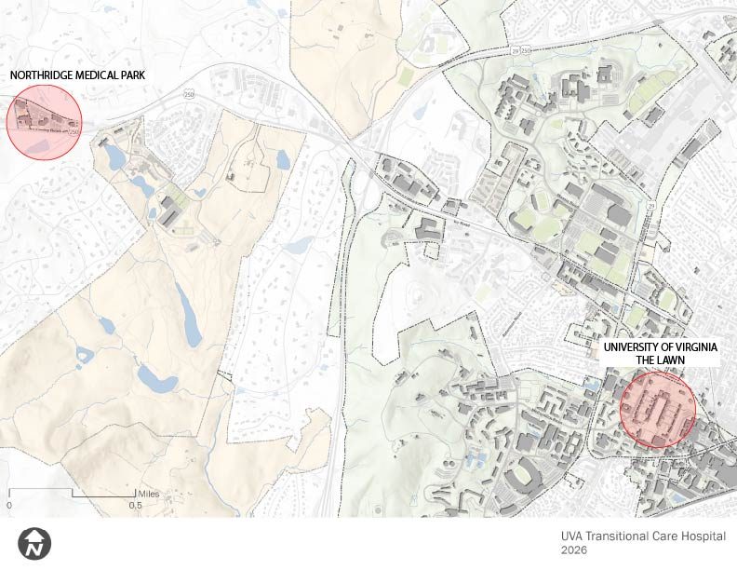

Image 2: View of the Northridge Medical Park Facility
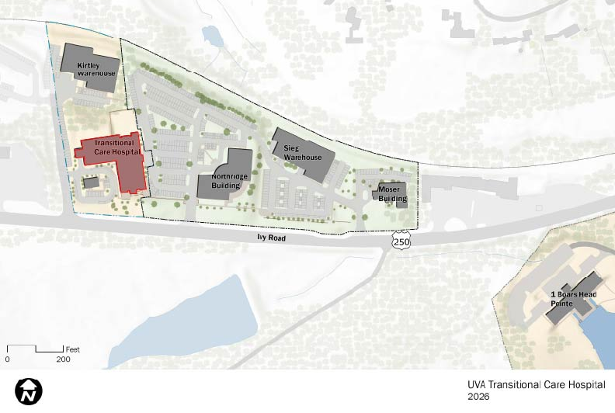

Image 3: Overall view of existing Transitional Care Hospital Building

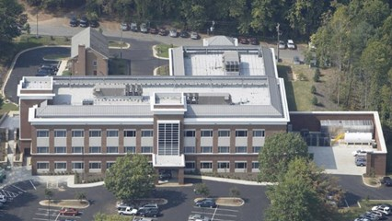

Image 4: Existing level 1
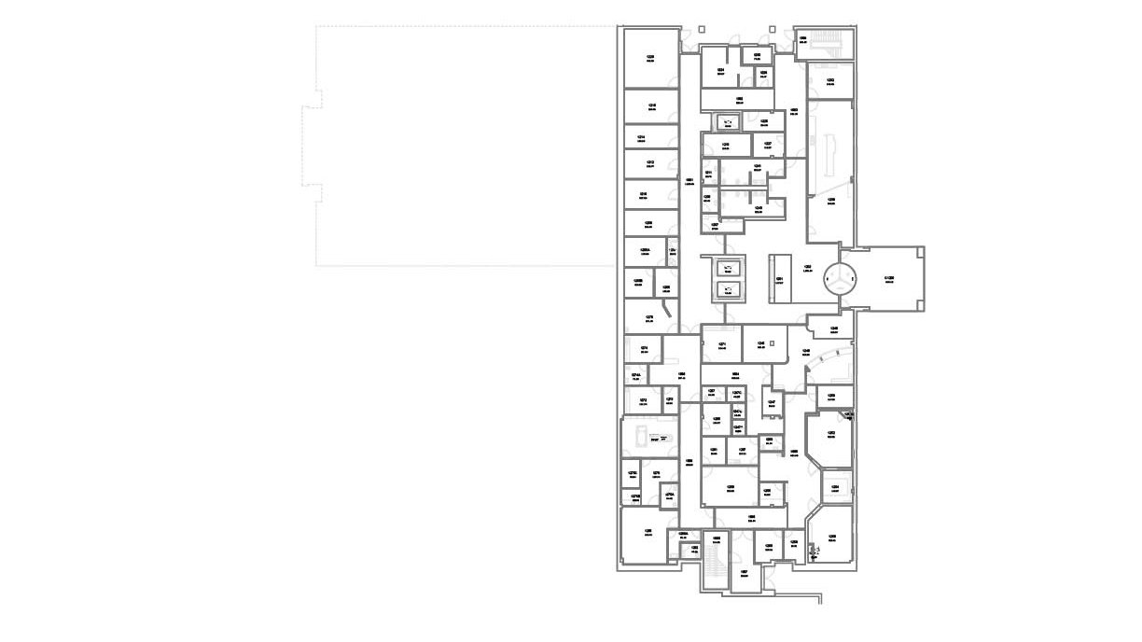

Image 5: Existing level 2
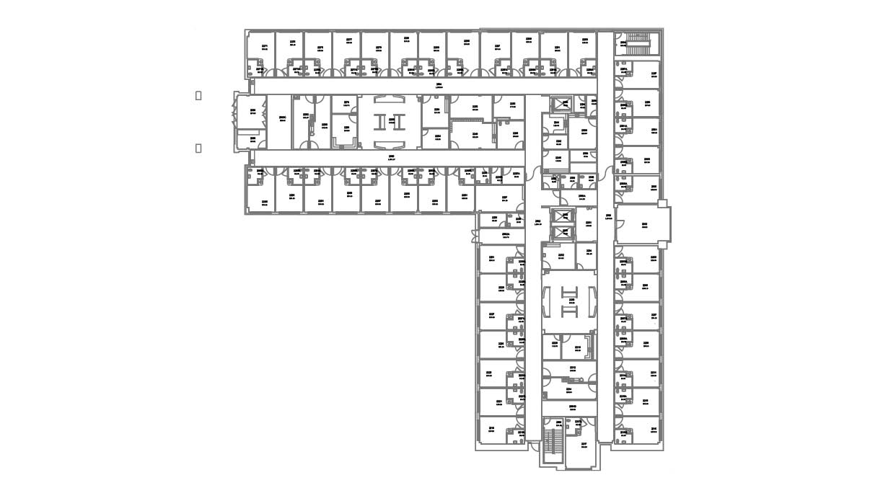

Image 6: Existing level 3
