The University of Virginia (University or UVA) invites highly qualified Architectural/ Engineering (A/E) firms to submit a Letter of Interest/ Statement of Qualifications and associated supporting materials for consideration in the selection of a consultant team to provide program verification, architectural, and engineering design services for a renovation of the Darden Hall academic building at UVA’s College at Wise in accordance with the latest version of the UVA Higher Education Capital Outlay Manual (HECOM). The first phase of the project will be Schematic Design. Upon successful completion of Schematic Design, the University may in its sole discretion elect to retain the selected firm for full design and construction services for any or all phases of the future project.

Purpose & Program Background:

The University of Virginia’s College at Wise is a public, four-year residential liberal arts college located in Southwest Virginia. The College sits on an expansive 396-acre campus nestled amid the Appalachian Mountains, where students can experience unique cultural opportunities as well as the great outdoors. Offering a variety of academic degrees, pre-professional study tracks, and teaching licensures, the College maintains an impressive 13:1 student-faculty ratio.

Through excellence in teaching, personalized attention, and commitment to individual growth, The University of Virginia’s College at Wise prepares students to be engaged citizens. Drawing upon its foundation as a public liberal arts institution in the Appalachian region of Virginia, the College strives to build a diverse community of learners with the drive to serve and lead in their communities, the nation, and the world.

To deliver on this mission, the College’s faculty and students require spaces that allow for a mix of both individual and collaborative academic workspaces and classrooms enabled by the latest technologies. Originally opened in 1997, Darden Hall no longer meets many of the College’s aspirational requirements for contemporary learning and collaboration spaces. The College aspires to provide an educational facility that reinforces and enhances the commitment to cultivate a vibrant and diverse community engaging in scholarship and learning. The Darden Hall Renovation project will aim to rectify these weaknesses by renovating the existing building to be consistent with modern standards – and peer institutions – for openness, collaboration, technology, and impact.

Darden Hall is one of the College’s most heavily utilized academic facilities and currently home to the Education, Computer Science, and Software Engineering programs. The academic spaces as configured and equipped today are not well suited to support the robust technological environment these programs demand.

Future Consideration: The College has requested funding for the construction of a new Technology Classroom Building in the academic precinct, adjacent to Darden Hall. If approved, this facility will house several of the academic programs currently in Darden Hall including Math & Computer Science, Data Analytics, and the Department of Business. Darden Hall would then support expanded and graduate programs in the Education, Social Science, and Behavioral Sciences through additional classrooms, labs, and offices.

Project Drivers:

Key considerations include efficient use of interior spaces, an increase in faculty offices and classrooms, and additional restrooms. The College is seeking design options that enhance the faculty and student experience by providing inspiring new interiors featuring natural light, innovative collaborative spaces, and dynamic classrooms and offices.

The project goals for the Darden Hall Renovation include the following:

- Renovate the interior of Darden Hall (34,500 GSF) to meet space and layout requirements, replace systems, improve building infrastructure, and add 50 years of life to the facility.
- Provide robust technological and hands-on learning environments for Education, Math + Computer Science (near term), and Social Science departments (long term) to pursue the leading edge of these academic offerings.
- Increase utilization of Darden Hall and unlock the spatial constraints that restrict function and ease of use.
- Transform Darden Hall’s role on campus into a vibrant hub and a place where students and faculty want to spend time.

Criteria in Support of Strategic Plan:

This Project is in direct support of the University’s 2030 Strategic Plan to strengthen our foundation supporting students, faculty, and staff by enhancing the student and faculty experience to be consistent with modern standards.

Project Status:

A detailed project program has been completed and will be made available during the Request for Proposal (RFP) stage of this process.

Project Site:

Darden Hall is centrally located within the University of Virginia’s College at Wise academic precinct. The facility is immediately adjacent to the UVA Wise Library and directly across from Zehmer Hall and the newly renovated Pippen Wylie School of Nursing.

Qualifications:

The selected firm will have a proven record of design excellence, with a demonstrated ability to bring ideas, expertise, and imagination to a complex building project. The design team must demonstrate considerable experience in the planning, designing, documenting, and construction administration of projects of comparable scale and complexity in a higher education setting. Experience in obtaining LEED certification and familiarity with HECOM will be required.

Selection Process Schedule:

- RFQ Advertised………… | October 27, 2025
- Response Deadline……. | December 4, 2025, by 2:00 pm**
- Shortlist Notified………. | December 16, 2025
- RFPs Issued ………….... | December 17, 2025
- Preproposal Site Visit…. | TBD
- Proposal Deadline………. | January 21, 2026, by 2:00 pm**
- Interviews………………... | January 30, 2026
** The University will not accept late submissions for any reason.

Submittal Requirements & Process:

Submitted material shall be electronic format only. Interested firms may send one (1) thumb drive containing your submittal in PDF format, OR an email containing the submittal if size permits, OR send a link to a file storage system. The digital copy should be one unlocked PDF file of the entire submission. The submittal is to include the following:

- Letter of Interest addressed to the Selection Committee, which is no longer than two (2) pages in length, and which states specifically the firm’s successful experience in planning and designing very similar facilities in campus and/or other similar settings.
- Statement of Qualifications using the Office of Contract Administration Services (OCAS) standard form which the firm can obtain from the OCAS website at:

https://www.fm.virginia.edu/docs/fpc/contractadmin/SOQ-form.pdf.

The email address provided should be for the person who receives information regarding this RFQ. No general firm or marketing emails please.
- Representative images of the projects listed under “Recent Project Experience” in the Statement of Qualifications.
- Standard forms AE-1 through AE-6 which are available at:

https://dgs.virginia.gov/globalassets/business-units/bcom/documents/forms/dgs-30-004_03-19_ae_data_forms.xlsx

If proposal is a joint venture or association or two or more firms, UVA requires forms AE-1 through AE-6 for each firm, with the proposed division of A/E services clearly indicated by firm and by individual staff members.
- Firms can list Subconsultants on the AE-1 or firms can submit an AE-2 for them, but firms should not submit any other AE forms for Subconsultants at this time.
- Current references and current contact information for each project (five-project minimum) featured in AE forms above. Include contact information for an Owner’s Representative, a User Client, and a Construction Manager (CM) for each project.

Submittals will be evaluated based on the demonstrated significant experience of the firm and its proposed personnel with similar facilities and projects within a higher education setting; the ability to meet specific Project objectives, e.g., budget, schedule, quality, etc.; successful experience with HECOM; experience in design with CM/ Subcontractor participation; experience with completion of sequential trade packages for construction; and other criteria as the Selection Committee may determine. Subsequently, the shortlisted firms will receive a detailed Request for Proposal (RFP), and the University will invite them to present a more detailed response and make an oral presentation.

The University must receive the above submission materials according to the schedule above at the following address:

University of Virginia
Capital Construction & Renovations, Office of Contract Administration Services
Attention: Bruce Jackson
1571 Pratt Drive, Facilities Management Shop #2
Charlottesville, VA 22904
Mailing address:
P.O. Box 400735
Charlottesville, VA 22904-4735

Questions: 434-924-6387or brj2n@virginia.edu

Please do not contact the Project Manager or others at the University regarding this Project. Firms should submit all questions and correspondence regarding this procurement through Bruce Jackson in the Office of Contract Administration Services.

A copy of this Request for Qualifications is available on the Capital Construction & Renovations, Office of Contract Administration Services website at:

https://www.fm.virginia.edu/depts/fpc/contractadmin/advertisements.html

The University will require the successful firm to have a license to do business in Virginia and be able to demonstrate professional registration.

eVA Business to Government Vendor Registration:

The eVA Internet electronic procurement solution, web site portal https://www.eva.virginia.gov/, is the Commonwealth of Virginia’s comprehensive electronic procurement system. The portal is the gateway for firms to conduct business with state agencies and public bodies. The State expects all agencies and public bodies to use eVA. The State encourages all firms desiring to provide goods and/or services in the Commonwealth to participate in eVA. The University requires selected firms to register in eVA prior to the University making an award.

The University will consider the firm’s past and proposed participation by “SWaM” firms in the evaluation of proposals including Minority-Owned (M), Women-Owned (W), Micro (O), Service-Disabled Veteran (SDV), Small Business (S), Employment Service Organization (ESO), (8a), Economically Disadvantaged Woman Owned Small Business (EDWOSB), and Federal Service-Disabled Veteran (FSDV) Businesses. SWaM firms must register with and obtain certification from the Department of Small Business & Supplier Diversity (SBSD) in Richmond. Assistance is available for registration. The University requires quarterly reporting of expenditures to SWaM consulting firms or suppliers used in this contract by the selected firms.

Appendix A

Image 1: Proximity map showing the location of Darden Hall (numbered 26)
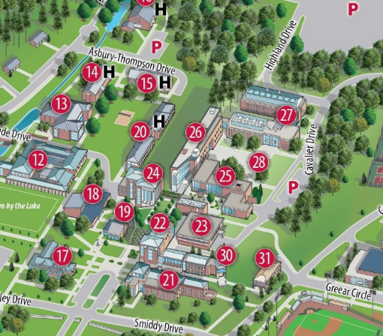

Image 2: Existing Darden Hall exterior (prior to replacement of glazing)

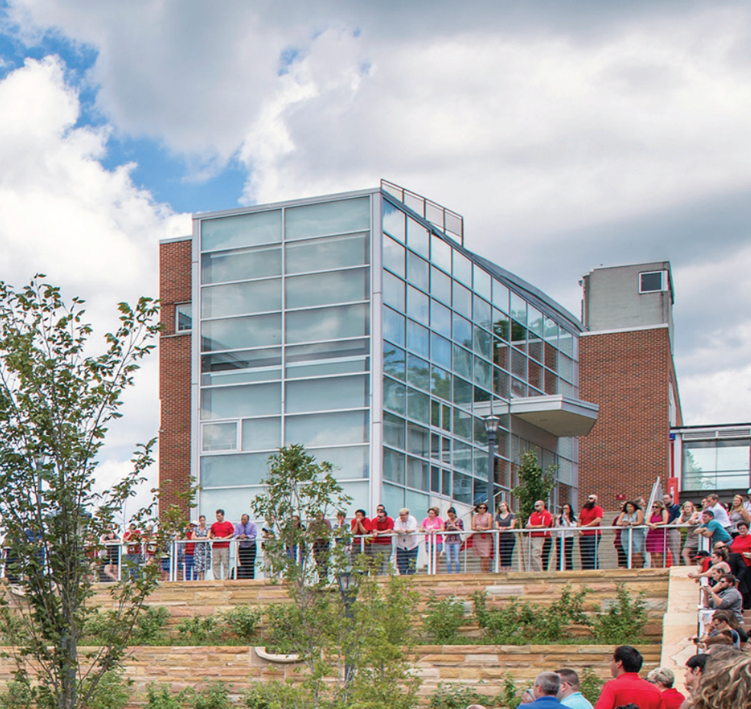

Image 3: Existing Darden Hall interior (central hallway)
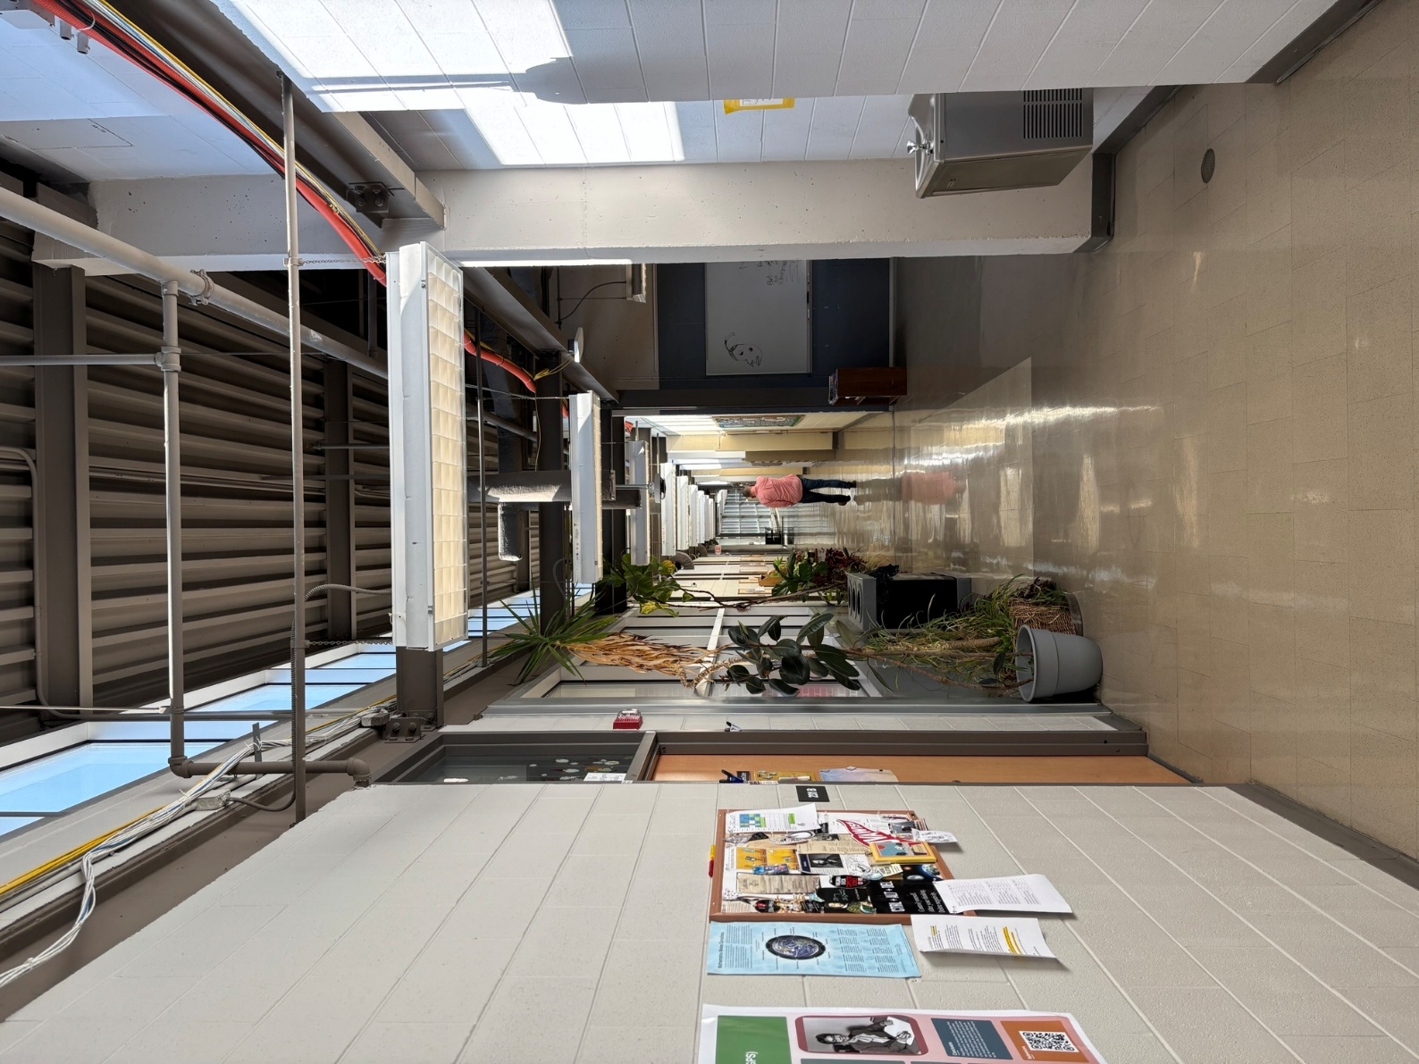

Image 4: Existing Darden Hall interior (typical classroom)
