The University of Virginia (University or UVA) invites highly qualified Owner’s Representative (OR) firms to submit a Letter of Interest/ Statement of Qualifications and associated supporting materials for consideration in the selection of a firm to provide OR services for the Grove Street Corridor Site in accordance with the latest version of the UVA Higher Education Capital Outlay Manual (HECOM). The first phase of the project will include participation with the A/E firm in a planning study involving deep community engagement and discussion of the desired program. Upon successful completion of the planning effort, the University may in its sole discretion elect to retain the selected firm for full services for any or all phases of the future project including but not limited to programming, design, selection of the Construction firm, construction, commissioning, and turnover. UVA or UVA’s Architect/ Engineer (A/E), Consultants, and Construction Contractor will hold all project contracts, and UVA will make payment according to the terms of any such contracts. UVA will provide full project management services.

Purpose & Program Background:

UVA owns seven parcels along Grove Street, adjacent to the Cherry Avenue Entrance Corridor – the 999 – 1001 parcel (referred to as Site A) and the adjacent 6 parcels of the 900 block of Grove and King (referred to as Site B). The purpose of the planning study is to assess potential program uses of the sites to support UVA Health and the community, and explore potential density, access, and related impacts.

Project Drivers:

The Grove Street sites (A and B), are designated redevelopment zones based on the 2023 Grounds Framework Plan. Redevelopment zones provide for potential growth and were designated based on their location, size, and potential opportunities to contribute to the University at large. UVA has established a practice of studying redevelopment zones with detailed planning studies to understand the opportunities and challenges of the site(s). Since these sites are on the southern edge of Grounds, an important aspect of this planning study will be neighborhood engagement with the Fifeville community early in the process of developing the study. Another important aspect will be the consideration of program options for the site(s) and are likely to include neighborhood clinics and procedure areas, community uses, and parking in a mixed-use format, although other options will be considered. The proposed zoning for this area is campus (CM), with no overlays and the density is unlimited. Site A is between the railroad tracks and Grove Street, and Site B is between Grove Street and King Street. Both sites have frontage along Roosevelt Brown Boulevard.

Project Status:

The Grove Street planning study commenced in Spring of 2024 and is expected to have initial study results by the end of the year.

Project Sites:

The project sites include seven parcels along Grove Street, adjacent to the Cherry Avenue Entrance Corridor – the 999 – 1001 parcel (referred to as Site A) and the adjacent 6 parcels of the 900 block of Grove and King (referred to as Site B). Site A is 1.97 acres and 85,744 square feet, and Site B is 1.13 acres and 49,117 square feet. The zoning in the general context includes corridor-mixed use and low density residential. Both sites have frontage along Roosevelt Brown Boulevard, which is a busy City arterial that connects with Cherry Street leading to Fifth Street to the southeast and West Main Street to the north. Please see existing conditions on page 5 for additional detail and maps of the site.

Qualifications:

The selected firm will have a demonstrated ability to bring ideas, expertise, and imagination to a detailed planning study for projects of comparable scale and complexity in an academic/ healthcare setting. Key considerations include clinical programming aspects and community engagement. The selected OR will possess the following key qualifications and attributes:

- Expertise & Experience – We require a candidate with extensive knowledge and experience in academic/ healthcare construction management. The ideal representative should be well-versed in the intricacies of the construction process, including planning, design, procurement, and construction methods. UVA will give preference to candidates with previous experience in ambulatory, procedural, parking, and community space integration.

- Project Oversight – The OR must demonstrate the ability to standardize templates, reports, dashboards, and budgets to provide comprehensive oversight of the project. They should possess a proven track record in monitoring progress, schedules, and reviewing project documentation to ensure strict compliance with specifications, regulations, and industry standards. Their oversight should be characterized by the production of crisp reports designed to minimize delays, manage cost overruns, and identify potential conflicts while ensuring the project stays on schedule.

- Cost Control – The ideal candidate should have a strong background in monitoring the project budget. They should be adept at working closely with the Owner to establish a realistic budget, evaluating changes in the work, and identifying potential cost-saving opportunities. Their expertise should effectively maximize the project's investment and minimize unnecessary expenses, ultimately ensuring the project remains on budget through completion.

- Communication & Coordination – We require a representative capable of seamlessly coordinating the efforts of numerous stakeholders, including architects, engineers, contractors, and subcontractors. They should serve as a central point of contact, facilitating effective communication and collaboration among all parties involved. The ability to streamline the decision-making process, maintain transparency, and efficiently resolve any conflicts that may arise during construction is essential.

- Innovation & Best Practices – The OR should be well-versed in advising on and maintaining national best practices. They should ensure that the project consistently meets quality standards and aligns with specification goals and industry best practices.

- Consensus Building – A strong background in building consensus within an academic/ healthcare setting to reduce change order requests is crucial. The selected candidate should have the expertise to thoroughly evaluate and approve change orders, striking a balance between necessary modifications and cost containment.

Selection Process Schedule:

- RFQ Advertised………… | April 1, 2024
- Response Deadline……. | April 29, 2024, 2024, by 2:00 pm**
- Shortlist Meeting………. | TBD
- RFPs Issued ………….... | TBD
- Preproposal Site Visit…. | TBD
- Proposal Deadline………. | TBD**
- Interviews………………... | TBD
** The University will not accept late submissions for any reason.

Submittal Requirements and Process:

Submitted material shall be electronic format only. Interested firms may send one (1) thumb drive containing your submittal in PDF format, or an email containing the submittal if size permits, or send a link to a file storage system. The digital copy should be one unlocked PDF file of the entire submission. The submittal is to include the following:

- Letter of Interest addressed to the Selection Committee that is no longer than two (2) pages in length, and which states specifically the firm’s successful experience in providing OR services for very similar facilities in hospital and/or other similar settings.
- Statement of Qualifications using the Office of Contract Administration Services (OCAS) standard form which the firm can obtain from the OCAS website at:

https://www.fm.virginia.edu/docs/fpc/contractadmin/SOQ-form.pdf.

The email address provided should be for the person who will receive information regarding this RFQ – no general firm or marketing emails please.
- Standard forms AE-1 through AE-6 which are available at:

https://dgs.virginia.gov/globalassets/business-units/bcom/documents/forms/dgs-30-004_03-19_ae_data_forms.xlsx

If proposal will be a joint venture or association of two or more firms, UVA requires forms AE-1 through AE-6 for each firm, with the proposed division of OR services clearly indicated by firm and by individual staff members.
- Representative images of the projects listed under “Representative Project Data” in the AE-5.
- Current references and current contact information for each project listed under “Representative Project Data” in the AE-5. Include contact information for an Architect/ Engineer (A/E), a User Client, and a Construction Manager (CM)/ Contractor for each project.

Submittals will be evaluated based on the demonstrated significant experience of the firm and its proposed personnel with similar facilities and projects within an academic/ healthcare setting; the ability to meet specific project objectives, e.g., budget, schedule, quality, etc.; experience in design with Contractor/ Subcontractor participation; experience with completion of sequential trade packages for construction; and other criteria as the Selection Committee may determine. Subsequently, the shortlisted firms will receive a detailed Request for Proposal (RFP) and the University will invite them to present a more detailed response and make an oral presentation.
The University must receive the above submission materials according to the schedule above at the following address:

University of Virginia
Capital Construction & Renovations, Office of Contract Administration Services
Attention: Bruce Jackson
1571 Pratt Drive, Facilities Management Shop #2
Charlottesville, VA 22904
Mailing address:
P.O. Box 400735
Charlottesville, VA 22904-4735

Questions: 434-924-6387or brj2n@virginia.edu

Please do not contact the Project Manager or others at the University regarding this project. Firms should submit all questions and correspondence regarding this procurement through Bruce Jackson in the Office of Contract Administration Services.

A copy of this Request for Qualifications is available on the Capital Construction & Renovations, Office of Contract Administration Services website at:

https://www.fm.virginia.edu/depts/fpc/contractadmin/advertisements.html

The University will require the successful firm to have a license to do business in Virginia and be able to demonstrate professional registration.

eVA Business to Government Vendor Registration:

The eVA Internet electronic procurement solution, website portal https://www.eva.virginia.gov/, is the Commonwealth of Virginia’s comprehensive electronic procurement system. The portal is the gateway for firms to conduct business with state agencies and public bodies. The State expects all agencies and public bodies to use eVA. The State encourages all firms desiring to provide goods and/or services in the Commonwealth to participate in eVA. The University requires selected firms to register in eVA prior to the University making an award.

The University will consider the firm’s history and proposed participation by “SWaM” firms in the evaluation of proposals including Minority-Owned (M), Women-Owned (W), Micro (O), Service-Disabled Veteran (SDV), Small Business (S), Employment Service Organization (ESO), (8a), Economically Disadvantaged Woman Owned Small Business (EDWOSB), and Federal Service-Disabled Veteran (FSDV) Businesses. SWaM firms must be registered with and certified by the Department of Small Business & Supplier Diversity (SBSD) in Richmond. Assistance is available for registration. The University requires quarterly reporting of expenditures to SWaM consulting firms or suppliers used in this contract by the selected firms.

Existing Conditions:

Below are maps of the Grove sites in the context of overall UVA Grounds and UVA Health (top), and overall context of Fifeville and the Cherry Street Corridor (bottom).
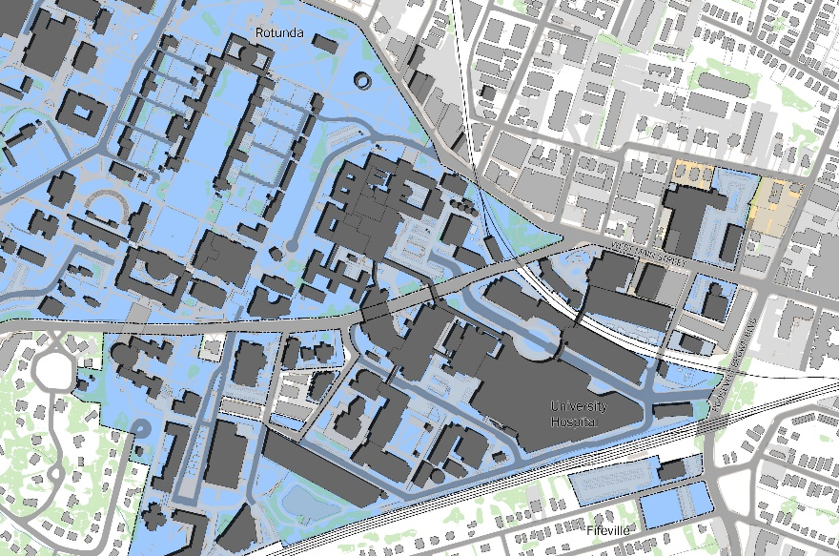
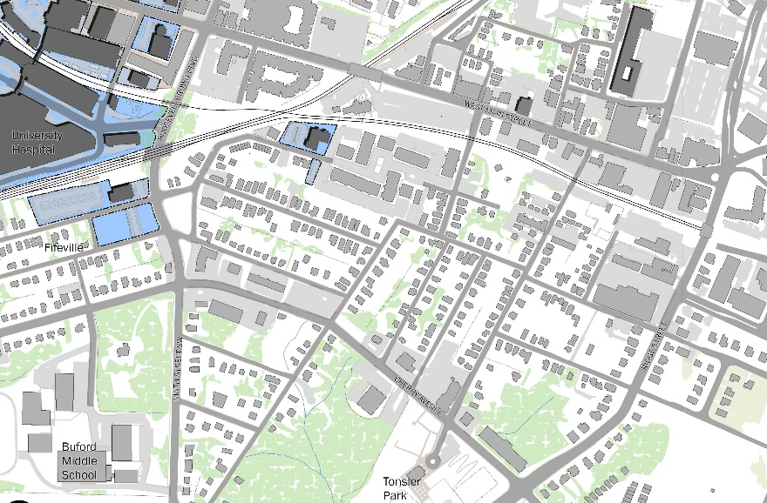
Grove Street sites
Cherry Avenue Corridor
Roosevelt Brown Blvd.
UVA Health
Site B

Site A
Site B

Site A
Fifth Street
UVA Central Grounds

