The University of Virginia (University or UVA) invites highly qualified Planning/ Architectural (A/E) firms to submit a Letter of Interest/ Statement of Qualifications and associated supporting materials for consideration in the selection of a consultant team to provide planning services for the Oak Lawn site in accordance with the latest version of the UVA Higher Education Capital Outlay Manual (HECOM). The first phase of the project will be a planning study. Upon successful completion of the planning effort, the University may in its sole discretion elect to retain the selected firm for full services for any or all phases of the future project.

Purpose & Program Background:

UVA recently acquired the 5.2-acre parcel (TMP 30-169) known as ‘Oak Lawn’. It is located at 501 9th Street SW, at the corner of Cherry Avenue & Ninth Street SW, adjacent to the Cherry Avenue Entrance Corridor. The purpose of the planning study is to assess childcare and potential program uses of the site in support of UVA Health and the community while protecting the historic value of the property and exploring potential density, access, transportation, and related impacts.

Project Drivers:

Since this site is on the southern edge of Grounds, an important aspect of this planning study will be neighborhood engagement with the Fifeville community early in the process and during the development of the planning study. Another key aspect will be the consideration of program options for the site, which are likely to include childcare and community uses. Addressing the historic preservation of the existing house and landscape, including two historic cemeteries, is an integral aspect of this project. Ultimately, this is a land use study that will assess the time required for planning, redesign, and development of the property based on the potential program(s), community engagement, historic preservation requirements, preliminary and detailed site and zoning entitlements, and final site plan approval.

Project Status:

The Oak Lawn planning study is expected to commence in Spring of 2024 and have initial study results by the end of the year.

Project Site:

Oak Lawn is a 5.2 acre historically significant property with redevelopment potential and is zoned R-1SH (single family residential). It is listed on two National Register of Historic Places nominations. It is also listed on the Virginia Landmarks Register (VLR) and is a City of Charlottesville Individually Protected Property (IPP). The property is in Area C, as defined by the Three-Party Agreement between the University, City, and County, requiring the University to follow both state and local review entitlement processes for any proposed development. The newly adopted zoning for the property is R-C, which increases the allowable by-right residential density to 8 or 10 units and allows other identified uses by-right or with a special use permit. In light of the property status, the following matters below should be considered in the planning process.

- Special use permits or rezoning of the property requires approval by the local Planning Commission and City Council.
- Significant changes to the design or use of the property would initiate several layers of review from state and local agencies.
- Redevelopment of a local IPP requires review and issuance of a Certificate of Appropriateness by the city’s Board of Architectural Review (BAR).
- The property’s VLR status requires that proposed changes be reviewed through consultation with Virginia Department of Historic Resources (DHR). DHR may also require mitigation of the effects of the proposed changes to the property.
- Substantial changes to the property, including demolition of any resources, require review and approval by the Virginia Art and Architecture Review Board (AARB).
- The use of federal funds for development on the property would trigger environmental compliance review at the federal level under Section 106 of the National Historic Preservation Act.

Qualifications:

The selected firm will have a proven history of design excellence, with a demonstrated ability to bring ideas, expertise, and imagination to a detailed planning study. The design team must demonstrate considerable experience in planning, historic preservation planning, programming, designing, documenting of projects of comparable scale and complexity in an academic/ healthcare setting and with significant historic structures. Experience in obtaining LEED certification and familiarity with HECOM will be required.

Selection Process Schedule:

- RFQ Advertised………… | January 23, 2024
- Response Deadline……. | February 20, 2024
- Shortlist Meeting………. | February 29, 2024
- RFPs Issued ………….... | March 1, 2024
- Preproposal Site Visit…. | TBD
- Proposal Deadline………. | March 29, 2024
- Interviews………………... | April 9, 2024
** The University will not accept late submissions for any reason.

Submittal Requirements and Process:

Submitted material shall be electronic format only. Interested firms may send one (1) thumb drive containing your submittal in PDF format, OR an email containing the submittal if size permits, OR send a link to a file storage system. The digital copy should be one unlocked PDF file of the entire submission. The submittal is to include the following:

- Letter of Interest addressed to the Selection Committee that is no longer than two (2) pages in length, and which states specifically the firm’s successful experience in planning and designing very similar facilities in campus and/or other similar settings.
- Statement of Qualifications using the Office of Contract Administration Services (OCAS) standard form which the firm can obtain from the OCAS website at:

https://www.fm.virginia.edu/docs/fpc/contractadmin/SOQ-form.pdf.

The email address provided should be for the person who will receive information regarding this RFQ – no general firm or marketing emails please.
- Representative images of the projects listed under “Recent Project Experience” in the Statement of Qualifications.
- Standard forms AE-1 through AE-6 which are available at:

https://dgs.virginia.gov/globalassets/business-units/bcom/documents/forms/dgs-30-004_03-19_ae_data_forms.xlsx

If proposal is a joint venture or association or two or more firms, UVA requires forms AE-1 through AE-6 for each firm, with the proposed division of A/E services clearly indicated by firm and by individual staff members.
- Firms can list Subconsultants on the AE-1 or firms can submit an AE-2 for them, but firms should not submit any other AE forms for Subconsultants at this time.
- Current references and current contact information for each project (five-project minimum) featured in AE forms above. Include contact information for an Owner’s Representative, a User Client, and a Construction Manager (CM) for each project.

Submittals will be evaluated based on the demonstrated significant experience of the firm and its proposed personnel with similar facilities and projects within an academic setting; the ability to meet specific Project objectives, e.g., budget, schedule, quality, etc.; successful experience with HECOM; experience in design with CM/ Subcontractor participation; experience with completion of sequential trade packages for construction; and other criteria as the Selection Committee may determine. Subsequently, the shortlisted firms will receive a detailed Request for Proposal (RFP) and the University will invite them to present a more detailed response and make an oral presentation.
The University must receive the above submission materials according to the schedule above at the following address:

University of Virginia
Capital Construction & Renovations, Office of Contract Administration Services
Attention: Bruce Jackson
1571 Pratt Drive, Facilities Management Shop #2
Charlottesville, VA 22904
Mailing address:
P.O. Box 400735
Charlottesville, VA 22904-4735

Questions: 434-924-6387or brj2n@virginia.edu

Please do not contact the Project Manager or others at the University regarding this Project. Firms should submit all questions and correspondence regarding this procurement through Bruce Jackson in the Office of Contract Administration Services.

A copy of this Request for Qualifications is available on the Capital Construction & Renovations, Office of Contract Administration Services website at:

https://www.fm.virginia.edu/depts/fpc/contractadmin/advertisements.html

The University will require the successful firm to have a license to do business in Virginia and be able to demonstrate professional registration.

eVA Business to Government Vendor Registration:

The eVA Internet electronic procurement solution, website portal https://www.eva.virginia.gov/, is the Commonwealth of Virginia’s comprehensive electronic procurement system. The portal is the gateway for firms to conduct business with state agencies and public bodies. The State expects all agencies and public bodies to use eVA. The State encourages all firms desiring to provide goods and/or services in the Commonwealth to participate in eVA. The University requires selected firms to register in eVA prior to the University making an award.

The University will consider the firm’s history and proposed participation by “SWaM” firms in the evaluation of proposals including Minority-Owned (M), Women-Owned (W), Micro (O), Service-Disabled Veteran (SDV), Small Business (S), Employment Service Organization (ESO), (8a), Economically Disadvantaged Woman Owned Small Business (EDWOSB), and Federal Service-Disabled Veteran (FSDV) Businesses. SWaM firms must register with and obtain certification from the Department of Small Business & Supplier Diversity (SBSD) in Richmond. Assistance is available for registration. The University requires quarterly reporting of expenditures to SWaM consulting firms or suppliers used in this contract by the selected firms.

Existing Conditions:

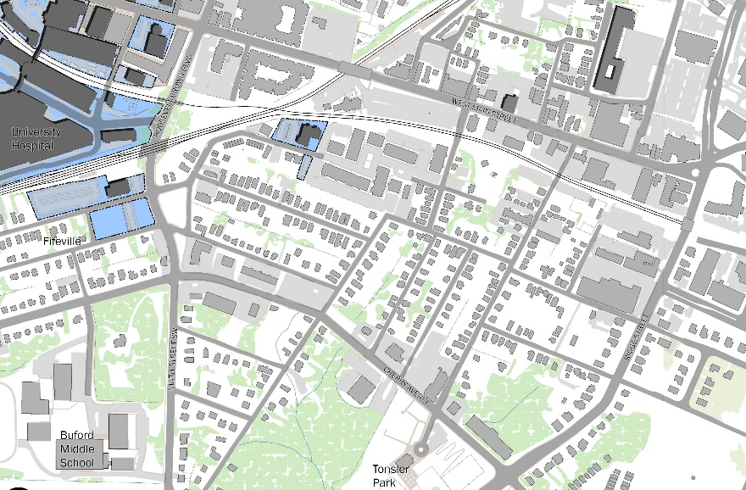
Below is a map of the Oak Lawn site in the context of UVA Health, the Fifeville neighborhood, and the Cherry Avenue Corridor.
Cherry Avenue Corridor
Fifth Street
Oak Lawn

Roosevelt Brown Blvd
UVA
Health
West Main Street

