REQUEST FOR LETTERS OF INTEREST
and Statements of Qualifications

The University of Virginia, Charlottesville, invites highly qualified firms to submit Letters of Interest and Statements of Qualifications along with background information on Form HECO-16 (obtain adapted version from http://www.fm.virginia.edu/depts/fpc/index.html) for construction services related to the:

Center for the Arts
RFP #23-102

The University seeks to retain a Construction Manager to join our team during construction document development phase to provide constructability review, scheduling scenarios, logistics coordination, value management, early bid package assistance, full construction services for the University in accordance with the provisions of the University of Virginia Higher Education Capital Outlay Manual and RFP, and any other related services as directed by the University. The University has determined that Competitive Sealed Bidding is not practicable or fiscally advantageous; therefore, the contract will be awarded as a Construction Management at Risk with Design Phase Services as the project delivery method.

Project Overview:

The Center for the Arts includes a 1,200-seat academic and community performing arts venue, a museums facility that co-locates the holdings and programs of UVA’s Fralin Museum and Kluge-Ruhe Gallery, and the College of Arts and Sciences’ music department. Having major arts units co-located and community-facing will create an integrated and powerful University identity and user experience that will distinguish UVA from its peers. In capitalizing on shared space there are benefits in building efficiencies and opportunities for interdisciplinary collaboration.

The programming and facilities available at the Performing Arts Center (PAC) complement the activities of the Music Department. The Music Department’s use of PAC rehearsal space will dramatically increase utilization. Co-locating the Fralin and the Kluge-Ruhe achieves a long-held ambition to consolidate University collections and build significant academic study and educational outreach programs.

The site should be developed to its highest and best use. The Center for the Arts will wrap the east end of the existing parking garage on the sites identified as parcels 8 and 9 as shown on the Ivy Corridor Landscape Framework Plan. This location is an important and highly visible site overlooking the pond at the corner of Emmet Street and Ivy Road. As it will be located at one of the city’s most prominent intersections, the new Center for the Arts complex will not only serve as a central point of arrival but will also boldly affirm the University’s commitment to the arts and their central place in our educational mission and vision for the future.

The University proposes a 210,000 gsf building with overlapping programs totaling approximately 110,000gsf for Performing Arts, 35,000 for Music and Dance, and 65,000 for Museums. Construction is anticipated to begin in Q4 2026 and be completed Q4 2029.

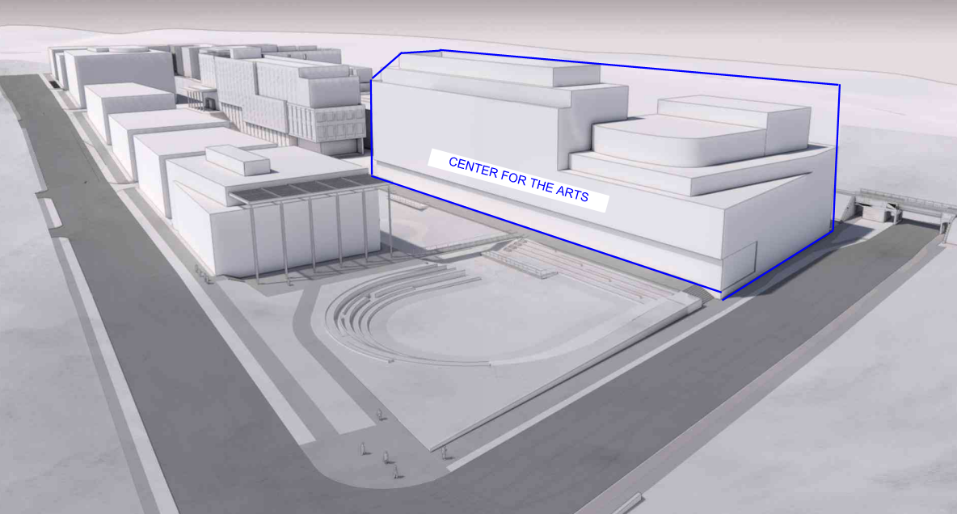

Center for the Arts massing study.

Special Considerations:

The project may be impacted by adjacent non-University projects. The City has plans for a Smart Scale Project on Emmet Street and a private developer has plans to build a hotel across from the site on Emmett Street. The site is tightly constrained with new facilities and fresh landscape development including a pond, bridges, and a promenade. There is limited road access on three sides of the building. There is heavy pedestrian activity in the area due to an adjacent commuter garage. Laydown areas adjacent to the site is severely constrained.

Submittal Information:

The University is interested in demonstrated experience in the management of similar projects within a university setting. Examples of previous work associated with this type of project is important as well as personnel who have had direct participation with these types of projects, and experience working together on project teams. Examples of cost control and scheduling are also important.

Where possible, all materials submitted should be fully recyclable. Submissions should be collated, on standard letter-sized paper and preferably clipped together without binding. To conserve paper, double sided printing is strongly encouraged.

Submittals will be evaluated, and a short-list of firms selected. The selection of short-listed firms will be based on demonstrated qualifications in projects of this type, ability to meet the proposed schedules, the quality and experience of the proposed team, the firm’s plan for involvement of SWaM firms, experience with the University of Virginia Capital Outlay System, project safety record (not the firm), and other criteria as the selection committee may determine appropriate. Only firms licensed to do business in Virginia will be considered. The short-listed firms will be issued a detailed scope of work/ request for proposal and invited to present a more detailed proposal and oral presentation of their qualifications and experience.

One (1) hardcopy original and an electronic version (e.g., thumb drive) of the Letters of Interest/ Statements of Qualifications must be submitted by close of business (nominally 4:00 PM) on May 30, 2024 to the attention of:

George Cullen, Contract Administrator for Construction
Facilities Management Department – Capital Construction & Renovations
University of Virginia, 1571 Pratt Drive, FM Shop #2, Charlottesville, VA 22904

Requests for Proposals (RFPs) will be issued on or about June 11, 2024 to short-listed firms only. RFP responses must be received no later than close of business (nominally 4:00 PM) on July 11, 2024. A non-mandatory pre-proposal conference, for the short-listed firms only, will be held virtually on a date and time to be determined.

Selected firms will be required to register in eVA (the Governor’s electronic procurement web site, https://eva.virginia.gov) prior to the deadline for submission of responses to the RFP to be eligible for the award of the contract. Company’s own status and/or proposed use of Small, Women-owned, Minority-owned, Micro, Service-Disabled Veteran, Employment Service Organization, 8(a), Economically Disadvantaged Woman-owned Small Business, Woman-owned Small Business, and Federal Service-Disabled Veteran-owned (SWaM) firms will be considered in the evaluation of proposals. SWaM firms must be registered with the Virginia Department of Small Business and Supplier Diversity (SBSD) in Richmond for verification and consideration. Quarterly reporting of expenditures to SWaM firms will be required for the selected contractor.

Questions may be directed to George Cullen at gec2n@virginia.edu.

The Rector and Visitors of The University of Virginia
By: George Cullen, Contract Administrator for Construction

