The University of Virginia (University or UVA) invites highly qualified Architectural/ Engineering (A/E) firms to submit a Letter of Interest/Statement of Qualifications and associated supporting materials for consideration in the selection of a consultant team to provide programming, planning, architectural, and engineering design services for the design and construction of the Fontaine Data Center at UVA’s Fontaine Research Park (Fontaine), in accordance with the latest version of the UVA Higher Education Capital Outlay Manual (HECOM). The first phase of the project will be pre-design. Upon successful completion of the pre-design effort, the University may in its sole discretion elect to retain the selected firm for full design and construction services for any or all phases of the future project.

Purpose and Program Background:

In 2022, the University charged the High-Performance Computing Infrastructure Committee (HPC-IC) to project research computing needs and the infrastructure necessary to support those needs over the next 5-10 years. The HPC-IC had considerable conversation about the importance of a solid, leading edge HPC infrastructure. It serves as the foundation for a robust research program, aligns us with our peers, and enables us to become competitive both for the faculty we can recruit and the research we can perform.

The committee looked at many options to expand the existing data center capacity to meet the growth needs and recommended a new data center in the Fontaine Research Park with the expectation that it will be operational in 2026.

Project Drivers:

The University currently operates 2 data centers, the University Data Center (UDC), which opened in 2011, and the Carruthers Data Center (remodeled in 2014). Both facilities provide back-up power capabilities and air-cooled racks, which have reasonable power and cooling for historical and current data center needs. Given the current growth of HPC, the UDC is expected to reach its UPS (Uninterruptable Power Supply) and cooling capacity in 2024. In addition to capacity constraints, the UDC in its current design will not support the more modern, higher power rack density for newer HPC machines.

The proposed new facility is assumed to accommodate 8MW with an initial computing capacity of 2MW (Tier II resiliency). A future expansion should be planned to include an additional 8MW (16MW total). In addition, the building and associated infrastructure shall:

- Ensure that appropriate information security and regulatory compliance requirements are met.
- Consider University sustainability goals and how synergies may be exploited.
- Be cost effective, both initial capital or up-front costs as well as lifecycle maintenance, update of hardware, and leasing/ licensing costs.

Project Status:

This Request for Qualifications follows the Project approval by the UVA Board of Visitors at their June 2023 meeting. Pre-design is expected to start this fiscal year and a detailed project program and site analysis scheduled to be completed by this fall.

Project Site:

The proposed site for the Fontaine Data Center is located at the southeast corner of the Fontaine Research Park adjacent to a new Central Energy Plant currently in design. Fontaine has been identified by two major integrated space planning efforts as the primary University site to develop translational research and the infrastructure necessary to support future development.

Qualifications:

The selected firm will have a proven history of design excellence, with a demonstrated ability to bring ideas, expertise, and imagination to a complex building project. The design team must demonstrate considerable experience in the planning, programming, designing, documenting, and construction administration of projects of comparable scale and complexity in an academic setting. Experience in obtaining LEED certification and familiarity with HECOM will be required.

Selection Process Schedule:

- RFQ Advertised………… | June 11, 2023
- Response Deadline……. | July 6, 2023 by 4:00 pm**
- Shortlist Notified………. | July 19, 2023
- RFPs Issued ………….... | July 21, 2023
- Preproposal Site Visit…. | TBD
- Proposal Deadline………. | August 16, 2023, by 4:00 pm**
- Interviews………………... | August 23, 2023
** The University will not accept late submissions for any reason.

Submittal Requirements and Process:

Submitted material shall be electronic format only. Interested firms may send one (1) thumb drive containing your submittal in PDF format, OR an email containing the submittal if size permits OR send a link to a file storage system. The digital copy should be one PDF file of the entire submission. The submittal is to include the following:

- Letter of Interest addressed to the Selection Committee that is no longer than two (2) pages in length, and which states specifically the firm’s successful experience in planning and designing very similar facilities in campus and/or other similar settings.
- Statement of Qualifications using the Office of Contract Administration Services (OCAS) standard form which the firm can obtain from the OCAS website at:

https://www.fm.virginia.edu/docs/fpc/contractadmin/SOQ-form.pdf.

The email address provided should be for the person who will receive information regarding this RFQ, no general firm or marketing emails please.
- Representative images of the projects listed under “Recent Project Experience” in the Statement of Qualifications.
- Standard forms AE-1 through AE-6 which are available at:

https://dgs.virginia.gov/globalassets/business-units/bcom/documents/forms/dgs-30-004_03-19_ae_data_forms.xlsx

If proposal is a joint venture or association or two or more firms, UVA requires forms AE-1 through AE-6 for each firm, with the proposed division of A/E services clearly indicated by firm and by individual staff members.
- Firms can list Subconsultants on the AE-1 or firms can submit an AE-2 for them, but firms should not submit any other AE forms for Subconsultants at this time.
- Current references and current contact information for each project (five-project minimum) featured in AE forms above. Include contact information for an Owner’s Representative, a User Client, and a Construction Manager (CM) for each project.

Submittals will be evaluated based on the demonstrated significant experience of the firm and its proposed personnel with similar facilities and projects within an academic setting; the ability to meet specific Project objectives, e.g., budget, schedule, quality, etc.; successful experience with HECOM; experience in design with CM/ Subcontractor participation; experience with completion of sequential trade packages for construction; and other criteria as the Screening Committee may determine. Subsequently, the shortlisted firms will receive a detailed Request for Proposal (RFP) and the University will invite them to present a more detailed response and make an oral presentation.

The University must receive the above submission materials according to the schedule above at the following address:

University of Virginia
Capital Construction & Renovations, Office of Contract Administration Services
Attention: Bruce Jackson
1450 Leake Drive, Lower Level
Charlottesville, VA 22904
Mailing address:
P.O. Box 400735
Charlottesville, VA 22904-4735

Questions: 434-924-6387or brj2n@virginia.edu

Please do not contact the Project Manager or others at the University regarding this Project. Firms should submit all questions and correspondence regarding this procurement through Bruce Jackson in the Office of Contract Administration Services.

A copy of this Request for Qualifications is available on the Capital Construction & Renovations, Office of Contract Administration Services website at:

https://www.fm.virginia.edu/depts/fpc/contractadmin/advertisements.html

The University will require the successful firm to have a license to do business in Virginia and be able to demonstrate professional registration.

eVA Business to Government Vendor Registration:

The eVA Internet electronic procurement solution, web site portal https://www.eva.virginia.gov/, is the Commonwealth of Virginia’s comprehensive electronic procurement system. The portal is the gateway for firms to conduct business with state agencies and public bodies. The State expects all agencies and public bodies to use eVA. The State encourages all firms desiring to provide goods and/or services in the Commonwealth to participate in the eVA Internet e-procurement solution. The University requires selected firms to register in the eVA Internet e-procurement solution prior to the University making an award.

The University will consider the firm’s past and proposed participation by “SWaM” firms in the evaluation of proposals including Minority-Owned (M), Women-Owned (W), Micro (O), Service-Disabled Veteran (SDV), Small Business (S), Employment Service Organization (ESO), (8a), Economically Disadvantaged Woman Owned Small Business (EDWOSB), and Federal Service-Disabled Veteran (FSDV) Businesses. SWaM firms must register with and obtain certification from the Department of Small Business & Supplier Diversity (SBSD) in Richmond. Assistance is available for registration. The University requires quarterly reporting of expenditures to SWaM consulting firms or suppliers used in this contract by the selected firms.

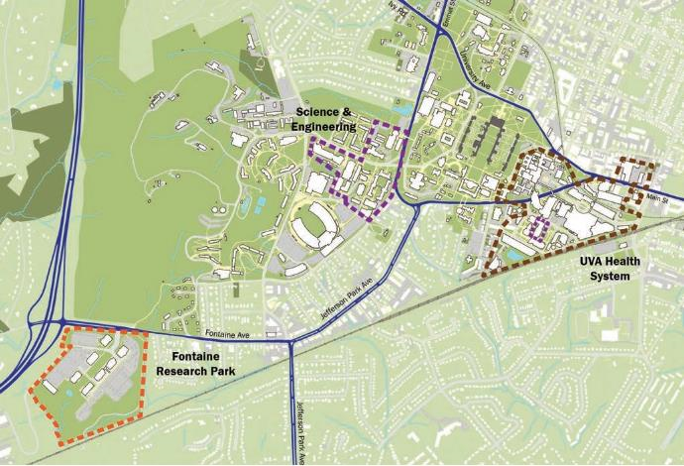
Fontaine Research Park Context

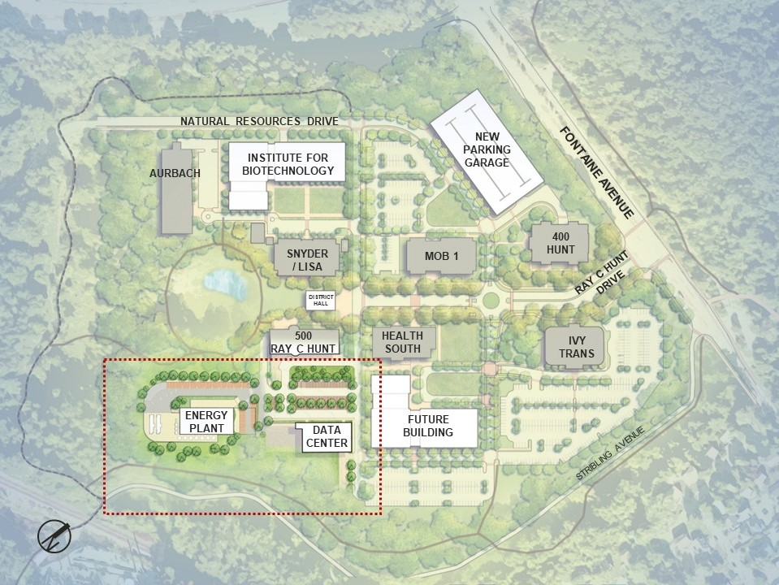
Fontaine Research Park Near-Term Master Plan with proposed site for the Data Center

