The University of Virginia (University or UVA) invites highly qualified Architectural/ Engineering (A/E) firms to submit a Letter of Interest/ Statement of Qualifications and associated supporting materials for consideration in the selection of a consultant team to provide clinical programming, planning, architectural, and engineering design services for a programming study of the University Hospital South Tower Shell Floors 6-8 Fit-out in accordance with the latest version of the UVA Higher Education Capital Outlay Manual (HECOM). The first phase of the project will be a programming study. Upon successful completion of the study, the University may in its sole discretion elect to retain the selected firm for full design and construction services for any or all phases of the future project.

Purpose & Program Background:

The University Hospital, originally designed and constructed in the late 1980s, is a part of the UVA Medical Center complex, which includes a Level 1 trauma center, 696 inpatient beds, the UVA Children's Hospital, the Emily Couric Cancer Center, the Charles Strickler Transplant Center, and more than 100 primary and specialty care clinics with over 1 million visits each year (see Appendix A images). During the last ten years, the UVA Medical Center has made major investments in critical infrastructure systems supporting the UVA Hospital, including the recent addition of the South Tower. Completed in 2020, the new 440,000-square-foot bed tower includes 84 private patient rooms with the capacity to accommodate 84 additional beds in the future.

The UVA Children’s Hospital is ranked number one in the State and provides a full range of pediatric and high risk maternal fetal care to the region. UVA’s excellent standing in the State has resulted in an ever-increasing demand being placed on a fixed number of pediatric intensive care and neonatal intensive care inpatient beds. Two of the three shell floors in the South Tower are being targeted to provide additional neonatal and pediatric inpatient capacity while the third is likely to be developed for adult intensive care use. The programming study will look at the highest and best use of the capacity afforded by the shell floor fit-out as well as options for retrofitting existing pediatric inpatient space on the 7th floor of University Hospital. A review of best practices for pediatric and neonatal inpatient care delivery models from across the country will be a significant design input. The resultant findings will provide a road map for expanding pediatric inpatient care at UVA across the full spectrum of patient care acuity levels and provide relief for adult intensive care bed capacity constraints.

Project Drivers:

The initial phase of this Project will focus on developing and evaluating options, schedule, and budget to fit-out floors 6-8 of the University Hospital South Tower as well as a broader evaluation of the pediatric inpatient platform on the 7th floor of University Hospital. Key considerations include constructability options that minimize disruption to the hospital’s operations through well analyzed phasing and deep understanding of current bed utilization throughout the impacted areas. Development of a logistics plan that balances inpatient bed availability with construction efficiency and schedule. Prioritization will be given to neonatal beds both during the construction phase and at completion to align with institutional needs to serve this unique patient population. Analysis of mechanical systems both in place and necessary to support the fit-out of the South Tower shell floors will be undertaken with key recommendations incorporated into the final plans.

The current initial scope of work for the A/E firm in coordination with the Owners Representative includes the following:

- NICU Clinical Operations Study
- Project Program & Program Verification
  - Floor 6 or 8 is assumed to be like existing occupied floors (Accuity Adaptable patient rooms)
  - Floor 7’s program is assumed to be a NICU Unit
  - Remaining floor will explore an option to maximize number of inpatient beds and program requirements.
- Development of NICU/ PICU Master Plan to include 7th- floor expansion space in South Tower and existing NICU/ PICU unit in West Tower
- Medical Planning Test-Fits for floors 6-8
- Preliminary Phasing Studies to inform cost and schedule duration of options evaluated (assuming development of 2-3 options)
- Engineering Studies to identify systems required for fit-out (including narratives and diagrams to inform cost and schedule impact)
- Typical Room Medical Equipment planning service required for fit-out (including medical equipment list and conceptual cost)
- Cost Estimating Services to establish Construction Cost Estimates for fit-out.
- Meetings/ Presentations:
  - Steering Committee
  - Focus Groups
  - Working Group
  - Additional Ad-hoc Meetings as Necessary

Criteria in Support of Strategic Plan:

This Project is in direct support of the University’s tripartite mission of education, research, and patient care by ensuring that the UVA Hospital will continue to provide the highest quality of care well into the future. In addition, the Project continues the Medical Center’s multi-year investments in the Hospital, with a comprehensive infrastructure renovation and investments in clinical support functions such as imaging, pharmacy, and a new clinical laboratory. These investments are supportive of the goals of increasing patient volumes and providing the highest levels of tertiary and quaternary care possible in today’s rapidly evolving health care environment.

Project Status:

This Request for Qualifications follows the Board of Visitors June 2023 approval of the Project’s study phase to develop a detailed Project program with the intent of fully identifying scope, budget and schedule for the design and construction phases of the proposed Project.

Project Site:

The University Hospital sits at the center of UVA’s Health precinct directly adjacent to ambulatory care and medical research buildings. The Hospital is within the University’s Central Grounds and east of the UVA Lawn and World Heritage site.

Qualifications:

The selected firm will have a proven record of design excellence, with a demonstrated ability to bring ideas, expertise, and imagination to a complex building project. The selected Architect and Engineering design team must demonstrate significant healthcare experience.

The selected design firm will need to be a partner in the envisioning of this Project, bring expertise in programming and planning healthcare facilities, have experience in evaluating inpatient and outpatient throughput, and planning for projected volume and workflow efficiency.

The selected firm must also be a leader in sustainable design practices and have experience with LEED for Healthcare.

As always, the ability to document and manage the process to deliver a project on an aggressive schedule and within budget is essential. The University expects experience in obtaining LEED certification and the ability to comply with HECOM procedures.

Selection Process Schedule:

- RFQ Advertised………… | December 3, 2023
- Response Deadline……. | January 12, 2024 by 4:00 pm**
- Shortlist Notified………. | January 26, 2024
- RFPs Issued ………….... | January 29, 2024
- Preproposal Site Visit…. | February 8, 2024
- Proposal Deadline………. | February 27, 2024, by 4:00 pm**
- Interviews………………... | March 12, 2024
** The University will not accept late submissions for any reason.

Submittal Requirements & Process:

Submitted material shall be electronic format only. Interested firms may send one (1) thumb drive containing your submittal in PDF format, OR an email containing the submittal if size permits, OR send a link to a file storage system. The digital copy should be one unlocked PDF file of the entire submission. The submittal is to include the following:

- Letter of Interest addressed to the Selection Committee that is no longer than two (2) pages in length, and which states specifically the firm’s successful experience in planning and designing very similar facilities in campus and/or other similar settings.
- Statement of Qualifications using the Office of Contract Administration Services (OCAS) standard form which the firm can obtain from the OCAS website at:

https://www.fm.virginia.edu/docs/fpc/contractadmin/SOQ-form.pdf.

The email address provided should be for the person who will receive information regarding this RFQ. No general firm or marketing emails please.
- Representative images of the projects listed under “Recent Project Experience” in the Statement of Qualifications.
- Standard forms AE-1 through AE-6 which are available at:

https://dgs.virginia.gov/globalassets/business-units/bcom/documents/forms/dgs-30-004_03-19_ae_data_forms.xlsx

If proposal is a joint venture or association or two or more firms, UVA requires forms AE-1 through AE-6 for each firm, with the proposed division of A/E services clearly indicated by firm and by individual staff members.
- Firms can list Subconsultants on the AE-1 or firms can submit an AE-2 for them, but firms should not submit any other AE forms for Subconsultants at this time.
- Current references and current contact information for each project (five-project minimum) featured in AE forms above. Include contact information for an Owner’s Representative, a User Client, and a Construction Manager (CM) for each project.

Submittals will be evaluated based on the demonstrated significant experience of the firm and its proposed personnel with similar facilities and projects within a healthcare setting; the ability to meet specific Project objectives, e.g., budget, schedule, quality, etc.; successful experience with HECOM; experience in design with CM/ Subcontractor participation; experience with completion of sequential trade packages for construction; and other criteria as the Screening Committee may determine. Subsequently, the shortlisted firms will receive a detailed Request for Proposal (RFP) and the University will invite them to present a more detailed response and make an oral presentation.

The University must receive the above submission materials according to the schedule above at the following address:

University of Virginia
Capital Construction & Renovations, Office of Contract Administration Services
Attention: Bruce Jackson
1571 Pratt Drive, Facilities Management Shop #2
Charlottesville, VA 22904
Mailing address:
P.O. Box 400735
Charlottesville, VA 22904-4735

Questions: 434-924-6387or brj2n@virginia.edu

Please do not contact the Project Manager or others at the University regarding this Project. Firms should submit all questions and correspondence regarding this procurement through Bruce Jackson in the Office of Contract Administration Services.

A copy of this Request for Qualifications is available on the Capital Construction & Renovations, Office of Contract Administration Services website at:

https://www.fm.virginia.edu/depts/fpc/contractadmin/advertisements.html

The University will require the successful firm to have a license to do business in Virginia and be able to demonstrate professional registration.

eVA Business to Government Vendor Registration:

The eVA Internet electronic procurement solution, web site portal https://www.eva.virginia.gov/, is the Commonwealth of Virginia’s comprehensive electronic procurement system. The portal is the gateway for firms to conduct business with state agencies and public bodies. The State expects all agencies and public bodies to use eVA. The State encourages all firms desiring to provide goods and/or services in the Commonwealth to participate in eVA. The University requires selected firms to register in eVA prior to the University making an award.

The University will consider the firm’s past and proposed participation by “SWaM” firms in the evaluation of proposals including Minority-Owned (M), Women-Owned (W), Micro (O), Service-Disabled Veteran (SDV), Small Business (S), Employment Service Organization (ESO), (8a), Economically Disadvantaged Woman Owned Small Business (EDWOSB), and Federal Service-Disabled Veteran (FSDV) Businesses. SWaM firms must register with and obtain certification from the Department of Small Business & Supplier Diversity (SBSD) in Richmond. Assistance is available for registration. The University requires quarterly reporting of expenditures to SWaM consulting firms or suppliers used in this contract by the selected firms.

Appendix A

Image 1: Proximity map showing the location of the hospital in relation to Central Grounds.

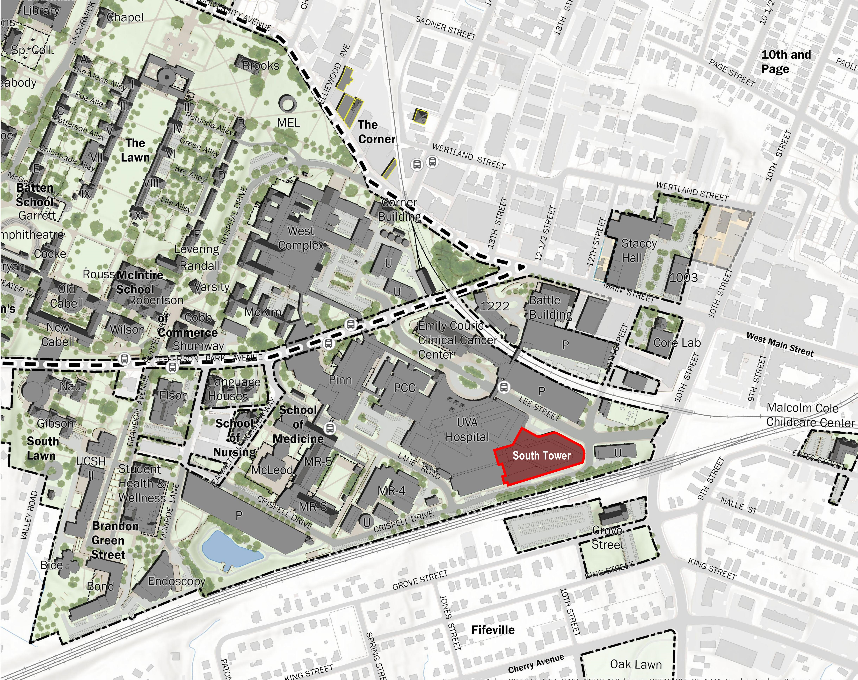

Image 2: Overall view of the hospital looking south.

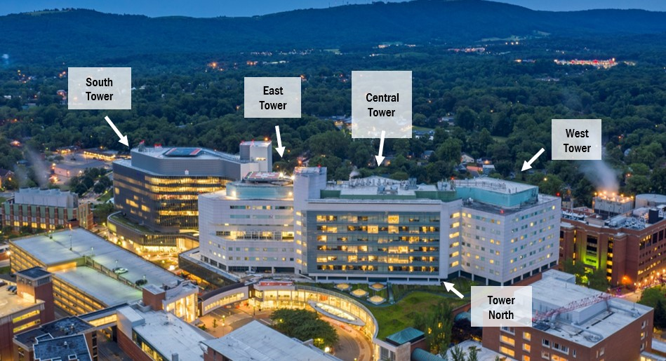

Image 3: Overall view of the hospital from the southeast, overlooking Crispell Drive.

Image 4: 28-bed ICU floorplan which is typical for floors 3-5 of South Tower. Floors 6-8 (which are the basis for the programming study) have the same exterior footprint without the interior partitions.

