The University of Virginia (University or UVA) invites highly qualified Owner’s Representative (OR) firms to submit a Letter of Interest/ Statement of Qualifications and associated supporting materials for consideration in the selection of a firm to provide OR services for the University Hospital South Tower Shell Floors 6-8 Fit-out in accordance with the latest version of the UVA Higher Education Capital Outlay Manual (HECOM). The scope of services will include participation in the selection of the A/E firm; planning, programming, and design; selection of the Construction Management firm; construction; and commissioning and turnover. The Owner or Owner’s Architect/ Engineer (A/E), Consultants, and Construction Manager (CM) will hold all Project contracts, and the Owner will make payment according to the terms of any such contracts.

UVA will hold the A/E and CM contracts and will provide full project management services.

Purpose & Program Background:

The University Hospital, originally designed and constructed in the late 1980s, is a part of the UVA Medical Center complex, which includes a Level 1 trauma center, 696 inpatient beds, the UVA Children's Hospital, the Emily Couric Cancer Center, the Charles Strickler Transplant Center, and more than 100 primary and specialty care clinics with over 1 million visits each year (see Appendix A images). During the last ten years, the UVA Medical Center has made major investments in critical infrastructure systems supporting the UVA Hospital, including the recent addition of the South Tower. Completed in 2020, the new 440,000-square-foot bed tower includes 84 private patient rooms with the capacity to accommodate 84 additional beds in the future.

Project Drivers:

The initial phase of this Project will focus on developing and evaluating options, schedule, and budget to fit-out floors 6-8 of the University Hospital South Tower. Key considerations include constructability options that minimize disruption to the hospital’s operations.

The current initial scope of work for the A/E firm in coordination with the OR includes the following:

- NICU Clinical Operations Study
- Project Program & Program Verification
  - Floor 6 or 8 is assumed to be like existing occupied floors (Accuity Adaptable patient rooms)
  - Floor 7’s program is assumed to be a NICU Unit
  - Remaining floor will explore an option to maximize number of inpatient beds and program requirements.
- Development of NICU/ PICU Master Plan to include 7th- floor expansion space in South Tower and existing NICU/ PICU unit in West Tower
- Medical Planning Test-Fits for floors 6-8
- Preliminary Phasing Studies to inform cost and schedule duration of options evaluated (assuming development of 2-3 options)
- Engineering Studies to identify systems required for fit-out (including narratives and diagrams to inform cost and schedule impact)
- Typical Room Medical Equipment planning service required for fit-out (including medical equipment list and conceptual cost)
- Cost Estimating Services to establish Construction Cost Estimates for fit-out.

- Meetings/ Presentations:
  - Steering Committee
  - Focus Groups
  - Working Group
  - Additional Ad-hoc Meetings as Necessary

Criteria in Support of the Strategic Plan:

This Project is in direct support of the University’s tripartite mission of education, research, and patient care by ensuring that the UVA Hospital will continue to provide the highest quality of care well into the future. In addition, the Project continues the Medical Center’s multi-year investments in the Hospital, with a comprehensive infrastructure renovation and investments in clinical support functions such as imaging, pharmacy, and a new clinical laboratory. These investments are supportive of the goals of increasing patient volumes and providing the highest levels of tertiary and quaternary care possible in today’s rapidly evolving health care environment.

Project Status:

This Request for Qualifications follows the Board of Visitors June approval of the Project’s study phase to develop a detailed Project program with the intent of fully identifying scope, budget, and schedule for the design and construction phases of the proposed Project.

Project Site:

The University Hospital sits at the center of UVA’s Health precinct directly adjacent to ambulatory care and medical research buildings. The Hospital is within the University’s Central Grounds and east of the UVA Lawn and World Heritage site.

Qualifications:

The selected OR will possess the following key qualifications and attributes:

- Expertise & Experience – We require a candidate with extensive knowledge and experience in healthcare construction management. The ideal representative should be well-versed in the intricacies of the construction process, including planning, design, procurement, and construction methods. UVA will give preference to candidates with previous experience in the build-out of ICU, NICU, and Oncology beds.

- Project Oversight – The OR must demonstrate the ability to standardize templates, reports, dashboards, and budgets to provide comprehensive oversight of the Project. They should possess a proven track record in monitoring progress, schedules, and reviewing project documentation to ensure strict compliance with specifications, regulations, and industry standards. Their oversight should be characterized by the production of crisp reports designed to minimize delays, manage cost overruns, and identify potential conflicts while ensuring the Project stays on schedule.
- Cost Control – The ideal candidate should have a strong background in monitoring the Project budget. They should be adept at working closely with the Owner to establish a realistic budget, evaluating changes in the work, and identifying potential cost-saving opportunities. Their expertise should effectively maximize the Project's investment and minimize unnecessary expenses, ultimately ensuring the Project remains on budget through completion.

- Communication & Coordination – We require a representative capable of seamlessly coordinating the efforts of numerous stakeholders, including architects, engineers, contractors, and subcontractors. They should serve as a central point of contact, facilitating effective communication and collaboration among all parties involved. The ability to streamline the decision-making process, maintain transparency, and efficiently resolve any conflicts that may arise during construction is essential.

- Innovation & Best Practices – The OR should be well-versed in advising on and maintaining national best practices. They should ensure that the Project consistently meets quality standards and aligns with specification goals and industry best practices.

- Consensus Building – A strong background in building consensus within a healthcare setting to reduce change order requests is crucial. The selected candidate should have the expertise to thoroughly evaluate and approve change orders, striking a balance between necessary modifications and cost containment.

Selection Process Schedule:

- RFQ Advertised………… | November 6, 2023
- Response Deadline……. | November 17, 2023, by 4:00 pm**
- Shortlist Meeting………. | TBD
- RFP Issued ………….... | TBD
- Preproposal Site Visit…. | TBD
- Proposal Deadline………. | TBD, by 4:00 pm**
- Interviews………………... | TBD
** The University will not accept late submissions for any reason.

Submittal Requirements & Process:

Submitted material shall be electronic format only. Interested firms may send one (1) thumb drive containing your submittal in PDF format, or an email containing the submittal if size permits, or send a link to a file storage system. The digital copy should be one unlocked PDF file of the entire submission. The submittal is to include the following:

- Letter of Interest addressed to the Selection Committee that is no longer than two (2) pages in length, and which states specifically the firm’s successful experience in providing OR services for very similar facilities in hospital and/or other similar settings.
- Statement of Qualifications using the Office of Contract Administration Services (OCAS) standard form which the firm can obtain from the OCAS website at:

https://www.fm.virginia.edu/docs/fpc/contractadmin/SOQ-form.pdf.

The email address provided should be for the person who will receive information regarding this RFQ – no general firm or marketing emails please.

- Standard forms AE-1 through AE-6 which are available at:

https://dgs.virginia.gov/globalassets/business-units/bcom/documents/forms/dgs-30-004_03-19_ae_data_forms.xlsx

If proposal will be a joint venture or association of two or more firms, UVA requires forms AE-1 through AE-6 for each firm, with the proposed division of OR services clearly indicated by firm and by individual staff members.
- Representative images of the projects listed under “Representative Project Data” in the AE-5.
- Current references and current contact information for each project listed under “Representative Project Data” in the AE-5. Include contact information for an Architect/ Engineer (A/E), a User Client, and a Construction Manager (CM) for each project.

Submittals will be evaluated based on the demonstrated significant experience of the firm and its proposed personnel with similar facilities and projects within a healthcare setting; the ability to meet specific project objectives, e.g., budget, schedule, quality, etc.; experience in design with CM/ Subcontractor participation; experience with completion of sequential trade packages for construction; and other criteria as the Selection Committee may determine. Subsequently, the shortlisted firms will receive a detailed Request for Proposal (RFP) and the University will invite them to present a more detailed response and make an oral presentation.

The University must receive the above submission materials according to the schedule above at the following address:

University of Virginia
Capital Construction & Renovations, Office of Contract Administration Services
Attention: Bruce Jackson
1571 Pratt Drive, Facilities Management Shop #2
Charlottesville, VA 22904
Mailing address:
P.O. Box 400735
Charlottesville, VA 22904-4735

Questions: 434-924-6387or brj2n@virginia.edu

Please do not contact the Project Manager or others at the University regarding this Project. Firms should submit all questions and correspondence regarding this procurement through Bruce Jackson in the Office of Contract Administration Services.

A copy of this Request for Qualifications is available on the Capital Construction & Renovations, Office of Contract Administration Services website at:

https://www.fm.virginia.edu/depts/fpc/contractadmin/advertisements.html

The University will require the successful firm to have a license to do business in Virginia and be able to demonstrate professional registration.

eVA Business to Government Vendor Registration:

The eVA Internet electronic procurement solution, web site portal https://www.eva.virginia.gov/, is the Commonwealth of Virginia’s comprehensive electronic procurement system. The portal is the gateway for firms to conduct business with state agencies and public bodies. The State expects all agencies and public bodies to use eVA. The State encourages all firms desiring to provide goods and/or services in the Commonwealth to participate in eVA. The University requires selected firms to register in eVA prior to the University making an award.

The University will consider the firm’s history and proposed participation by “SWaM” firms in the evaluation of proposals including Minority-Owned (M), Women-Owned (W), Micro (O), Service-Disabled Veteran (SDV), Small Business (S), Employment Service Organization (ESO), (8a), Economically Disadvantaged Woman Owned Small Business (EDWOSB), and Federal Service-Disabled Veteran (FSDV) Businesses. The Department of Small Business & Supplier Diversity (SBSD) in Richmond must register and certify SWaM firms. Assistance is available for registration. The University requires quarterly reporting of expenditures to SWaM consulting firms or suppliers used in this contract by the selected firms.

Appendix A

Image 1: Overall view of the hospital looking south.

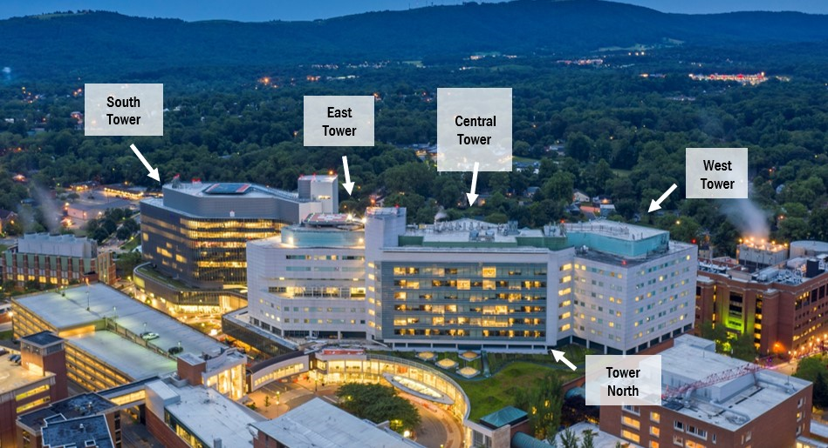
Image 2: Overall view of the hospital from the southeast, overlooking Crispell Drive.

Image 3: 28-bed ICU floorplan which is typical for floors 3-5 of South Tower. Floors 6-8 (which are the basis for the programming study) have the same exterior footprint without the interior partitions.
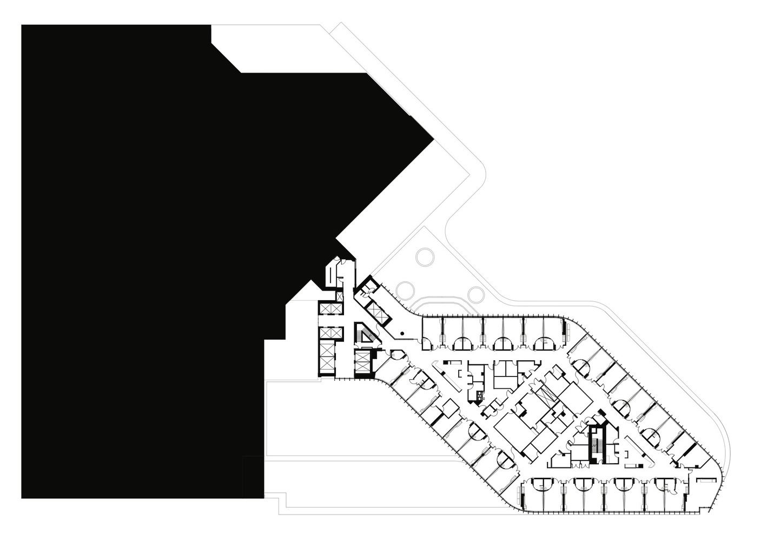

Image 4: Proximity map showing the location of the hospital in relation to Central Grounds.

