The University of Virginia (University or UVA) invites highly qualified Architectural/ Engineering (A/E) firms to submit a Letter of Interest/ Statement of Qualifications and associated supporting materials for consideration in the selection of a consultant team to provide planning services for the Grove Street Corridor site in accordance with the latest version of the UVA Higher Education Capital Outlay Manual (HECOM). The first phase of the project will be a planning study. Upon successful completion of the planning effort, the University may in its sole discretion elect to retain the selected firm for full services for any or all phases of the future project.

Purpose & Program Background:

UVA owns seven parcels along Grove Street, adjacent to the Cherry Avenue Entrance Corridor – the 999 – 1001 parcel (referred to as Site A) and the adjacent 6 parcels of the 900 block of Grove and King (referred to as Site B). The purpose of the planning study is to assess potential program uses of the sites to support UVA Health and the community, and explore potential density, access, and related impacts.

Project Drivers:

The Grove Street sites (A and B), are designated redevelopment zones based on the 2023 Grounds Framework Plan. Redevelopment zones provide for potential growth and were designated based on their location, size, and potential opportunities to contribute to the University at large. UVA has established a practice of studying redevelopment zones with detailed planning studies to understand the opportunities and challenges of the site(s). Since these sites are on the southern edge of Grounds, an important aspect of this planning study will be neighborhood engagement with the Fifeville community early in the process of developing the study. Another important aspect will be the consideration of program options for the site(s), and are likely to include neighborhood clinics, housing, childcare, community uses and parking in a mixed-use format, although other options will be considered. The proposed zoning for this area is campus (CM), with no overlays and the density is unlimited. Site A is between the railroad tracks and Grove Street, and Site B is between Grove Street and King Street. Both sites have frontage along Roosevelt Brown Boulevard.

Project Status:

The Grove Street planning study is expected to commence in Fall of 2023 and have initial study results by the end of the year.

Project Sites:

The project sites include seven parcels along Grove Street, adjacent to the Cherry Avenue Entrance Corridor – the 999 – 1001 parcel (referred to as Site A) and the adjacent 6 parcels of the 900 block of Grove and King (referred to as Site B). Site A is 1.97 acres and 85,744 square feet, and Site B is 1.13 acres and 49,117 square feet. The zoning in the general context includes corridor-mixed use and low density residential. Both sites have frontage along Roosevelt Brown Boulevard, which is a busy City arterial that connects with Cherry Street leading to Fifth Street to the southeast and West Main Street to the north. Please see existing conditions on page 4 for additional detail and maps of the site.

Qualifications:

The selected firm will have a proven history of design excellence, with a demonstrated ability to bring ideas, expertise, and imagination to a detailed planning study. The design team must demonstrate considerable experience in the planning, programming, designing, documenting, and construction administration of projects of comparable scale and complexity in an academic setting. Experience in obtaining LEED certification and familiarity with HECOM will be required.

Selection Process Schedule:

- RFQ Advertised………… | October 29, 2023
- Response Deadline……. | November 27, 2023 by 4:00 pm**
- Shortlist Meeting………. | December 11, 2023
- RFPs Issued ………….... | December 12, 2023
- Preproposal Site Visit…. | TBD
- Proposal Deadline………. | January 22, 2024, by 4:00 pm**
- Interviews………………... | February 1, 2024
** The University will not accept late submissions for any reason.

Submittal Requirements and Process:

Submitted material shall be electronic format only. Interested firms may send one (1) thumb drive containing your submittal in PDF format, OR an email containing the submittal if size permits, OR send a link to a file storage system. The digital copy should be one unlocked PDF file of the entire submission. The submittal is to include the following:

- Letter of Interest addressed to the Selection Committee that is no longer than two (2) pages in length, and which states specifically the firm’s successful experience in planning and designing very similar facilities in campus and/or other similar settings.
- Statement of Qualifications using the Office of Contract Administration Services (OCAS) standard form which the firm can obtain from the OCAS website at:

https://www.fm.virginia.edu/docs/fpc/contractadmin/SOQ-form.pdf.

The email address provided should be for the person who will receive information regarding this RFQ – no general firm or marketing emails please.
- Representative images of the projects listed under “Recent Project Experience” in the Statement of Qualifications.
- Standard forms AE-1 through AE-6 which are available at:

https://dgs.virginia.gov/globalassets/business-units/bcom/documents/forms/dgs-30-004_03-19_ae_data_forms.xlsx

If proposal is a joint venture or association or two or more firms, UVA requires forms AE-1 through AE-6 for each firm, with the proposed division of A/E services clearly indicated by firm and by individual staff members.
- Firms can list Subconsultants on the AE-1 or firms can submit an AE-2 for them, but firms should not submit any other AE forms for Subconsultants at this time.
- Current references and current contact information for each project (five-project minimum) featured in AE forms above. Include contact information for an Owner’s Representative, a User Client, and a Construction Manager (CM) for each project.

Submittals will be evaluated based on the demonstrated significant experience of the firm and its proposed personnel with similar facilities and projects within an academic setting; the ability to meet specific Project objectives, e.g., budget, schedule, quality, etc.; successful experience with HECOM; experience in design with CM/ Subcontractor participation; experience with completion of sequential trade packages for construction; and other criteria as the Selection Committee may determine. Subsequently, the shortlisted firms will receive a detailed Request for Proposal (RFP) and the University will invite them to present a more detailed response and make an oral presentation.
The University must receive the above submission materials according to the schedule above at the following address:

University of Virginia
Capital Construction & Renovations, Office of Contract Administration Services
Attention: Bruce Jackson
1571 Pratt Drive, Facilities Management Shop #2
Charlottesville, VA 22904
Mailing address:
P.O. Box 400735
Charlottesville, VA 22904-4735

Questions: 434-924-6387or brj2n@virginia.edu

Please do not contact the Project Manager or others at the University regarding this Project. Firms should submit all questions and correspondence regarding this procurement through Bruce Jackson in the Office of Contract Administration Services.

A copy of this Request for Qualifications is available on the Capital Construction & Renovations, Office of Contract Administration Services website at:

https://www.fm.virginia.edu/depts/fpc/contractadmin/advertisements.html

The University will require the successful firm to have a license to do business in Virginia and be able to demonstrate professional registration.

eVA Business to Government Vendor Registration:

The eVA Internet electronic procurement solution, website portal https://www.eva.virginia.gov/, is the Commonwealth of Virginia’s comprehensive electronic procurement system. The portal is the gateway for firms to conduct business with state agencies and public bodies. The State expects all agencies and public bodies to use eVA. The State encourages all firms desiring to provide goods and/or services in the Commonwealth to participate in the eVA Internet e-procurement solution. The University requires selected firms to register in eVA prior to the University making an award.

The University will consider the firm’s history and proposed participation by “SWaM” firms in the evaluation of proposals including Minority-Owned (M), Women-Owned (W), Micro (O), Service-Disabled Veteran (SDV), Small Business (S), Employment Service Organization (ESO), (8a), Economically Disadvantaged Woman Owned Small Business (EDWOSB), and Federal Service-Disabled Veteran (FSDV) Businesses. SWaM firms must be registered with and certified by the Department of Small Business & Supplier Diversity (SBSD) in Richmond. Assistance is available for registration. The University requires quarterly reporting of expenditures to SWaM consulting firms or suppliers used in this contract by the selected firms.

Existing Conditions:

Below are maps of the Grove sites in the context of overall UVA Grounds and UVA Health (top), and overall context of Fifeville and the Cherry Street Corridor (bottom).
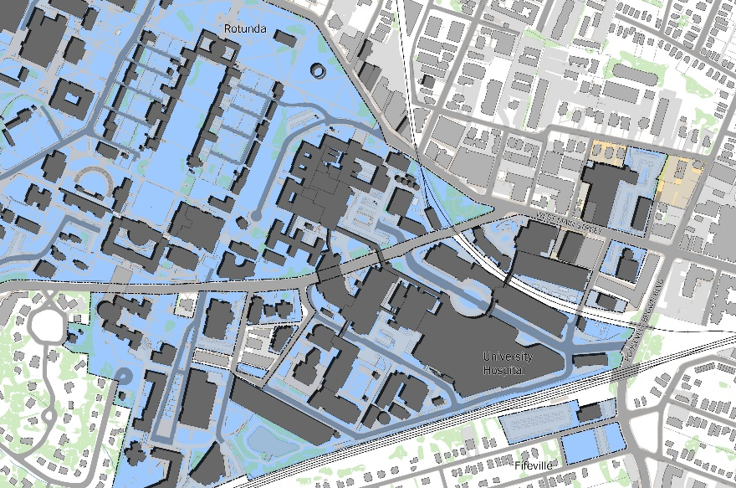
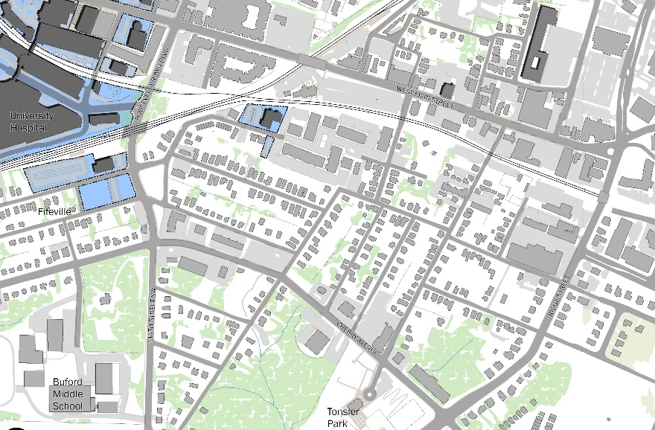
Grove Street sites
Cherry Avenue Corridor
Roosevelt Brown Blvd.
UVA Health
Site B

Site A
Site B

Site A
Fifth Street
UVA Central Grounds

