REQUEST FOR LETTERS OF INTEREST
and Statements of Qualifications

The University of Virginia, Charlottesville, invites highly qualified firms to submit Letters of Interest and Statements of Qualifications along with background information on Form HECO-16 (obtain adapted version from http://www.fm.virginia.edu/depts/fpc/index.html) for construction services related to the:

Karsh Institute of Democracy
&
Ivy Corridor Landscape and Infrastructure Phase 2
RFP #21-103

The University seeks to retain a Construction Manager to join our team during construction document development phase to provide constructability review, scheduling scenarios, logistics coordination, value management, early bid package assistance, full construction services for the University in accordance with the provisions of the University of Virginia Higher Education Capital Outlay Manual and RFP, and any other related services as directed by the University. The University has determined that Competitive Sealed Bidding is not practicable or fiscally advantageous; therefore, the contract will be awarded as a Construction Management at Risk with Design Phase Services as the project delivery method.

Project Overview:

The Karsh Institute of Democracy will be a 4-story 65,000 GSF facility located with the University’s Ivy Corridor development. The facility will include convening spaces for small- and large-scale events, including an auditorium enabled for television broadcast and remote collaboration, conference rooms, reception, and catering areas; spaces for scholarship including research labs and active learning spaces; and informal spaces for study, conversation, and reflection. Media production spaces will be especially important, encouraging faculty and students to speak to the world beyond the University. The facility will include a podcasting studio, video production space, broadcasting capabilities, and other technologies.

The proposed site for the Institute of Democracy Facility is identified as Parcels 3A and 3B in the Emmet Ivy Task Force Report: http://www.officearchitect.virginia.edu/index.php/item/1595-emmet-ivyreport, an important and highly visible site with the building at the terminus of a landscaped public realm.

As outlined in the Emmet Ivy Task Force Report, this building will “bring together neighbors, visitors and scholars from around the region and the world, in physical and virtual gatherings.” The new Hotel and Conference Center and existing Emmet-Ivy parking garage are adjacent to the site, two resources with significant shared use potential. The Karsh Institute of Democracy will host academic and research endeavors as well as public events. The goal is to foster a higher level of collaboration, inviting scholars, speakers, community members, and visitors to engage in conversations around democracy.

In addition to the Karsh facility, the CM will be responsible for redevelopment of Phase 2 of the Ivy Corridor Landscape and Infrastructure project. This scope includes completion of a loop road, grading, site utilities, stormwater infrastructure, surface parking, and site restoration on the 2.3-acre site surrounding the Karsh Institute of Democracy. Demolition of existing buildings will be by others.

Construction is anticipated to begin in Q2 2024 and be completed Q2 2026.

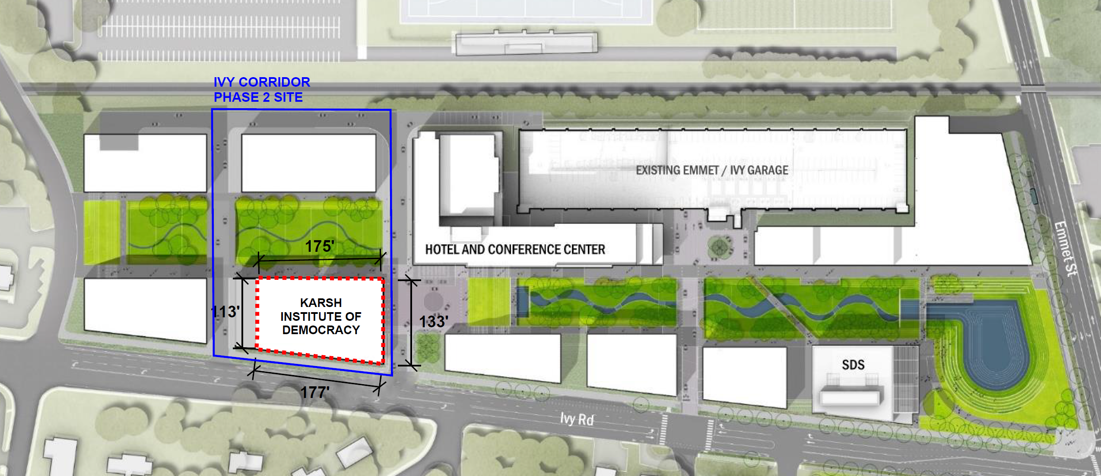

Karsh Institute of Democracy and Ivy Corridor Landscape & Infrastructure Phase 2 Site Plan

Special Considerations:

The project will be surrounded by ongoing construction on adjacent sites at the Hotel and Conference Center and the Ivy Corridor Phase 1 development, with sole access to the construction site off Ivy Road, a busy city street. The concurrent construction of multiple large projects in this area, as well as the need to maintain consistent access to the Emmet/Ivy parking garage will present numerous logistical and coordination related challenges. The CM will assist in coordinating grading/utility, environmental, and transportation activities in this congested area on the Ivy Corridor site.

Submittal Information:

The University is interested in demonstrated experience in the management of similar projects within a university setting. Examples of previous work associated with this type of project is important as well as personnel who have had direct participation with these types of projects, and experience working together on project teams. Examples of cost control and scheduling are also important.

Where possible, all materials submitted should be fully recyclable. Submissions should be collated, on standard letter-sized paper and preferably clipped together without binding. To conserve paper, double sided printing is strongly encouraged.

Submittals will be evaluated, and a short-list of firms selected. The selection of short-listed firms will be based on demonstrated qualifications in projects of this type, ability to meet the proposed schedules, the quality and experience of the proposed team, the firm’s plan for involvement of SWaM firms, experience with the University of Virginia Capital Outlay System, project safety record (not the firm), and other criteria as the selection committee may determine appropriate. Only firms licensed to do business in Virginia will be considered. The short-listed firms will be issued a detailed scope of work/ request for proposal and invited to present a more detailed proposal and oral presentation of their qualifications and experience.

One (1) hardcopy original and an electronic version (e.g., thumb drive) of the Letters of Interest/ Statements of Qualifications must be submitted by close of business (nominally 4:00 PM) on September 14, 2022 to the attention of:

George Cullen, Contract Administrator for Construction
Facilities Management Department – Capital Construction & Renovations
University of Virginia, 1450 Leake Drive, Lower Level, Charlottesville, VA 22904

Requests for Proposals (RFPs) will be issued on or about September 23, 2022 to short-listed firms only. RFP responses must be received no later than close of business (nominally 4:00 PM) on October 20, 2022. A non-mandatory pre-proposal conference, for the short-listed firms only, will be held virtually on a date and time to be determined.

Selected firms will be required to register in eVA (the Governor’s electronic procurement web site, https://eva.virginia.gov) prior to the deadline for submission of responses to the RFP to be eligible for the award of the contract. Company’s own status and/or proposed use of Small, Women-owned, Minority-owned, Micro, Service-Disabled Veteran, Employment Service Organization, 8(a), Economically Disadvantaged Woman-owned Small Business, Woman-owned Small Business, and Federal Service-Disabled Veteran-owned (SWaM) firms will be considered in the evaluation of proposals. SWaM firms must be registered with the Virginia Department of Small Business and Supplier Diversity (SBSD) in Richmond for verification and consideration. Quarterly reporting of expenditures to SWaM firms will be required for the selected contractor.

Questions may be directed to George Cullen at gec2n@virginia.edu.

The Rector and Visitors of The University of Virginia
By: George Cullen, Contract Administrator for Construction

