REQUEST FOR LETTERS OF INTEREST
and Statements of Qualifications

The University of Virginia, Charlottesville, invites highly qualified firms to submit Letters of Interest and Statements of Qualifications along with background information on Form HECO-16 (obtain adapted version from http://www.fm.virginia.edu/depts/fpc/index.html) for the design and construction related to the:

Brandon Avenue Upper Class Student Housing – Phase 2
RFP # 19-103

The University seeks to retain a Design/Build (DB) team for the design and construction for the second phase of upper class student housing along Brandon Avenue in accordance with the provisions of the University of Virginia Higher Education Capital Outlay Manual. The Design Builder will utilize the bridging documents to finish the design (Preliminary Design and Construction Document submissions) as well as provide full construction services. The University has determined that Competitive Sealed Bidding is not practicable or fiscally advantageous; therefore, the contract will be competitively negotiated and awarded as a Design/Build project delivery method.

Project Overview:

The University of Virginia proposes to construct two new residence halls on Brandon Avenue sites B and C, located on the west side of Brandon Avenue in the City of Charlottesville. The project will include approximately 350 student beds in apartment-style arrangements, plus associated social spaces, resident staff accommodations, and support spaces. A 300-seat dining facility will be located on the ground floor of the Site C building. Two levels of podium parking will be included beneath the Site C building.

The student apartments will be based upon a 16-bed apartment, connected over two floors via an internal, interconnecting stair. In order to foster multiple levels of community, the 16-bed apartment will be comprised of two groups of 8 single bedrooms, paired across a common living and dining area, stacked one above the other. Each 8-bed group will be comprised of two 4-bed sub-groups, each with a kitchen plus one full bath and one half bath. The exception to these are the apartments for the resident advisors and senior resident, which will be one-bedroom apartments.

Site B will be six stories in height, with Level 1 consisting of community space including a lobby, common lounge space, and a laundry space. Levels 2-6 consist of residential housing, with approximately four 16-bedroom apartments, two 14-bedroom apartments, two 8-bedroom apartments, one 7-bedroom apartment, and five studio apartments. A total of 120 beds are planned in 67,036 GSF of building area.

Site C will consist of two levels of enclosed parking (Levels P1 & P2), one level of community space including a lobby, dining, common lounge space, laundry, and four levels of residential housing. Approximately thirteen 16-bedroom apartments, one 15-bedroom apartment, one 1-bedroom apartment, and seven studio apartments. A total of 231 beds are planned in 119,578 GSF of building area. Approximately 95 parking spaces are planned in 55,476 GSF of garage area.

The building will employ a palette of brick veneer over metal framing and exterior sheathing with punched aluminum windows, and curtain walls. The roof will be EPDM roofing membrane with primary and secondary drains. See figure 1. The project site will be available in the fall of 2020. The Design Builder will communicate their preferred schedule to meet the substantial completion date of June 2023 but construction is anticipated to begin winter of 2020/2021.

Project Site:

The buildings are to be located on site B and site C of the new Brandon Avenue master plan. These sites are located to the west side of the new Brandon Avenue loop, south of JPA Avenue, west of the new Student Health building, and north of Bice House, and East of South Lawn Gibson Hall.

The project site is tight and the selected design build team will need to create an efficient site logistics plan. The fire access road down to Bice House that splits site C and site B will need to stay open through the duration of the project. The south of site C will be constrained by the Bice House fire access turn around. The University and the selected design build team can review options for occupying portions of Brandon Avenue and the western sidewalk during construction. Access to UVA Grounds for students living in Bice House and Bond House will need to be available throughout construction. See Figure 2.

All adjacent, existing occupied buildings will remain operational during the entire construction time period. The design build firm will participate with the University in determining the scheduling of construction to minimize disruption to the activities of the surround buildings.

Dining Consultant:

The University has collaborated with Tipton Associates for the preliminary design of the dining components located at site C. They have designed multiple dining components on grounds and understand the requirements of the University and Aramark, the University’s food vendor. The selected Design Build team will need to include Tipton Associates in their team to complete this design. A fee proposal for their work will be included in the RFP.

Design Consultants:

Per the Design RFP to provide Bridging Document services, UVA will not consider the Bridging Document A/E team as members of the D/B contract team. The current members of the Bridging Document A/E team will stay on as advisors to the University. These team members are:

Bridging Documents Elkus Manfredi Architects Ltd
Architect: Boston, MA
Landscape Architect: Michael Vergason Landscape Architects, Ltd
Alexandra, VA
MEP Engineer: R.G. Vanderweil Engineers, LLP
Boston, MA
Structural Engineer: Hope Furrer Associates
Towson, MD
Civil Engineer: Dewberry Engineers Inc.
Glen Allen, VA

Submittal Information:

The University is interested in demonstrated experience in the management of similar projects within a university setting. Examples of previous work associated with this type of project is important as well as personnel who have had direct participation with these types of projects, and experience working together on project teams. Examples of projects completed between the design firm and builder will also be important to highlight as well as examples of cost control, tight site logistics, and scheduling.

Where possible, all materials submitted should be fully recyclable. Submissions should be collated, on standard letter-sized paper and preferably clipped together without binding. To conserve paper, double sided printing is strongly encouraged.

Submittals will be evaluated, and a short-list of firms selected. The selection of short-listed firms will be based on demonstrated qualifications in projects of this type, ability to meet the proposed schedules, the quality and experience of the proposed team, the firm’s plan for involvement of SWaM firms, experience with the University of Virginia Capital Outlay system, project safety record (not the firm), and other criteria as the selection committee may determine appropriate. Only firms licensed to do business in Virginia will be considered. The short-listed firms will be issued a detailed scope of work/request for proposal including bridging documents and invited to present a more detailed proposal and oral presentation of their qualifications and experience.

One (1) original, thirteen (13) copies and an electronic version (e.g. Thumb drive) of the Letters of Interest/Statements of Qualifications must be submitted by close of business (nominally 5:00 PM) on March 10, 2020 to the attention of:

George Cullen, Contract Administrator for Construction
Capital Construction & Renovations
Facilities Management Department
University of Virginia
One Morton Drive, Suite 301
Charlottesville, VA 22903

Requests for Proposals (RFPs) will be issued on or about April 1, 2020 to short-listed firms only. RFP responses must be received no later than close of business (nominally 5:00 PM) on June 10, 2020. A non-mandatory pre-proposal meeting, for the short-listed firms only, will be held at the University of Virginia on a date and at a location to be determined.

Selected firms will be required to register in eVA (the Governor’s electronic procurement web site, www.eva.state.va.us) prior to the deadline for submission of responses to the RFP to be eligible for the award of the contract. Company’s own status and/or proposed use of Small, Women-owned and Minority-owned (SWaM) firms will be considered in the evaluation of proposals. SWaM firms must be registered with the Virginia Department of Small Business and Supplier Diversity (SBSD) in Richmond for verification and consideration. Quarterly reporting of expenditures to SWaM firms will be required for the selected contractor.

Questions may be directed to George Cullen at gec2n@virginia.edu, or by fax at (434) 982-5108.

The Rector and Visitors of The University of Virginia
By: George Cullen, Contract Administrator for Construction

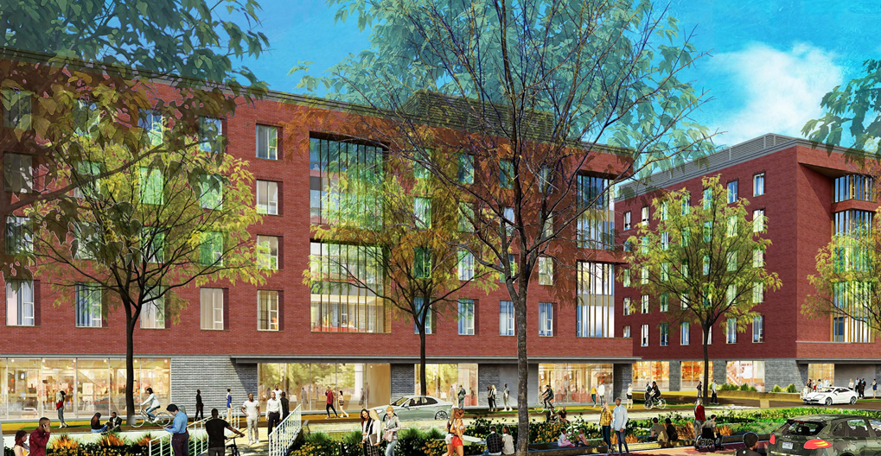Figure 1. Proposed view looking northwest.

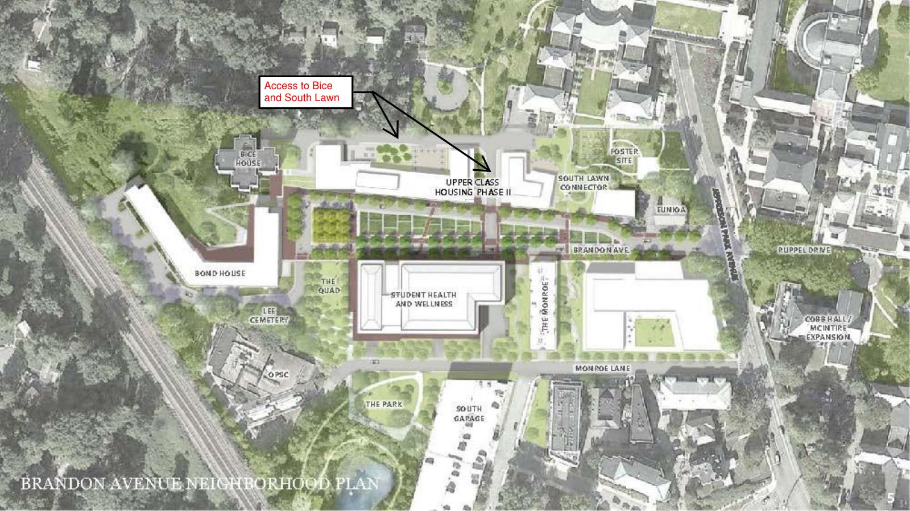
Figure 2. Rendering showing planned redevelopment along Brandon Avenue. The non-labeled building at the intersection of Jefferson Park Avenue is a placeholder for future development.

