Tableau Server Basics

- The home tab includes favorites, recently viewed, and reports others are viewing.
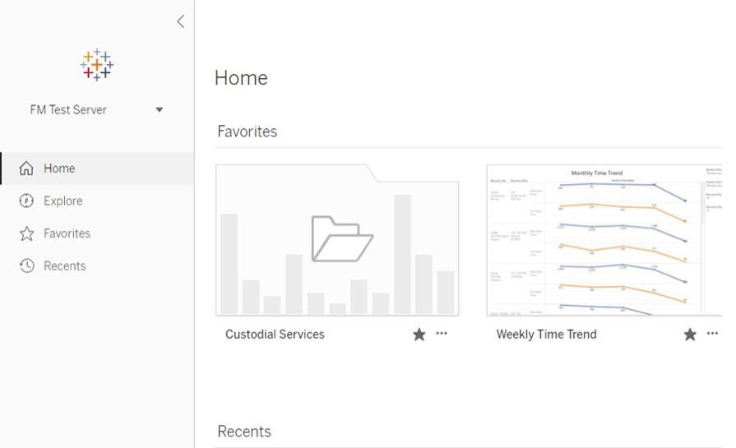

- You can favorite project folders, views, and workbooks.
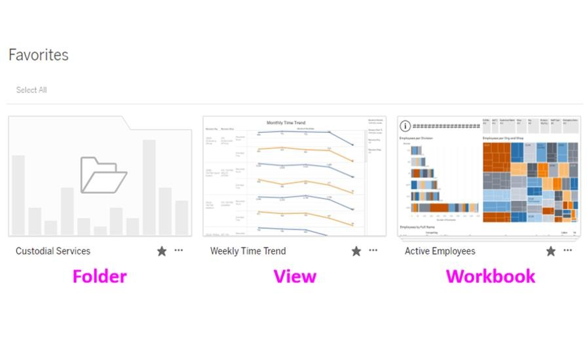
- Favorite by clicking the star
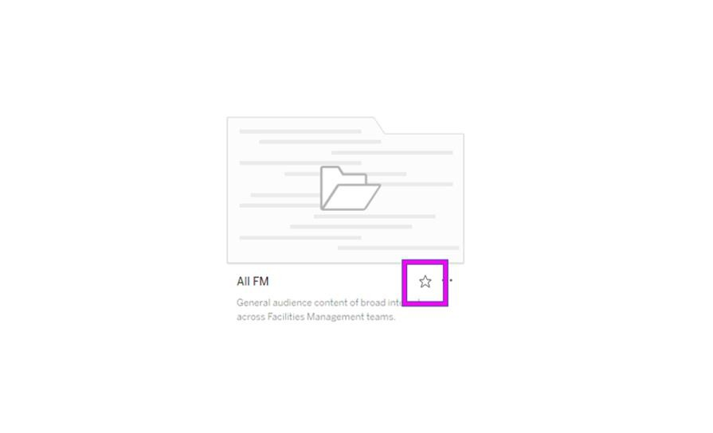

- The explore tab contains all the project folders
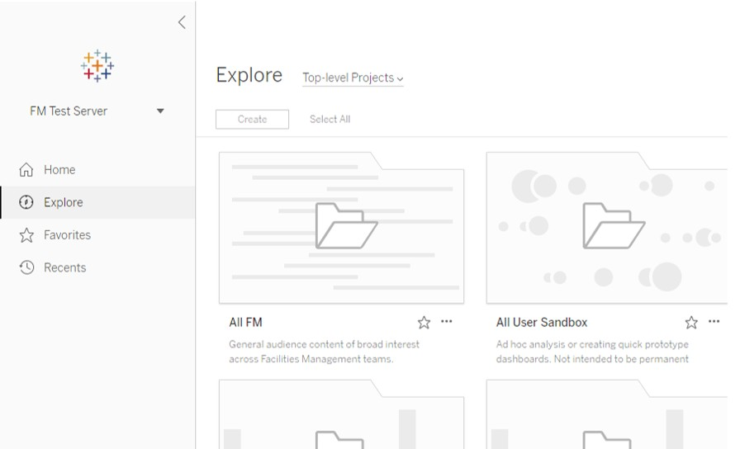

- Click on a project folder
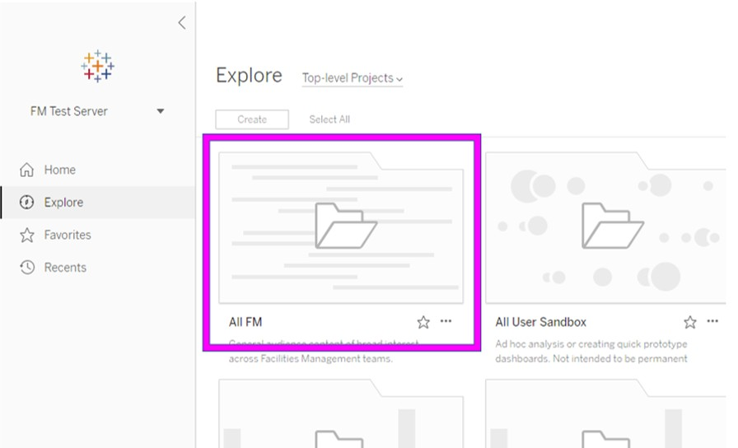

- This takes you to the workbooks inside the folder
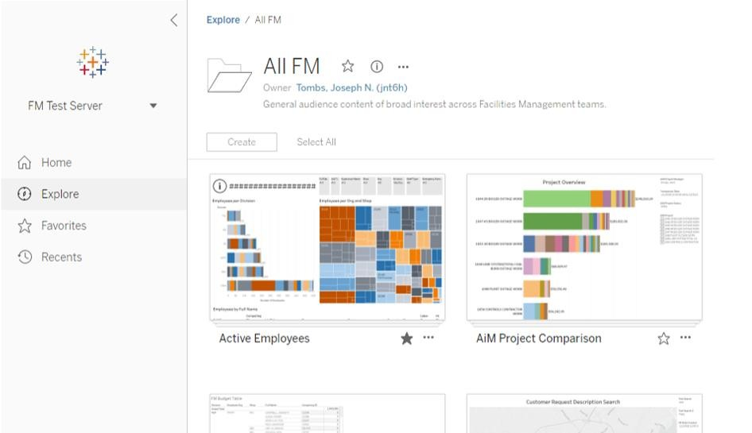

- Click on a workbook
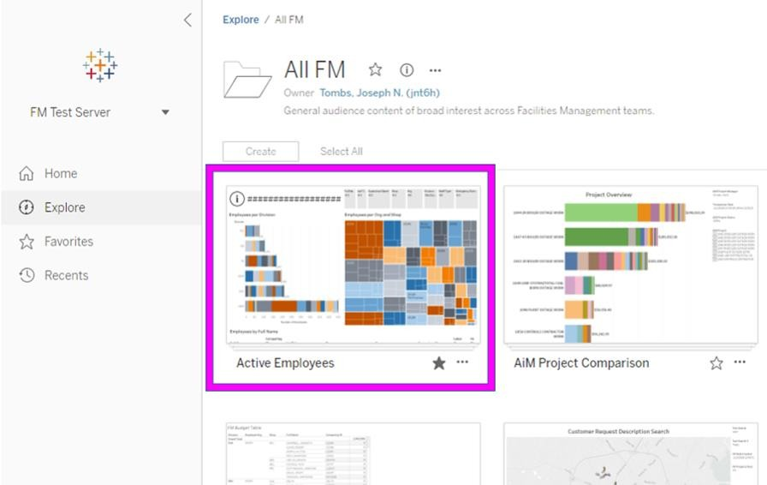

- This takes you to the views inside the workbook
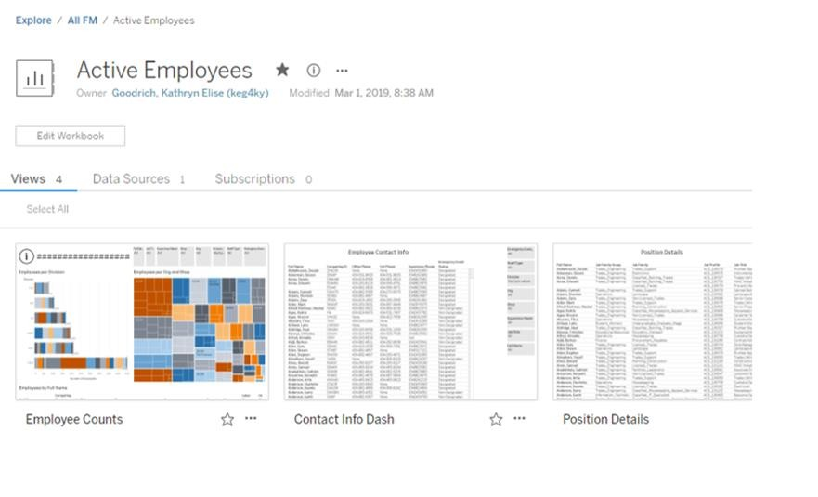

- Click on a view
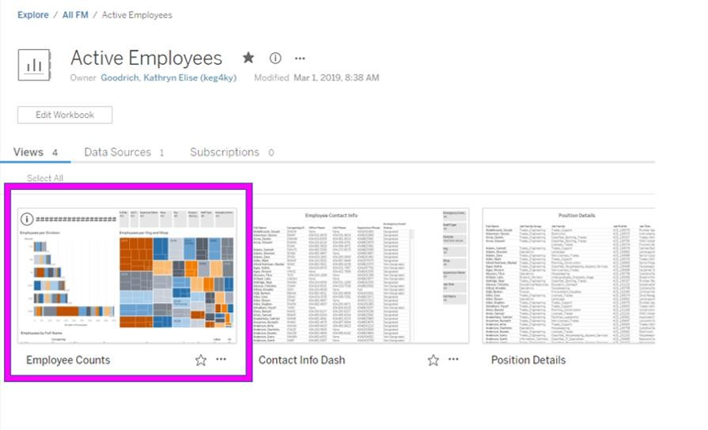

- This is a view. Views can have graphs, tables, and filters.
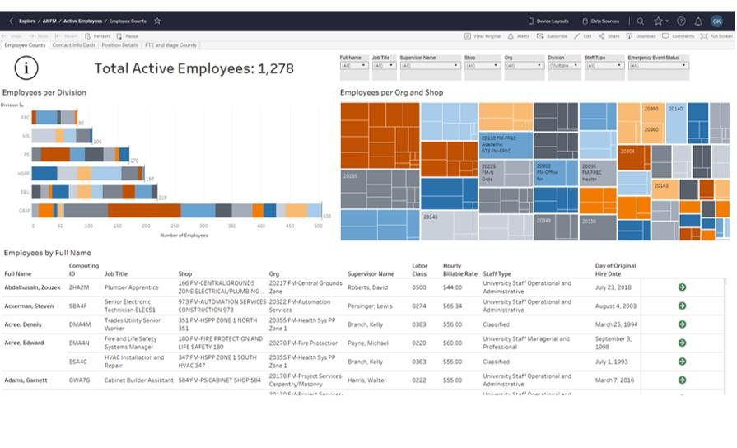

- Focus on the upper left corner of the view
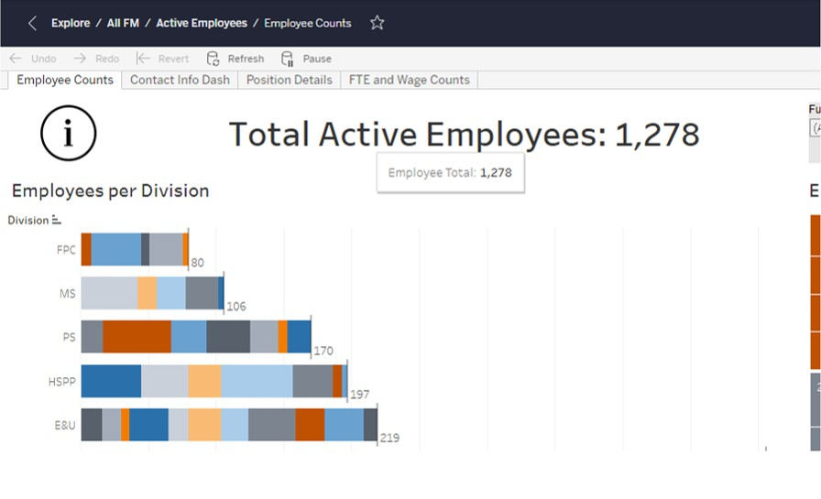

- This is the directory of the view. Use this to go back to the workbook, folder, or explore
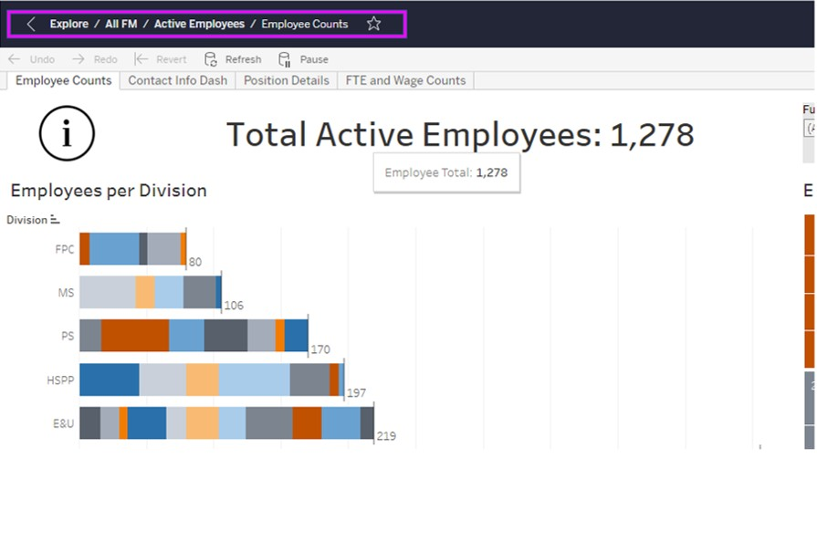

- These tabs are the other views in the workbook
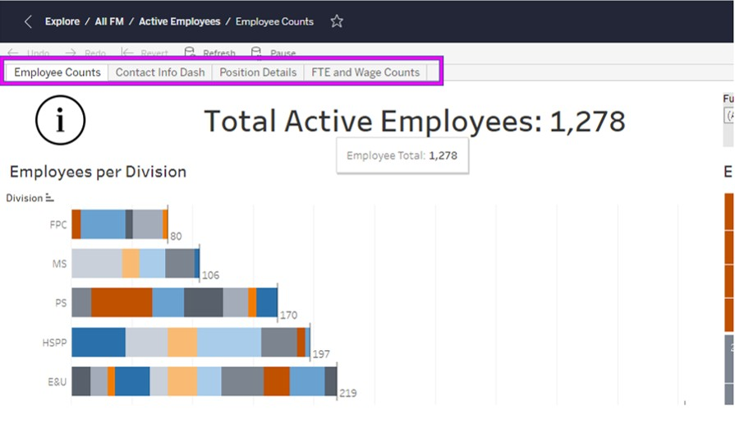

- Hover over this information symbol to read about the workbook.
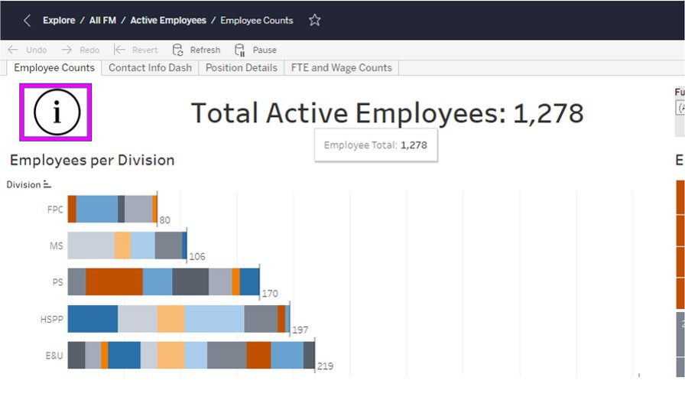

- Focus on the upper right corner of the view
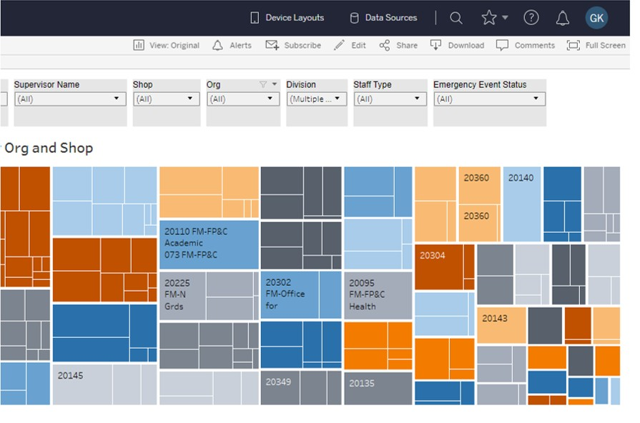

- Filters are used to choose what data reaches the view
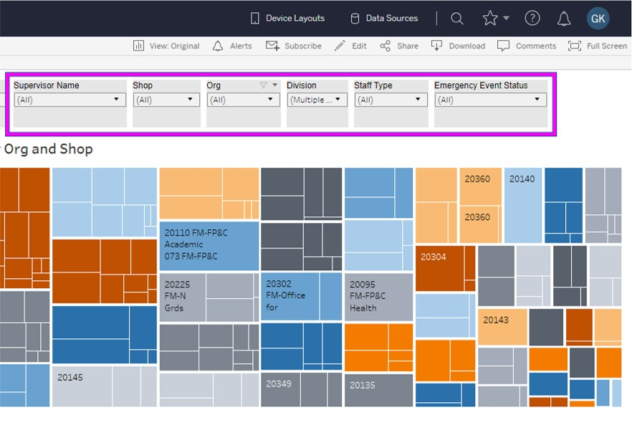

- After you set the filters, save them by clicking on the view button
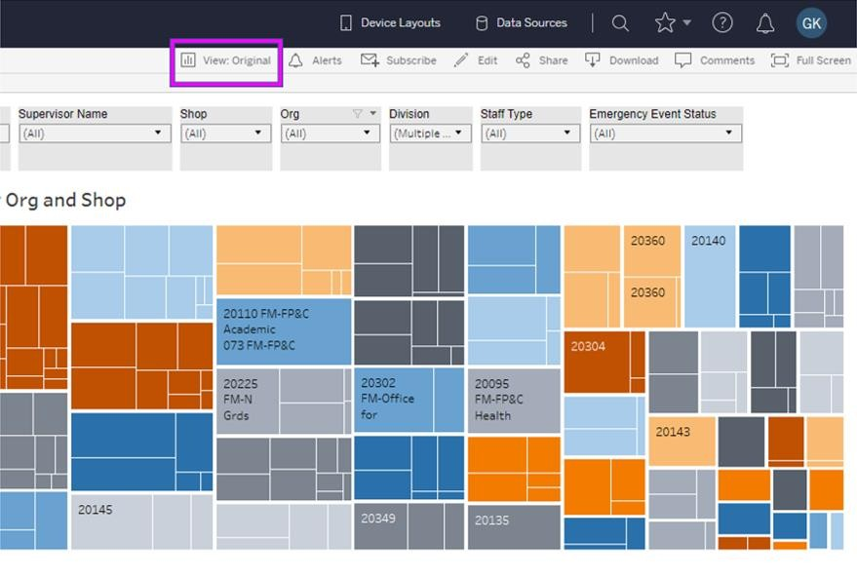

- Choose what to name the view. If you want, you can make it your default and/or make it public for everyone to see.
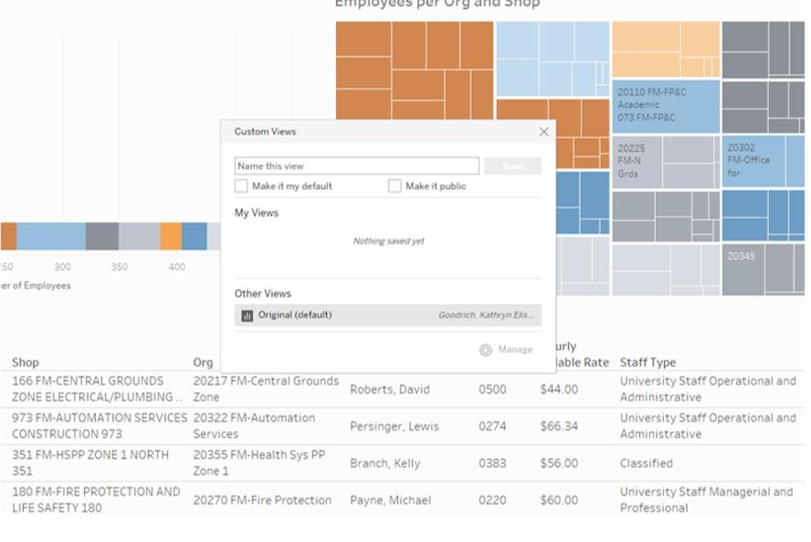

- Don’t forget to save!

