Downloading Data from Tableau Server

Open FM’s Tableau Server site:
Production: https://tableau.admin.virginia.edu/
Development: https://tableaudev.admin.virginia.edu/

Open the visualization you want to explore or use the search function to find info on a topic. For example, search for “employee.”

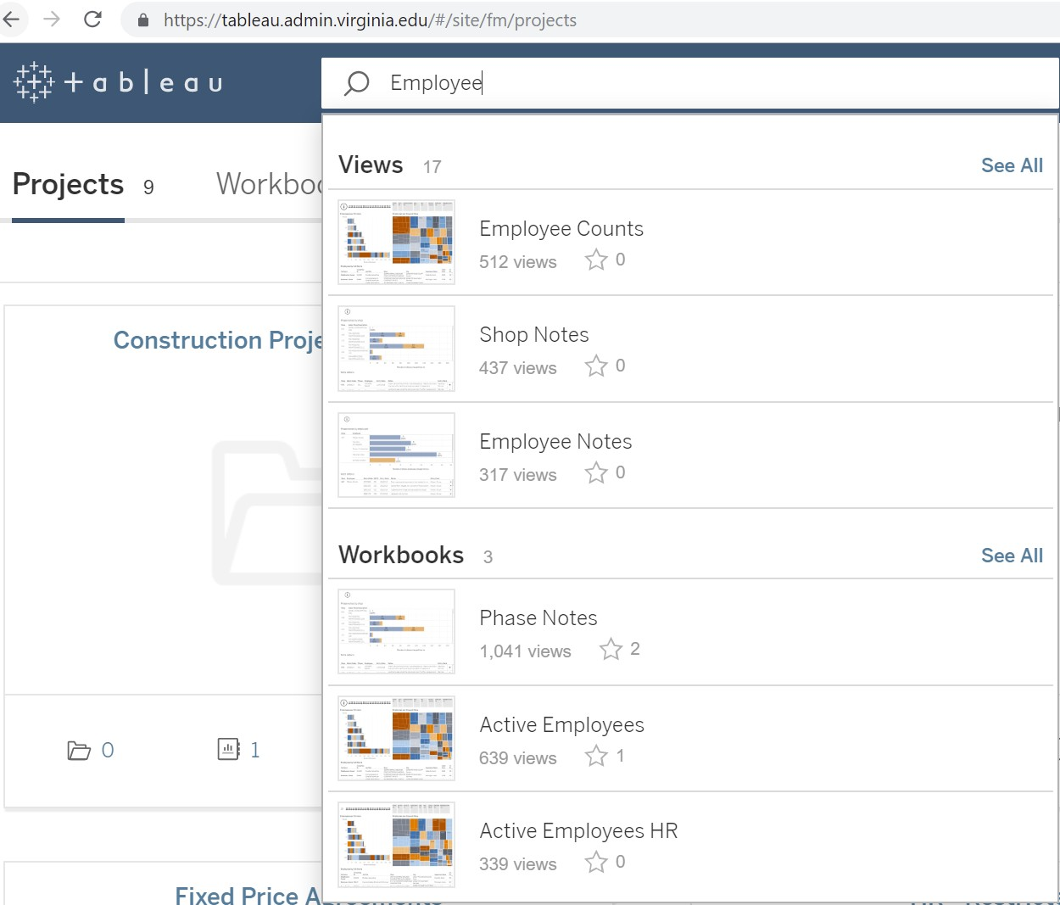

Sometimes you find data in a view that you want to slice and dice using Excel. It is easy to export textual data from Tableau Server. The data behind graphs can take more effort. Look for the “Download” link in the upper righthand part of the Tableau Server window.



Click “Download” and you will see several options. The option on the left below is for text-based data and export is easy. For graphs, you may see the buttons on the right. In this case, the “Data” button is grayed out. If you get the gray button, contact the Informatics team for help exporting the data.
❖ If you see Data and Crosstab greyed out, go back to the visualization and click twice in a cell in the table you want to download the data. This will guarantee you have selected the table. Try to click the download button again and see if this made the options available.

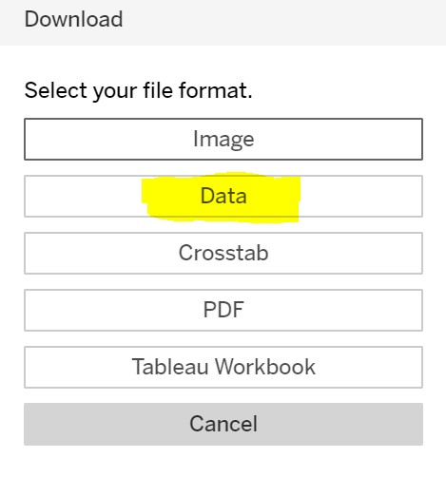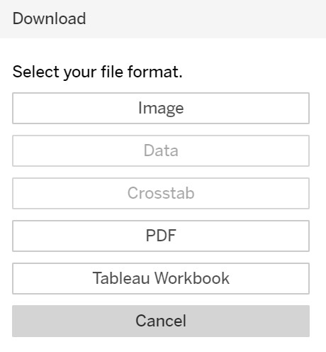

For graphs, you may see the buttons on the right. In this case, the “Data” button is grayed out. If you get the gray button, contact the Informatics team for help exporting the data.

If the “Data” button is available, it is a good choice for exporting to Excel. Click the “Data” button to see the options shown below. You can download a few fields using the “Summary” tab, more fields using the “Full data” tab, and the most fields by checking the “Show all column” checkbox on the “Full data” tab.

Try the “Full data” tab first and click the “Download all rows as a text file” link. It pulls in the info displayed in the viz along with data for the filters.

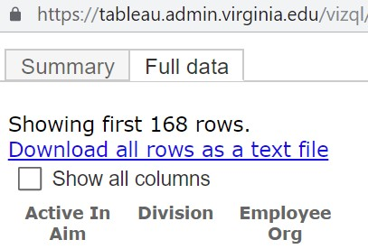

The download usually shows up as an Excel file. If it shows up as another file type, such as .csv, try opening it with Excel and let the analysis begin.

Contact the Informatics team if you discover something that other FM colleagues might be interested in seeing. We can consider ways to include it in future visualization work.

