
Leake Building | 1450 Leake Drive
P.O. Box 400726, Charlottesville, VA 22904-4726
(434) 982-4621 | Fax (434) 982-4628
www.fm.virginia.edu

Date: 7/14/26 Alert No. 2
NON-UVA PROJECT

CONSTRUCTION ALERT
CITY OF CHARLOTTESVILLE WEST MAIN UTILITIES REPLACEMENT

Culbreth Rd.

Vehicles:
Due to safety concerns associated with open-trench construction, the City of Charlottesville and the University of Virginia will temporarily close portions of Culbreth Road to complete the gas line installation.
From July 13–17, Culbreth Road will be closed between University Avenue and the parking garage. From July 20–24, Culbreth Road will be closed from Rugby Rd.and the parking garage. Parking garage access will remain available during both phases.

Work hours are Monday through Friday, 6:00 a.m. to 4:00 p.m. Detour and UVA signage will direct motorists to the appropriate garage entrance.

Pedestrians: Sidewalks will remain open.

Please note: The Charlottesville Department of Utilities is preparing to launch the West Main Street Utilities Replacement Project, a major infrastructure investment designed to strengthen utility services for decades to come. A continuation of Utilities' city-wide implementation of planned infrastructure improvements, this project will be a multi-year effort conducted in phases, replacing aging gas and water mains along University Avenue, West Main Street, and select side streets. This project represents a strategic investment in Charlottesville's future, with Phase One scheduled to begin in summer 2026.

https://connect.charlottesville.gov/westmainutilitiesproject

City of Charlottesville Contact Information
Jim Keller - Utilities Senior Project Manager kellerj@charlottesville.gov

PHOTOS/MAPS OF AREAS AFFECTED:

Culbreth Rd. closed from University Ave to the Culbreth garage. To access the Culbreth Garage use Rugby Rd.
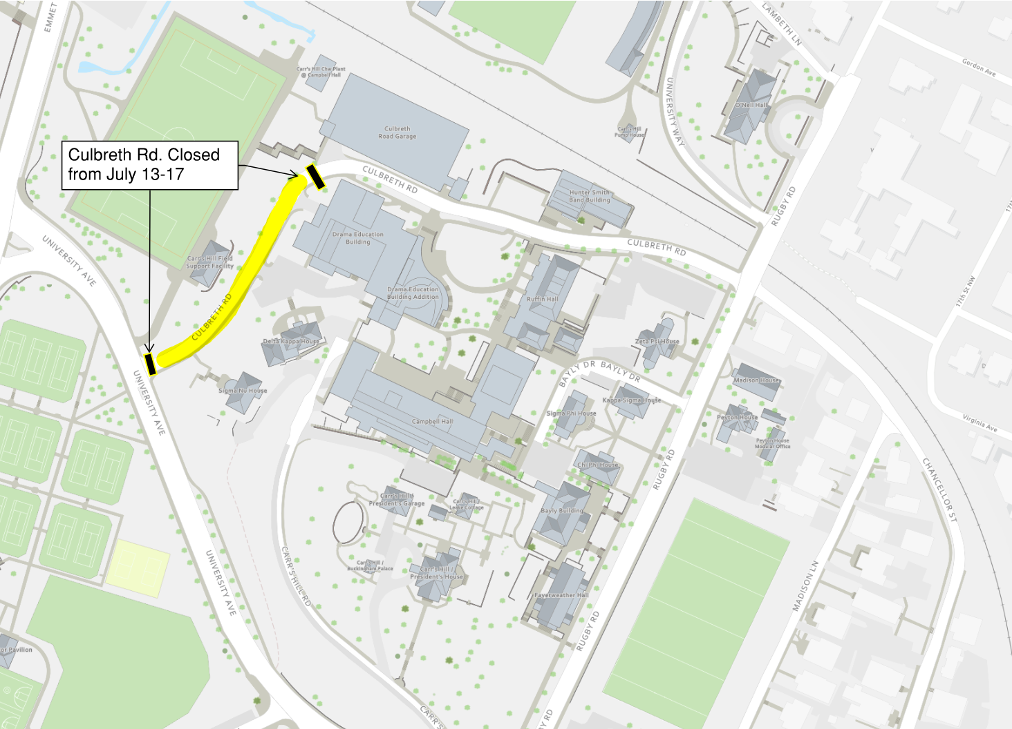

Culbreth Rd. closed from Rugby Rd. to the Culbreth garage. To access the Culbreth Garage use University Ave.
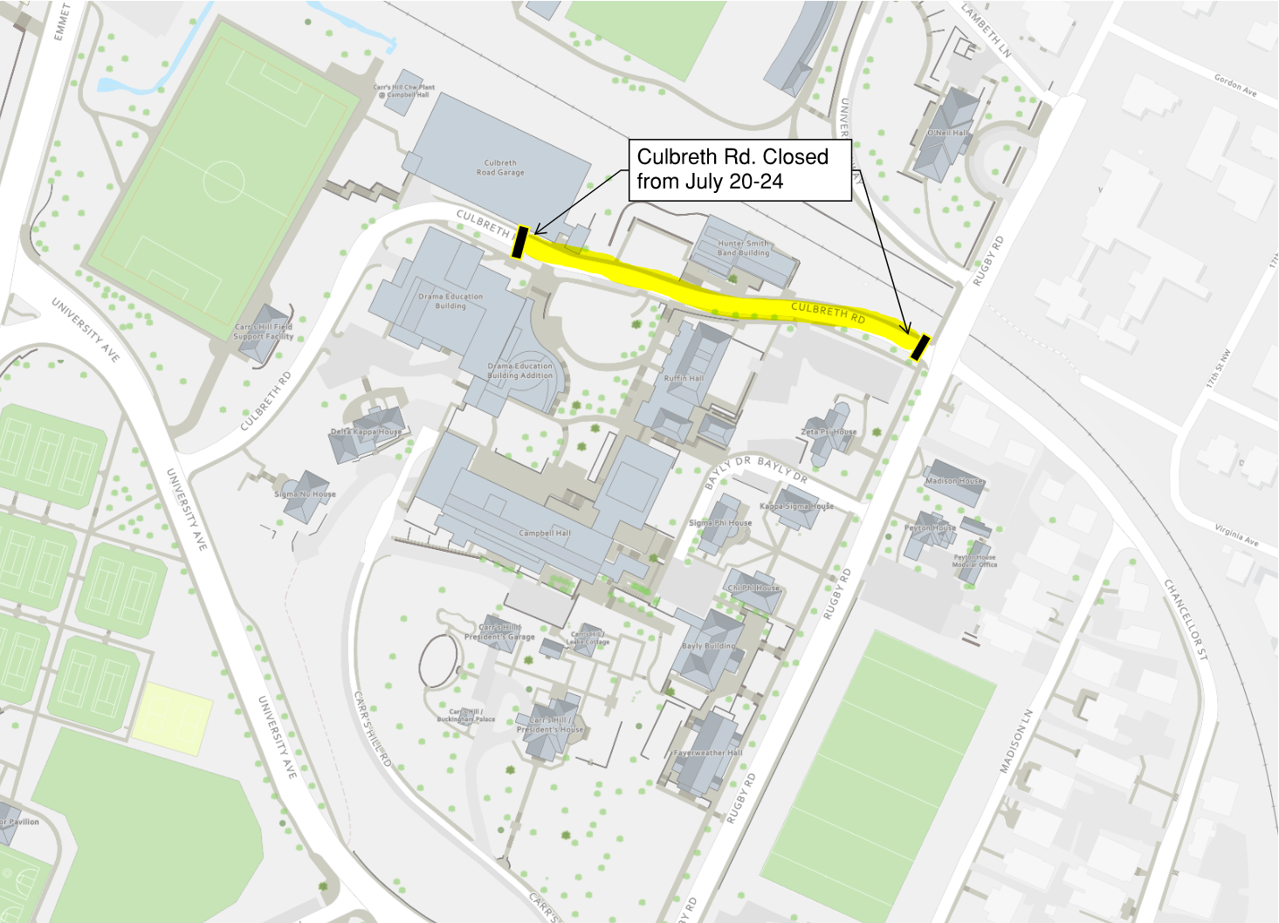
ISSUED BY:

- Megan Buschi - Senior Project Coordinator
UVA FM CC&R, jsg5fr@virginia.edu 434.400.8594

