Leake Building | 1450 Leake Drive
P.O. Box 400726, Charlottesville, VA 22904-4726
(434) 982-4621 | Fax (434) 982-4628
www.fm.virginia.edu

Date: [8/19/2026] Alert No. [3.]

CONSTRUCTION ALERT
Sidewalk Closure Off Copeley Rd

ITEMS OF INTEREST:
- The sidewalk across from palmer park off Copeley Rd will be closed from 8/24 to 9/4

EXIT & SIDEWALK ACCESSIBILITY
- ☐ Work blocks existing building exits, and was reviewed with OUBO prior to blockage.
☒ Work blocks existing sidewalks, and was reviewed with OUBO prior to blockage.
☐ No impact to existing building exits and sidewalks.

BACKGROUND:
- This is to support new signage, sidewalk and landscaping.

ISSUED BY:
- Kyle Jennings kmj2k@virginia.edu
- Adam Gragg arg8q@virginia.edu

PHOTOS/MAPS OF AREAS AFFECTED:

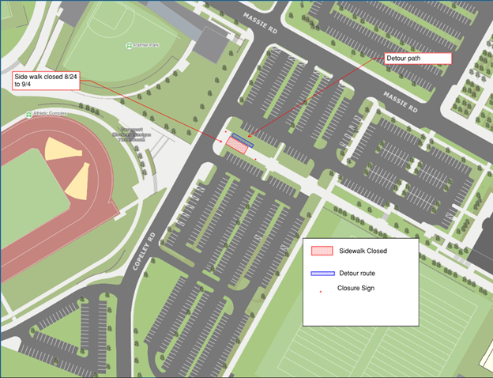
END OF ALERT

