

Leake Building | 1450 Leake Drive
P.O. Box 400726, Charlottesville, VA 22904-4726
(434) 924-1777 | Fax (434) 982-4628
UVA FM website

Date: August 11, 2026 Alert No. 01 REV 1

Construction Alert

School of Data Science (SDS) Entrepreneurship Building

Items of interest
- TRC, a utility locating contractor, will be performing utility test hole work along the northern sidewalk of Ivy Rd between Rothery Rd and the existing School of Data Science building on Wednesday August 12 through Friday August 14.
- Note, this is work that was rescheduled after unforeseen issues occurred during the initial mobilization in early July.
- Work Hours: 8:00 AM – 5:00 PM (daily)
- Impact: Sidewalk Closure
- Pedestrian Access: The section of sidewalk just south of the existing SDS and future SDS-E building sites will be closed. Pedestrians will need to utilize the sidewalk to the north, near the Ivy Corridor Stream for access around the work area.
- Roadway Impact: No lane closures or roadway impacts are anticipated as part of this work.

Exit & sidewalk accessibility
- ☐ Work blocks existing building exits and was reviewed with OUBO prior to blockage.
- ☒ Work blocks existing sidewalks and was reviewed with OUBO prior to blockage.
- ☐ No impact to existing building exits and sidewalks.

Background
- Project consists of the construction of a new School of Data Science Entrepreneurship Building, located on the site immediately west of the existing School of Data Science Building, which was completed in 2024. The total building square footage is anticipated to be approximately 62,000 GSF, comprised of five full stories, MEP Penthouse, and a pedestrian connector bridge to the existing SDS building.

Issued by
- Raleigh Roussos | Senior Project Manager | 434.987.4637 | rnd2u@virginia.edu

Photos/maps of areas affected
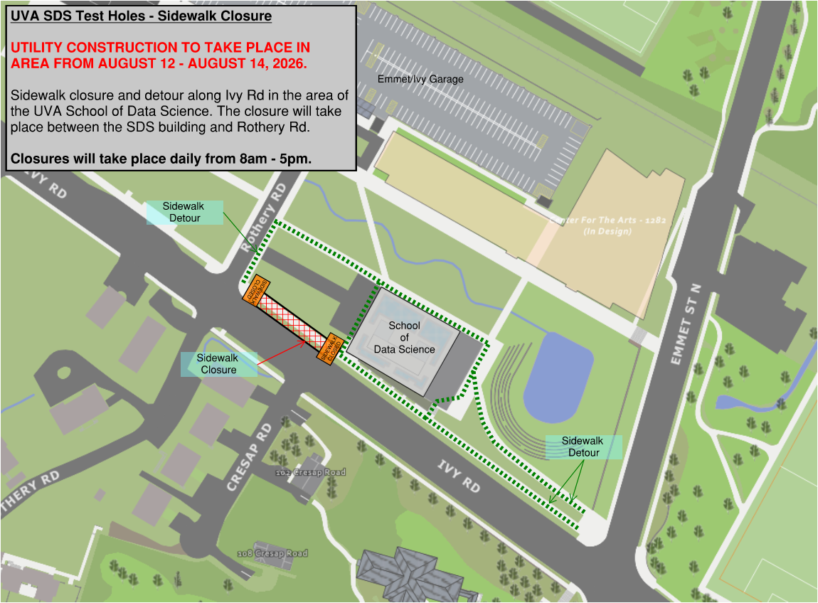

End of alert

