

Leake Building | 1450 Leake Drive
P.O. Box 400726, Charlottesville, VA 22904-4726
(434) 924-1777 | Fax (434) 982-4628
UVA FM website

Date: 5/11/2026 Alert No. 1

Construction Alert

Rotunda West Courtyard Renovation

Items of interest
- The general contractor will mobilize to install a laydown area in the lawn between the Rotunda and University Chapel on May 20. Full project mobilization in the west and east courtyards will begin the week after reunions, June 8, 2026. The project will be substantially completed by August 15, 2026, prior to the start of the fall semester.
- The primary impacts of this project will be construction traffic and noise caused by demolition of existing paving and concrete base. Construction vehicles will use pedestrian routes for access to the site but will not obstruct ADA or barrier-free routes. The sidewalk under the colonnade west of the Rotunda will be closed to pedestrian access for the duration of the project. This walk is not an ADA path, and an adjacent barrier-free path will be maintained for the duration of the project. Part of the Darden Courtyard will be blocked to enable waterproofing work on the east side of the Rotunda, beginning mid-June.

Exit & sidewalk accessibility
- ☐ Work blocks existing building exits and was reviewed with OUBO prior to blockage.
- ☒ Work blocks existing sidewalks and was reviewed with OUBO prior to blockage.
- ☐ No impact to existing building exits and sidewalks.

Background
- The Rotunda West Courtyard renovation is a donor-funded project to improve the landscape on the west side of the Rotunda to be in keeping with the Darden Courtyard on the east side of the Rotunda. The project scope also includes waterproofing of the northwest wing and a small amount of waterproofing in the southwest corner of the Darden Courtyard on the east side of the Rotunda.

Issued by
- Sarita Herman, Assistant Director of Project Management, smh2ne@virginia.edu
- Matt Pannell, Construction Administration Manager, mrp5g@virginia.edu

Map of areas affected
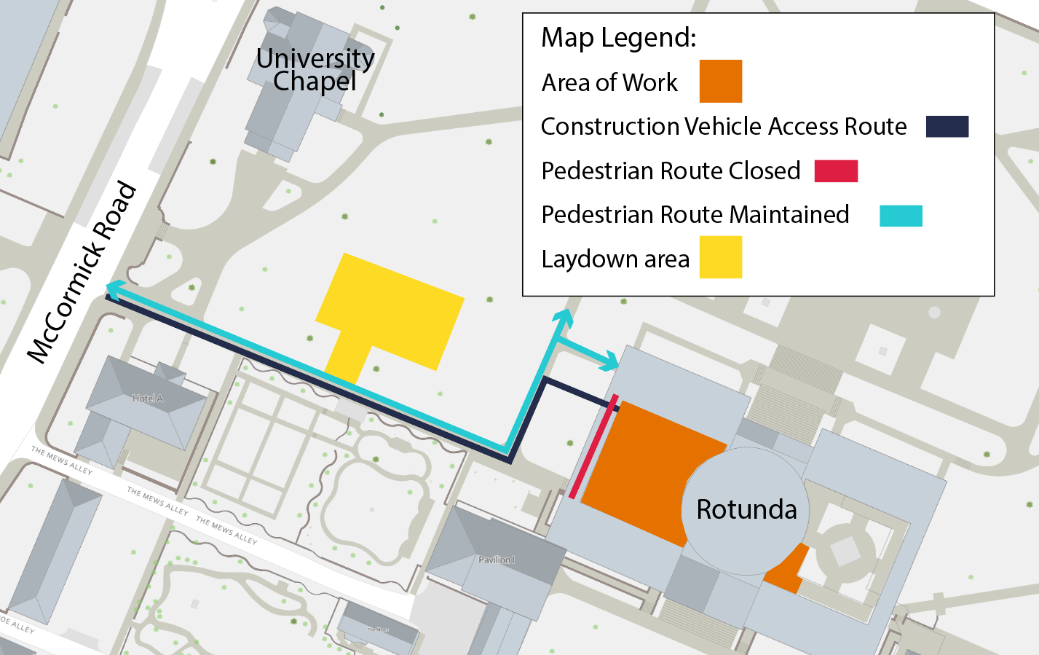

End of alert

