
Leake Building | 1450 Leake Drive
P.O. Box 400726, Charlottesville, VA 22904-4726
(434) 982-4621 | Fax (434) 982-4628
www.fm.virginia.edu

Date: May 12, 2026 Alert No. 1

CONSTRUCTION ALERT

Pavilion II Colossal Column

ITEMS OF INTEREST:
- Scaffolding will be constructed around the Pavilion II columns on May 27.
- Access to the walkway will remain open and overhead protection will be provided.
- It is expected to remain in place through August.

EXIT & SIDEWALK ACCESSIBILITY
- ☐ Work blocks existing building exits, and was reviewed with OUBO prior to blockage.
☒ Work blocks existing sidewalks, and was reviewed with OUBO prior to blockage.
☐ No impact to existing building exits and sidewalks.

BACKGROUND:
- The Colossal Columns of Pavilion II were recoated with cement parging at an unknown time. This cement has potential to damage the underlying original masonry shaft due to their incompatibility. The project is a conservation effort to carefully remove the cement parging and replace it with a breathable lime based parging.
- The column base and capitals, currently coated with multiple layers of latex paint will undergo paint removal.

ISSUED BY:
- Amy Moses, (434) 531-9160, arm8h@virginia.edu
- Matt Proffitt, (434) 987-2643, mwp4c@virginia.edu

PHOTOS/MAPS OF AREAS AFFECTED:

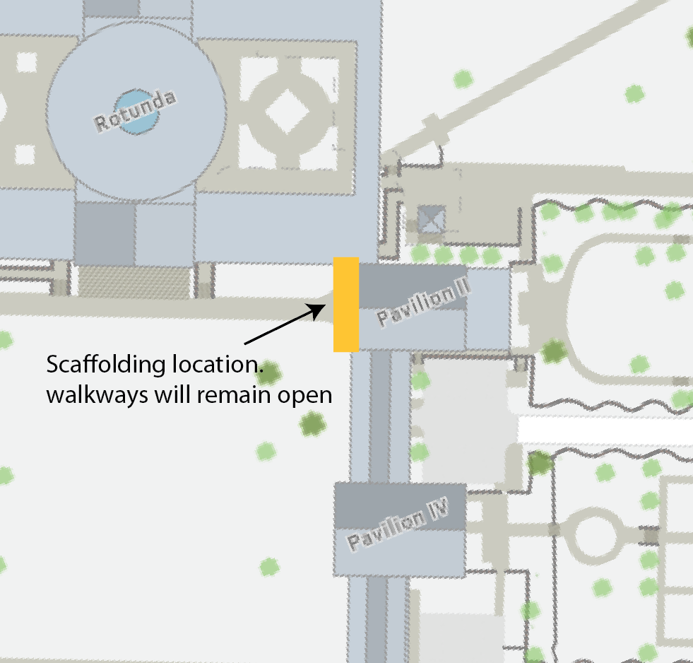

END OF ALERT

