

Leake Building | 1450 Leake Drive
P.O. Box 400726, Charlottesville, VA 22904-4726
(434) 924-1777 | Fax (434) 982-4628
UVA FM website

Date: September 16,2026 Alert No. 1

Construction Alert

Pavilion I Lower Garden

Items of interest
- Starting September 23rd a dump truck will be parked on Rotunda Walkway to facilitate the lower garden project debris removal
- Truck and equipment will not be on the walkway when a person is not present to move the truck as needed.
- Signage will also be provided to suggest alternative pathways.

Exit & sidewalk accessibility
- ☐ Work blocks existing building exits and was reviewed with OUBO prior to blockage.
- ☒ Work blocks existing sidewalks and was reviewed with OUBO prior to blockage.
- ☐ No impact to existing building exits and sidewalks.

Background
- To help with maintenance of garden pathways, the brick boarders are being reconstructed and a permeable surface is being installed to replace the existing honey dust material.

Issued by
- Amy Moses, arm8h@virginia.edu

Photos/maps of areas affected
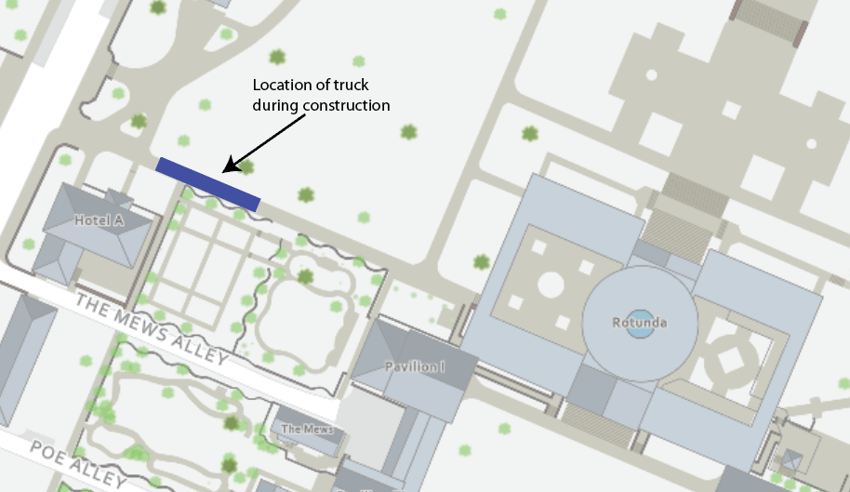

End of alert

