

Leake Building | 1450 Leake Drive
P.O. Box 400726, Charlottesville, VA 22904-4726
(434) 924-1777 | Fax (434) 982-4628
UVA FM website

Date: June 10, 2026 Alert No. 024

Construction Alert

UVA Manning Institute of Biotechnology

Items of interest
- As part of the Manning Institute of Biotechnology (MIoB) project, FM will be relocating and replacing the exterior steps and door located at the loading dock of 450 Ray C. Hunt Dr.
- The first part of this work will start June 17th, 2026
- Access to the loading dock and exit stairs will be maintained.

Exit & sidewalk accessibility
- ☐ Work blocks existing building exits and was reviewed with OUBO prior to blockage.
- ☐ Work blocks existing sidewalks and was reviewed with OUBO prior to blockage.
- ☒ No impact to existing building exits and sidewalks.

Background
- The MIoB project was required to change the orientation of the trash and recycling station located at 450 Ray C Hunt Dr. to make room for permanent electrical equipment. Relocating and replacing the exterior door and stairway will allow safe access to the new trash bin location.

Issued by
- Alex Elberson, UVA FM - CC&R wdz7ug@virginia.edu
- Mashal Hartman, UVA FM - CC&R ma4g@virginia.edu

Photos/maps of areas affected
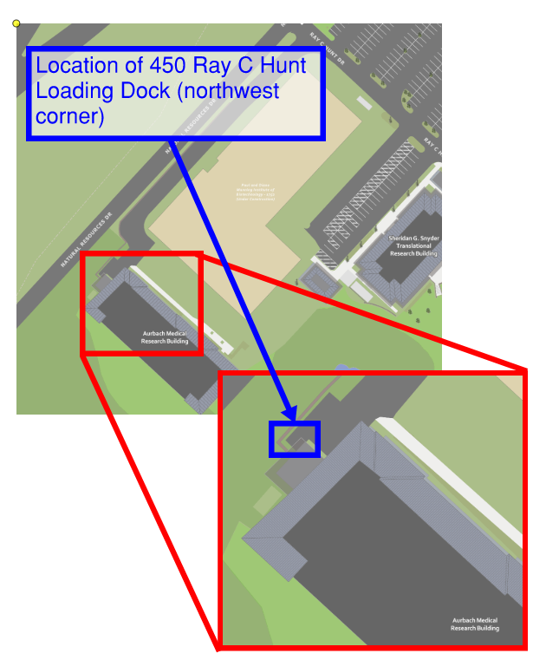

End of alert

