

Leake Building | 1450 Leake Drive
P.O. Box 400726, Charlottesville, VA 22904-4726
(434) 924-1777 | Fax (434) 982-4628
UVA FM website

Date: September 16,2026 Alert No. 1

Construction Alert

Hotel A Loggia and Drainage

Items of interest
- Starting September 23rd, the granolithic concrete will be removed from the Loggia of Hotel A.
- The pathway through the Loggia will be closed.
- Drainage on the west side of the Loggia and student rooms will start around the middle of October. Access through the arches will be prevented.
- Signage will also be provided to suggest alternative pathways.

Exit & sidewalk accessibility
- ☒ Work blocks existing building exits and was reviewed with OUBO prior to blockage.
- ☒ Work blocks existing sidewalks and was reviewed with OUBO prior to blockage.
- ☐ No impact to existing building exits and sidewalks.

Background
- The French drainage system is not allowing water to flow away from the masonry piers and likely is a main cause to the visible cracking in the masonry.
- The 1960s Utility chase that runs east to west under the loggia has also created areas of void under the granolithic concrete walking surface, which has started to crack and create an uneven walking surface.

Issued by
- Amy Moses, arm8h@virginia.edu

Photos/maps of areas affected

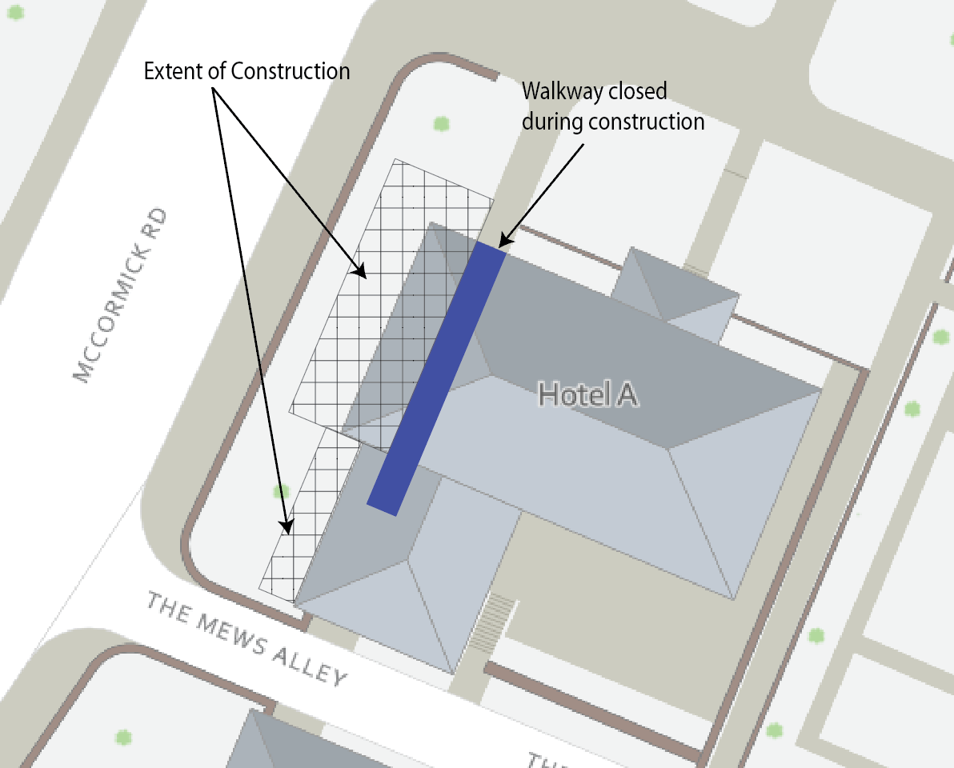

End of alert

