

Leake Building | 1450 Leake Drive
P.O. Box 400726, Charlottesville, VA 22904-4726
(434) 924-1777 | Fax (434) 982-4628
UVA FM website

Date: April 30, 2026 Alert No. No.01

Construction Alert

Fontaine Data Center Distribution Piping

Items of interest
- As part of the enabling work for the Fontaine Research Data Center, FM Energy & Utilities will begin installing underground utilities from the FCEP to the future data center site on May 4, 2026. This work is located to the east of 500 Ray C Hunt.
- Phase One work will begin May 4 and be completed around July 4, 2026. Fourteen total parking spaces will be impacted during this phase.
- Additional golf carts will be used to assist with patient transport. Patient parking spaces will be available directly west of FCEP. Access to the Building 500 loading dock will be maintained.
- All work is subject to weather conditions.

Exit & sidewalk accessibility
- ☐ Work blocks existing building exits and was reviewed with OUBO prior to blockage.
- ☐ Work blocks existing sidewalks and was reviewed with OUBO prior to blockage.
- ☒ No impact to existing building exits and sidewalks.

Background
- In support of the future Fontaine Research Data Center, distribution piping (hot water, chilled water, reclaim water, and processing cooling) will be installed from the new FCEP to the future site of the Data Center.

Issued by
- Taryn Spence | Project Manager | 434.872.3154
- Corey Jones | Utilities Distribution Manager | 434.989.8416

Photos/maps of areas affected

Exhibit One
PHASE ONE

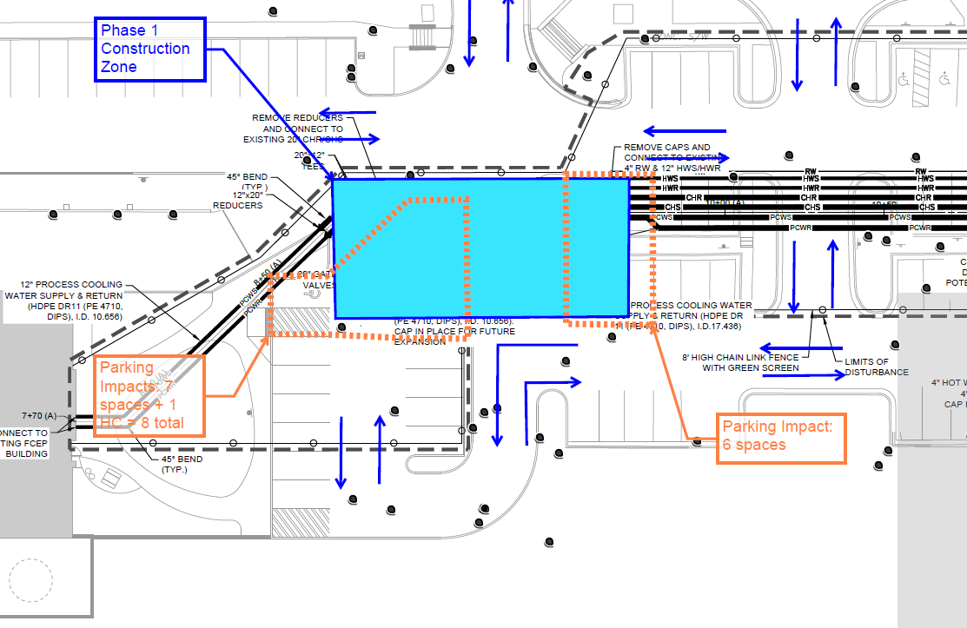
End of alert

