

Leake Building | 1450 Leake Drive
P.O. Box 400726, Charlottesville, VA 22904-4726
(434) 924-1777 | Fax (434) 982-4628
UVA FM website

Date: 14 August 2026 Alert No. 2

Construction Alert

Edgemont Rd Closure/LTHW repair

Items of interest
- Edgemont Road at Stone Hall Entrance and Aerospace Research Laboratory will have flagger operations provided by SL Williamson company to repair pavement on Tuesday 18 August 2026

Exit & sidewalk accessibility
- ☐ Work blocks existing building exits and was reviewed with OUBO prior to blockage.
- ☐ Work blocks existing sidewalks and was reviewed with OUBO prior to blockage.
- ☒ No impact to existing building exits and sidewalks.

Background
- The Low Temperature Hot Water Service at Stone Hall requires a repair to the existing service feed that is within the Edgemont Road throughway.

Issued by
- Corey M. Jones
Utilities Distribution Manager
Uva FM Energy & Utilities
Cmj9s@virginia.edu 434.989.8416

Photos/maps of areas affected

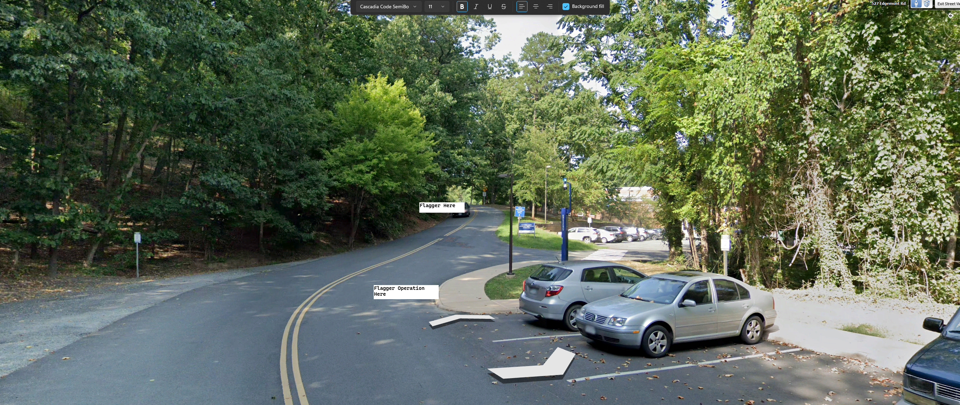

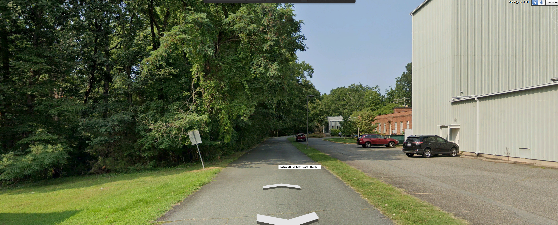

End of alert

