

Leake Building | 1450 Leake Drive
P.O. Box 400726, Charlottesville, VA 22904-4726
(434) 924-1777 | Fax (434) 982-4628
UVA FM website

Date: 8-13-2026 Alert No. 2

Construction Alert

Chemistry Chiller Plant Chiller Replacement

Items of interest
- Beginning Monday August 24^{th,} the parking lot in front of the Physical & Life Sciences Building and Chemistry Addition, between Chemistry Drive and Geldard Drive, will be closed for the duration of this project.
- The lot will be reopened in August of 2027.
- Sidewalks around the perimeter of the site will not be impacted.
- Access to building entrances and exits will be maintained.

Exit & sidewalk accessibility
- ☐ Work blocks existing building exits and was reviewed with OUBO prior to blockage.
- ☒ Work blocks existing sidewalks and was reviewed with OUBO prior to blockage.
- ☐ No impact to existing building exits and sidewalks.

Background
- The 3 existing chillers in the basement of Chemistry Addition have reached the end of their life cycle. This project will be replacing all 3 chillers and all supporting equipment and piping to provide a more reliable and efficient source of cooling to the district.

Issued by
- Dustin Watson, Construction Manager, UVA FM CC&R, dmw9w@virginia.edu, 434-906-6903.

Photos/maps of areas affected
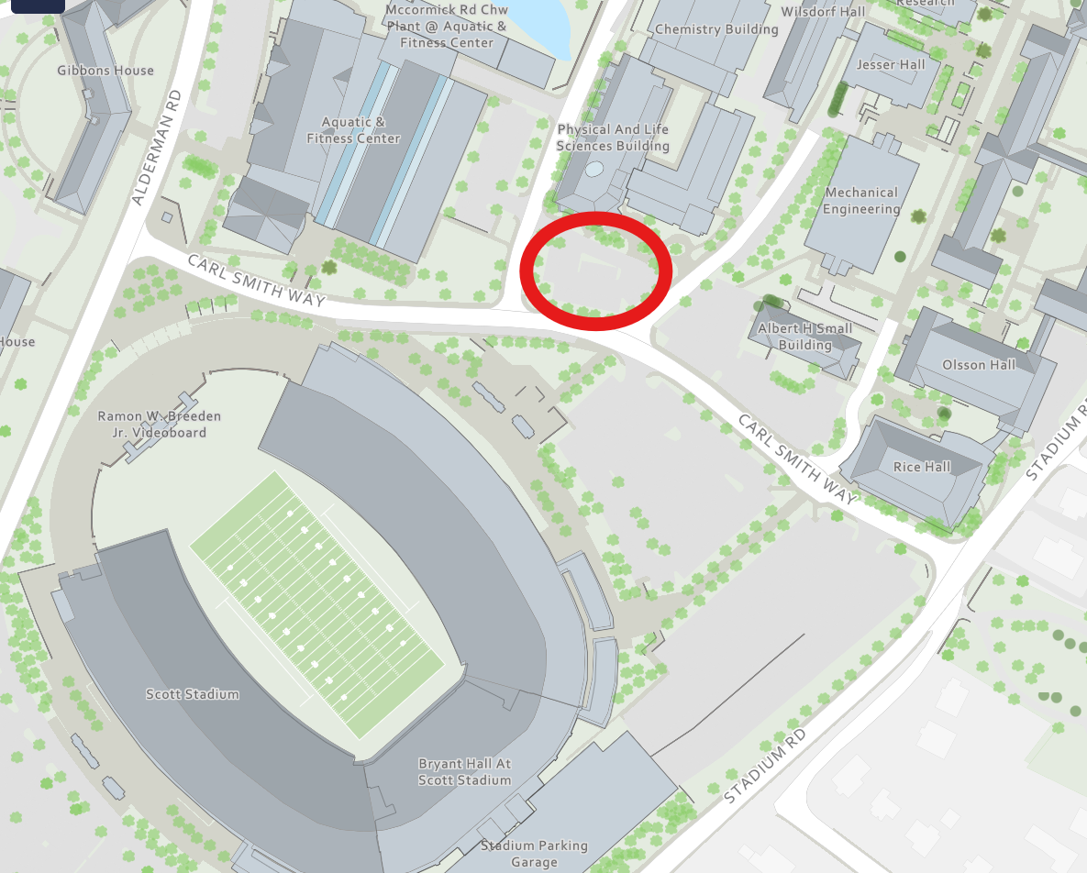
Impacted parking lot highlight in red above.
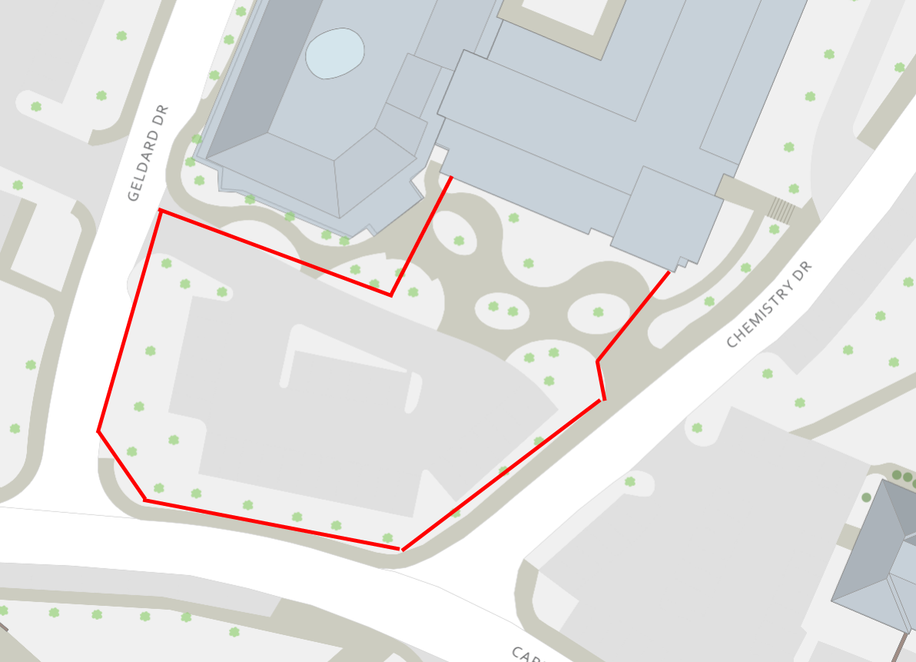
Layout of construction fencing outlined in red above. Sidewalks around the site will remain open and access to the building will be maintained. Work will not block any existing exits.

End of alert

