

Leake Building | 1450 Leake Drive

P.O. Box 400726, Charlottesville, VA 22904-4726

[(434) 982-4621](tel:4349824621) | **Fax** [(434) 982-4628](tel:4349824628)

[**www.fm.virginia.edu**](http://www.fm.virginia.edu)

Date: March 31, 2025

# CONSTRUCTION ALERT

# Fontaine Central Energy Plant

## BACKGROUND:

* The Fontaine Central Energy Plant will be UVA’s first fossil fuel-free plant. It will

initially support the new Manning Institute for Biotechnology but will eventually provide service to the entire Fontaine Park.

* To allow for the delivery of large pieces of equipment to the Fontaine Central Energy Plant jobsite, the project will be temporarily closing four parking spaces located in front of 515 Ray C. Hunt to allow the delivery trucks to maneuver safely into the site. These spaces (see diagram below for specific location) will be closed most of the day from **Thursday, April 3rd through Tuesday, April 8th**.

## ITEMS OF INTEREST:

* **Wednesday, April 2nd –** The four patient parking spaces will be closed in the evening after 5:00PM.
* **Thursday, April 3rd –** Spaces will be closed until mid-afternoon but will reopen for patient and visitor parking if time allows.
* **Friday, April 4th -** Spaces will be closed until noon but will be reopened for patient and visitor use in the afternoon.
* **Monday, April 7th –** Spaces will be closed until mid-afternoon but will reopen for patient and visitor parking if time allows.
* **Tuesday, April 8th –** Spaces will be closed until mid-afternoon but will reopen for patient and visitor parking once last deliver occurs and will then remain open going forward.
* **For more information, please visit the Fontaine Research Park FM Construction page** [**https://www.fm.virginia.edu/depts/fpc/projects/active/fontaine/index.html**](https://www.fm.virginia.edu/depts/fpc/projects/active/fontaine/index.html)

## ISSUED BY:

Dustin Watson, Construction Manager – UVA FM CC&R, [dmw9w@virginia.edu](mailto:dmw9w@virginia.edu), 434-906-6903

Chris Pouncey, Project Manager – UVA FM CC&R, [cp2xa@virginia.edu](mailto:cp2xa@virginia.edu), 434-981-3159

**SEE Fontaine Parking Map Below**

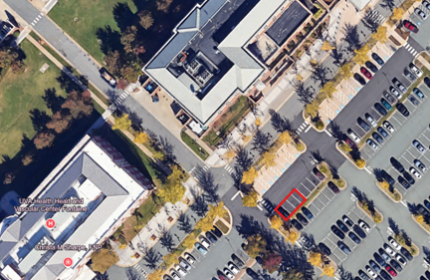

END OF ALERT