Date: August 29, 2020

CONSTRUCTION ALERT
Goodwin Bridge Scheduled Maintenance

ITEMS OF INTEREST:
- Please be aware of upcoming Pedestrian Bridge Closure (Goodwin Bridge) starting Friday 9/4 – Sunday 9/20.
- Be prepared to use alternate road crossing at Massie Rd. and Emmet Street intersection during this timeframe. See map below.

ISSUED BY:
- Hans McInturff – Construction Manager
(P) 434-297-2716
© 434-906-5280

PHOTOS/MAPS OF AREAS AFFECTED:
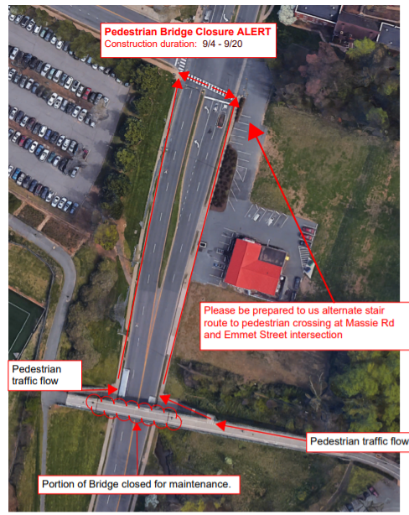

END OF ALERT

