McCormick Road Pedestrian Safety Improvement Proposal for Clark Hall to University Avenue

(background drawing prepared by Kimley Horn)

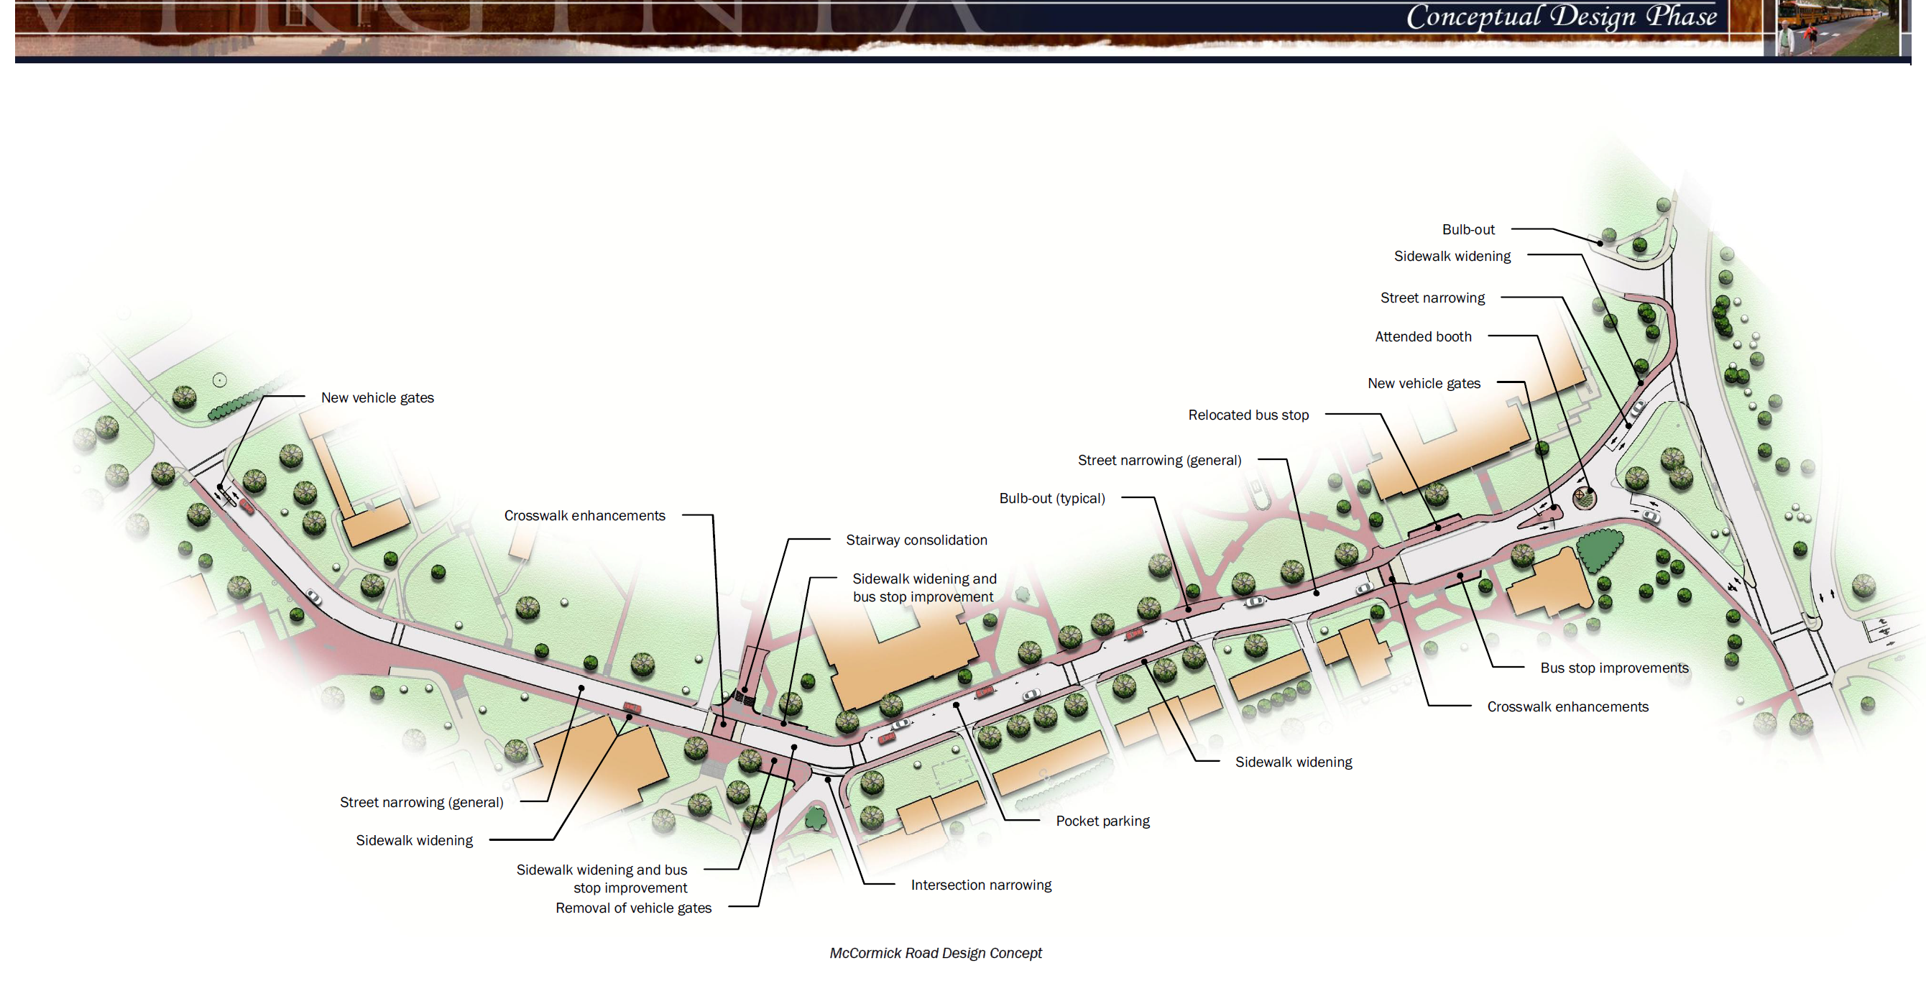

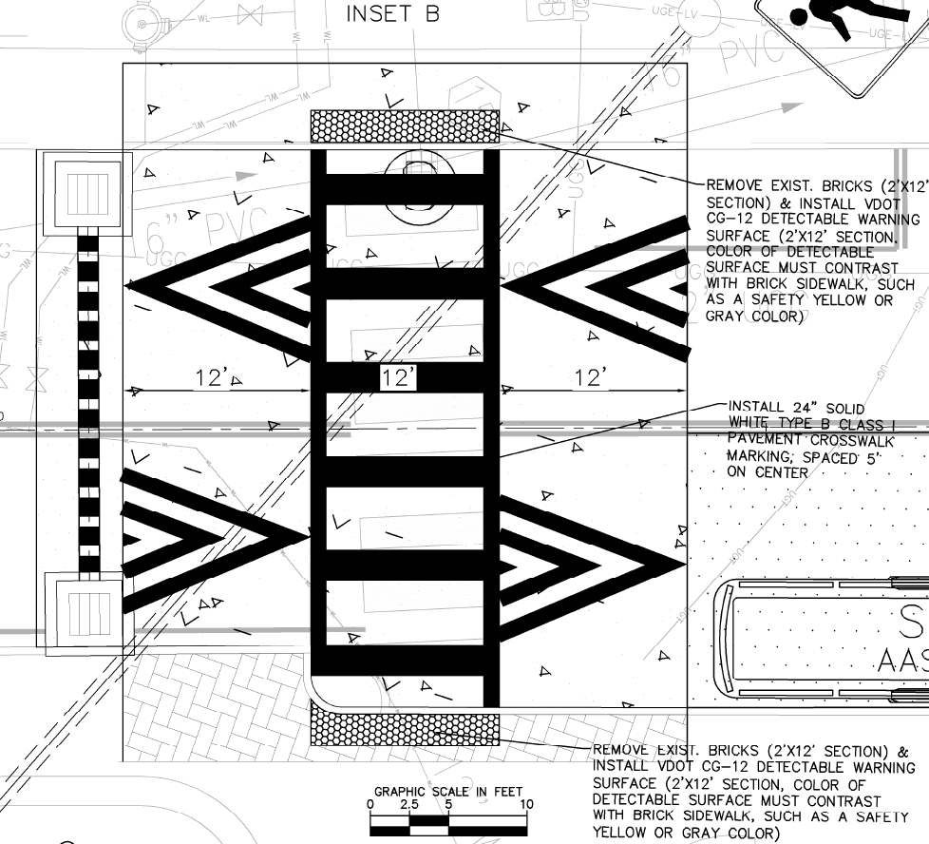

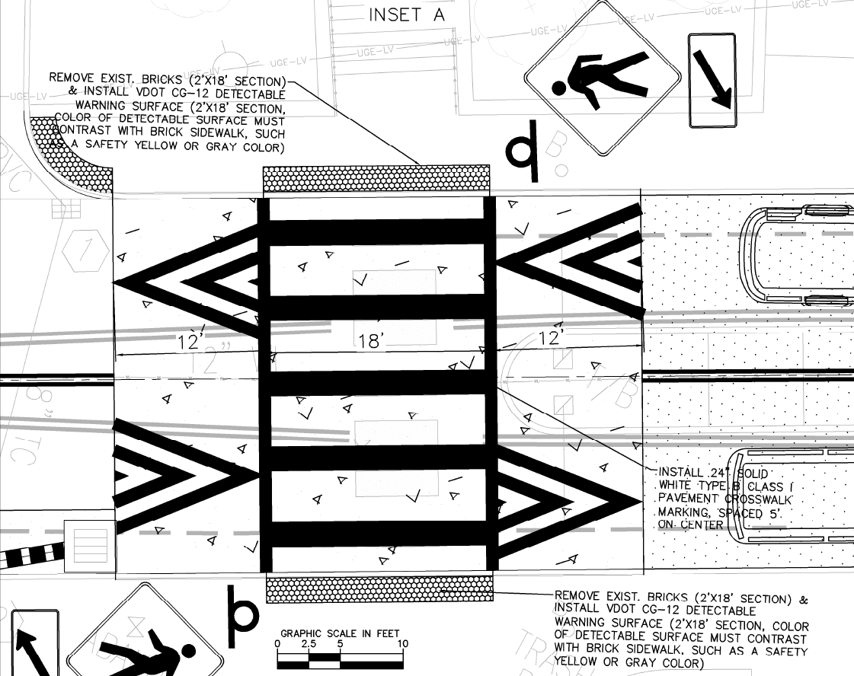

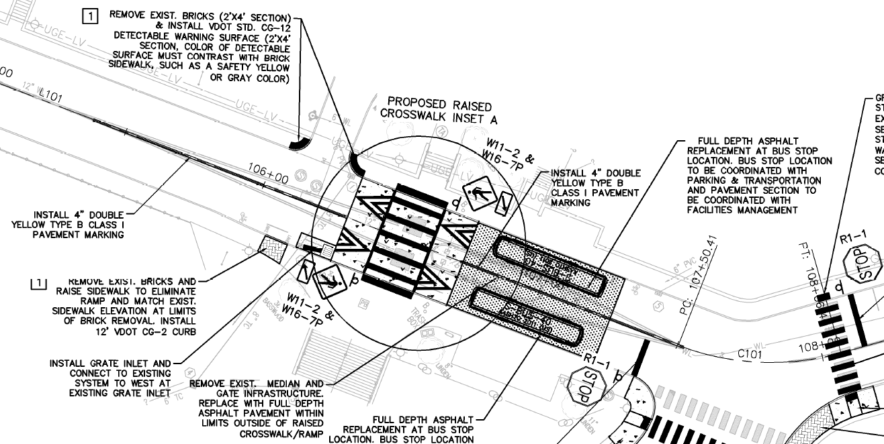

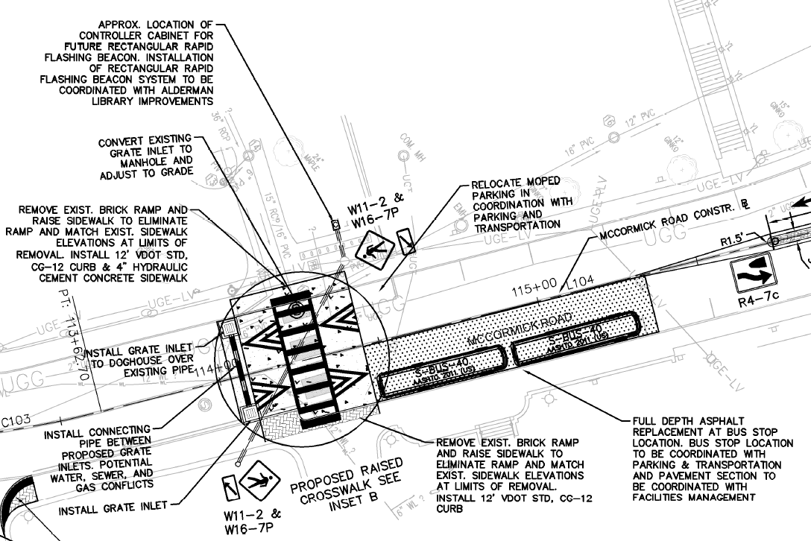

8. Alderman Library to Hotel A crosswalk enhancements include:

* Raised table crosswalk with specifications that meet or exceed VDOT standards
* Markings per VDOT standards
* Relocated storm drain inlet
* Lighting per UVa standards

2. Monroe Hall to Minor Hall crosswalk enhancements include:

* Raised table crosswalk with specifications that meet or exceed VDOT standards
* Markings per VDOT standards
* Lighting per UVa standards

4. Removal of inoperable vehicle gates. Install new access control infrastructure near the University Chapel

6. Install traffic control island to include:

* Traffic control gates
* License plate reader (LPR) access control or similar flexible technology
* Video call to UVa PD
* Programmable gates down and gates up hours via UVa approved system
* Vehicle detection and exit gate activation for traffic heading toward University Avenue
* Video monitoring of intersection (if requested by UVa PD)

5. Create ALL-WAY STOP intersection including:

* VDOT standard signage
* VDOT standard stop bars and markings

NOTE: McCormick Road is part of VDOT State Route 302. Consult with VDOT regarding each of the proposed changes.

eyedriooo

3. Install barrier-free access infrastructure in multiple locations along McCormick Road. Work with VDOT and the Office of the Architect to consider color options for tactile warning pads on the Range side of McCormick.

VDOT plans to pave McCormick Road from the Emmet Street bridge to University Avenue, in summer 2020, provided UVa updates accessible infrastructure to current standards.

1. Install rectangular rapid flashing beacon (RRFB) with automated pedestrian detection and activation

7. Install regular crosswalk to include:

* Markings (per VDOT standards)
* Lighting per UVa standards