The University of Virginia (University or UVA) invites highly qualified engineering consulting firms to submit a Letter of Interest/ Statement of Qualifications and associated supporting materials for consideration in the selection of a consultant team to provide engineering services for the Chemistry Addition Chiller Plant Renewal in accordance with the latest version of the UVA Higher Education Capital Outlay Manual (HECOM). The project will replace and potentially expand the existing chiller plant capacity; renew the cooling towers; and assess and if necessary, replace a section of 30-year-old condenser water piping.

Purpose & Program Background:

The University owns and operates extensive heating and cooling generation and distribution systems to condition the occupied space inside buildings connected to the central plants. As plant equipment approaches the end of useful life (based on reliability, cost of maintenance, or efficiency), renewal projects are initiated. This Project is specific to the chillers, cooling towers, and condenser piping associated with the Chemistry Addition Plant. There are currently three 1,200-ton centrifugal chillers and cooling towers installed between 1996 through 1998. The plant's design should include exploring options to increase its chilled water capacity. There will be a need for a study of existing conditions to determine how the University can effectively upgrade the plant within budget requirements.

Project Drivers:

The University’s cooling generation central plants, or chiller plants, provide year-round chilled water services for air conditioning and process applications to more than ten million square feet. The district, or centralized, approach to chilled water delivery significantly improves energy efficiency and cooling reliability. The chiller plant at Chemistry Addition is one of twelve chiller plants that the University currently operates. The equipment in Chemistry Addition is some of the older cooling equipment in the University’s cooling infrastructure. In efforts to continually optimize cooling efficiency, the University wishes to revitalize the Chemistry Addition Plant. The proposed plant upgrade will be to weigh out options between keeping current capacity at 3600 tons or increasing plant capacity to 4500 tons. In addition, the plant and associated infrastructure shall:

- Consider University sustainability goals and how synergies may be exploited.
- Be cost-effective, both initial capital and up-front costs as well as lifecycle maintenance.

Project Status:

This Request for Qualifications follows the Project approval by the UVA Board of Visitors at their June 2nd, 2023, meeting. Pre-design is expected to start this fiscal year and a detailed Project program and site analysis are scheduled to be completed by this fall.

Project Site:

The Chemistry Addition Chiller Plant is in the basement of the Chemistry Addition/ Physical and Life Sciences Building at 409 McCormick Road Charlottesville, VA 22903. Parking and access to the plant is more easily obtained by Whitehead Road across from Scott Stadium.

Qualifications:

The selected firm will have a proven history of design excellence, with a demonstrated ability to bring ideas, expertise, and imagination to a complex building project. The design team must demonstrate considerable experience in the planning, programming, designing, documenting, and construction administration of projects of comparable scale and complexity in an academic setting. Firms must demonstrate extensive experience in designing district energy plants that include chilled water production and distribution. Qualified firms must understand current and emerging thermal energy technologies. Experience in obtaining LEED certification and familiarity with HECOM will be required.

Selection Process Schedule:

- RFQ Advertised………… | May 5, 2024
- Response Deadline……. | June 3, 2024, 2024, by 2:00 pm**
- Shortlist Meeting………. | June 13, 2024
- RFPs Issued ………….... | June 14, 2024
- Preproposal Site Visit…. | TBD
- Proposal Deadline………. | July 15, 2024, by 2:00 pm**
- Interviews………………... | July 30, 2024
** The University will not accept late submissions for any reason.

Submittal Requirements and Process:

Submitted material shall be electronic format only. Interested firms may send one (1) thumb drive containing your submittal in PDF format, OR an email containing the submittal if size permits OR send a link to a file storage system. The digital copy should be one PDF file of the entire submission. The submittal is to include the following:

- Letter of Interest addressed to the Selection Committee that is no longer than two (2) pages in length, and which states specifically the firm’s successful experience in planning and designing similar facilities in campus and/or other similar settings.
- Statement of Qualifications using the Office of Contract Administration Services (OCAS) standard form which the firm can obtain from the OCAS website at:

https://www.fm.virginia.edu/docs/fpc/contractadmin/SOQ-form.pdf.

The email address provided should be for the person who will receive information regarding this RFQ – no general firm or marketing emails please.
- Representative images of the projects listed under “Recent Project Experience” in the Statement of Qualifications.
- Standard forms AE-1 through AE-6 which are available at:

https://dgs.virginia.gov/globalassets/business-units/bcom/documents/forms/dgs-30-004_03-19_ae_data_forms.xlsx

If the proposal will be a joint venture or association of two or more firms, UVA requires forms AE-1 through AE-6 for each firm, with the proposed division of A/E services clearly indicated by firm and by individual staff members.
- Firms can list Subconsultants on the AE-1 or firms can submit an AE-2 for them, but firms should not submit any other AE forms for Subconsultants at this time.
- Current references and current contact information for each project (five-project minimum) featured in AE forms above. Include contact information for an Owner’s Representative, a User Client, and a Construction Manager (CM) for each project.

Submittals will be evaluated based on the demonstrated significant experience of the firm and its proposed personnel with similar facilities and projects within an academic setting; the ability to meet specific Project objectives, e.g., budget, schedule, quality, etc.; successful experience with HECOM; experience in design with CM/ Subcontractor participation; experience with completion of sequential trade packages for construction; and other criteria as the Screening Committee may determine. Subsequently, the shortlisted firms will receive a detailed Request for Proposal (RFP) and the University will invite them to present a more detailed response and make an oral presentation.

The University must receive the above submission materials according to the schedule above at the following address:

University of Virginia
Capital Construction & Renovations, Office of Contract Administration Services
Attention: Bruce Jackson
1571 Pratt Drive, Facilities Management Shop #2
Charlottesville, VA 22904
Mailing address:
P.O. Box 400735
Charlottesville, VA 22904-4735

Questions: 434-924-6387or brj2n@virginia.edu

Please do not contact the Project Manager or others at the University regarding this Project. Firms should submit all questions and correspondence regarding this procurement through Bruce Jackson in the Office of Contract Administration Services.

A copy of this Request for Qualifications is available on the Capital Construction & Renovations, Office of Contract Administration Services website at:

https://www.fm.virginia.edu/depts/fpc/contractadmin/advertisements.html

The University will require the successful firm to have a license to do business in Virginia and be able to demonstrate professional registration.

eVA Business to Government Vendor Registration:

The eVA Internet electronic procurement solution, web site portal https://www.eva.virginia.gov/, is the Commonwealth of Virginia’s comprehensive electronic procurement system. The portal is the gateway for firms to conduct business with state agencies and public bodies. The State expects all agencies and public bodies to use eVA. The State encourages all firms desiring to provide goods and/or services in the Commonwealth to participate in eVA. The University requires selected firms to register in eVA prior to the University making an award.

The University will consider the firm’s past and proposed participation by “SWaM” firms in the evaluation of proposals including Minority-Owned (M), Women-Owned (W), Micro (O), Service-Disabled Veteran (SDV), Small Business (S), Employment Service Organization (ESO), (8a), Economically Disadvantaged Woman Owned Small Business (EDWOSB), and Federal Service-Disabled Veteran (FSDV) Businesses. SWaM firms must register with and obtain certification from the Department of Small Business & Supplier Diversity (SBSD) in Richmond. Assistance is available for registration. The University requires quarterly reporting of expenditures to SWaM consulting firms or suppliers used in this contract by the selected firms.

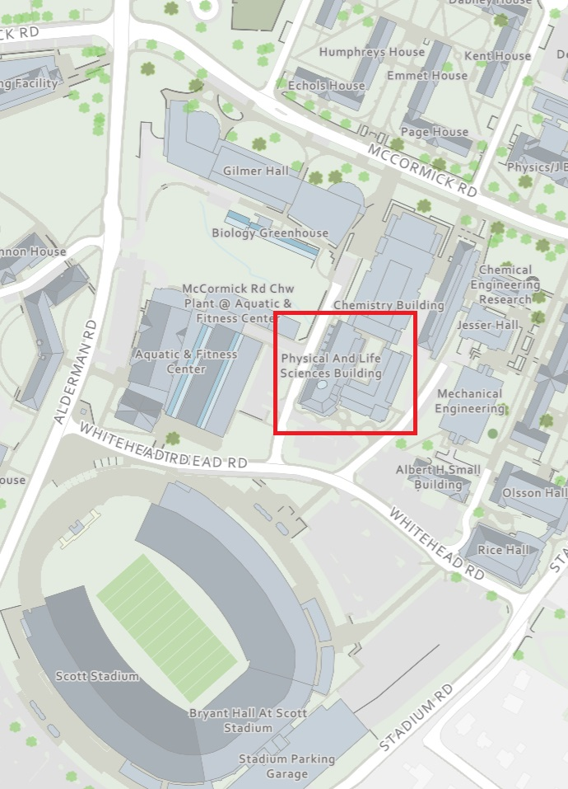
Chemistry Addition Plant Context

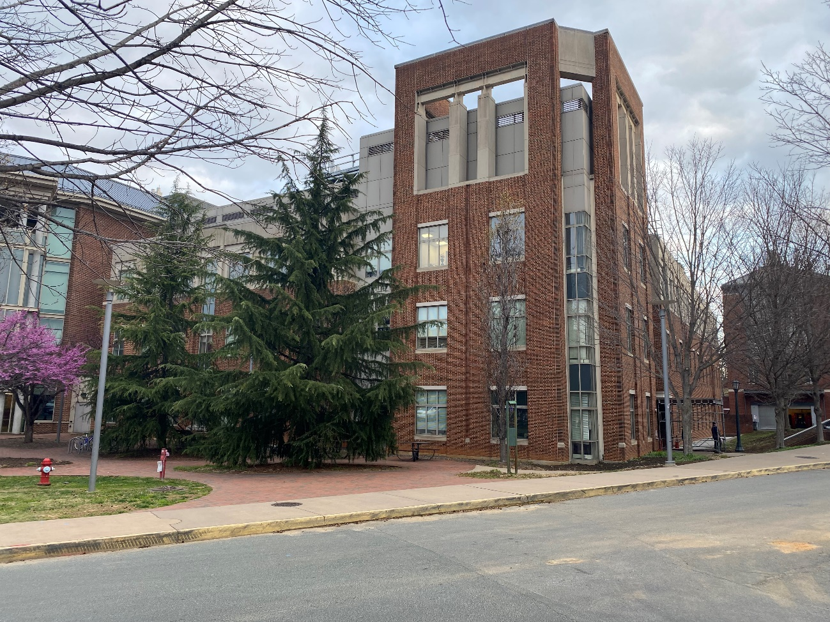
Entrance to Chemistry Addition Plant.
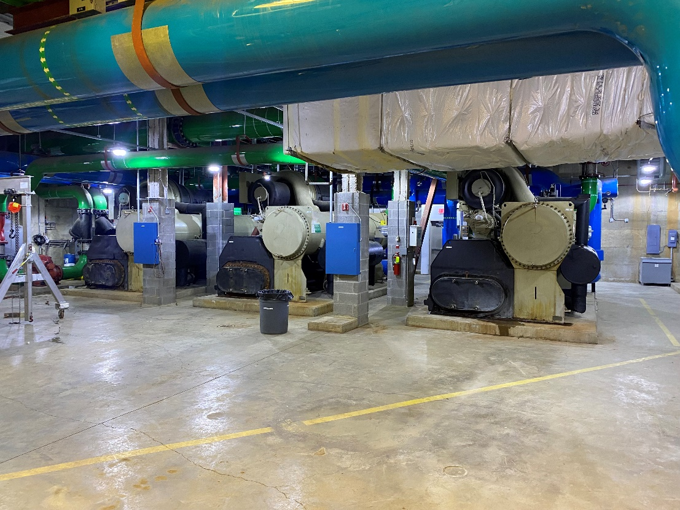
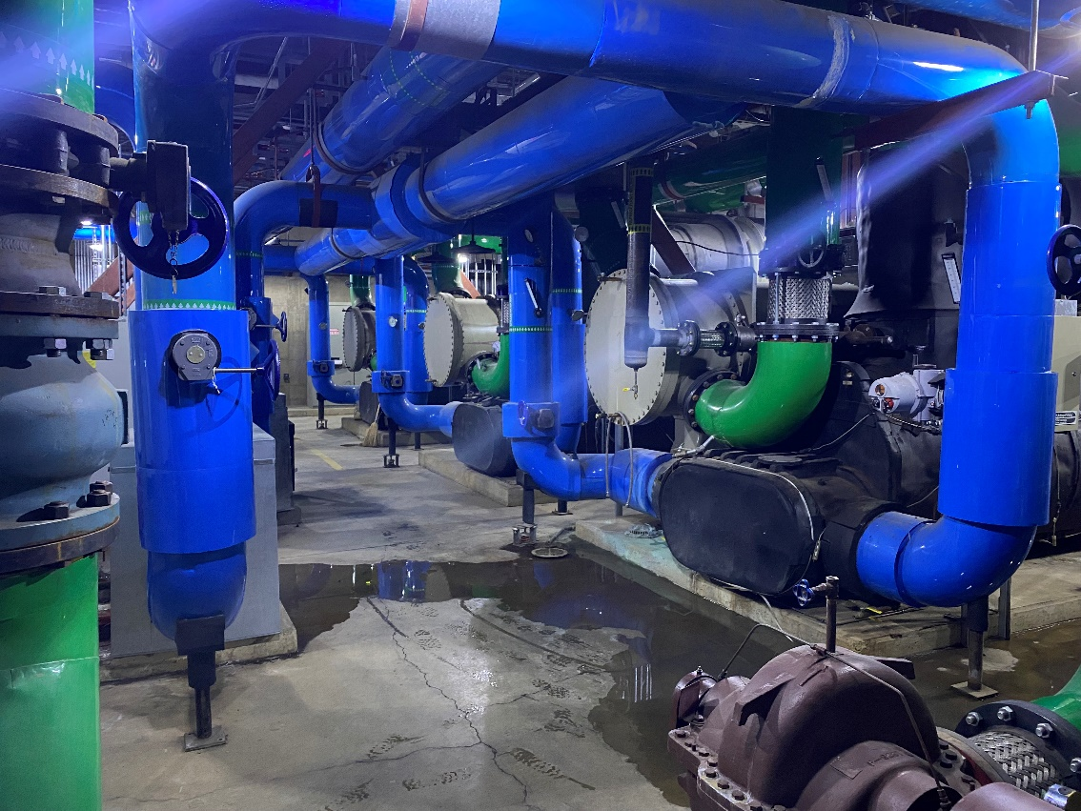
Existing Chillers, Piping & Equipment in Plant.

